**Department of Veterans Affairs**

**Maternity Tracker (MT) Project**



**Dashboard User Manual**

**Version 3.1 November 2017**



# Revision History

|  |  |  |
| --- | --- | --- |
| **Date** | **Description of Change** | **Author** |
| 11/21/2017 | Added new sections, updated existent section, added new images and updated some existent images to reflect the new look of the MCC Dashboard. | Alina Frey |
| 02/21/2017 | Updated to version 3.0 | T. Eaves |
| 11/18/2016 | Updated to version 2.0 | T. Eaves |
| 07/23/2016 | Updated dashboard illustration and IHE section. | T. Eaves |
| 06/10/2016 | Updates to document. | E. Gerardo |
| 03/15/2016 | Updates to document. | E. Roussos |
| 07/10/2015 | Enhancements to updates. | E. Roussos |
| 01/08/2015 | New Manual | M. Fieck |

# Table of Contents

Revision History i

Table of Contents iii

List of Figures v

Introduction 1

Product Description 1

Security Keys and Menu Options 1

Getting Started Using Maternity Tracker 3

Accessing Maternity Tracker 3

Sign In 4

Alerts 7

Sign Out 8

MCC Dashboard Elements and Functionality – Tracking / Configuration View 9

Dashboard 10

Tracked Patients 11

Trimester Filters 12

Flagged Patients 12

Flagged Patient Details 12

Progress Notes 13

Accept/Reject 14

Track A Patient 15

Search Patient 16

Start Tracking 16

Tracking History 17

Non-VA Care 18

Education Items 20

Add New 21

Edit Selected 24

Delete Selected 24

Checklist 24

Add New Checklist Item 25

Edit Selected Checklist Item 28

Delete Selected Checklist Item 29

MCC Dashboard Elements and Functionality – Patient View 30

Tracked Patients 32

Patient Summary 32

Patient Details 33

Current Pregnancy 37

Gravida/Para Details 51

Contact 52

Pregnancy Checklist (Patient Summary View) 53

Pregnancy Checklist 53

Edit Status 55

Edit Item 56

Delete Item 59

Add Item 59

Add Default Items 60

Pregnancies 61

View Current Pregnancy 62

View Selected past pregnancy 63

Delete Selected past pregnancy 63

Add Past Pregnancy 64

Pregnancy Outcome Types 67

Contact History 81

Add a Call Note 82

Call Note Details 83

Call Note Tabs 86

Call Note Tabs Details 94

Education 109

Add Education Item 111

Notes 113

Edit a Dashboard Note 115

Sign a Dashboard Note 115

Add Addendums to a Dashboard Note 116

View the details of a Note 119

Create a new note 120

Delete 121

Text4Baby Enrollment 121

Labs 124

Clinical Exchange Documents 126

View a Clinical Exchange Document 128

Receive a Clinical Exchange Document 129

Send a Clinical Exchange Document 133

Orders 141

Reminders 143

Consults 145

Radiology 147

Stop Tracking 149

Glossary 153

Glossary of Terms 153

Acronyms 154

# List of Figures

Figure 1: Welcome to the Maternity Tracker Dashboard 3

Figure 2: Login screen 3

Figure 3: Sign In 4

Figure 4: Select Division 4

Figure 5: User logged into MCC Dashboard 5

Figure 6: MCC Dashboard Left Side Panel – 2 views 6

Figure 7: MCC Dashboard – Main area 7

Figure 8: Alerts Display 7

Figure 9: MCC Dashboard – Tracking / Configuration View 9

Figure 10: Dashboard Tracking / Configuration View – Left side pane 10

Figure 11: Dashboard – Select Date Range 11

Figure 12: Tracked Patients 11

Figure 13: Tracked Patients – Filter Options 12

Figure 14: Flagged Patients 12

Figure 15: Flagged Patient Details 13

Figure 16: Progress Note View 14

Figure 17: Action Column (Flagged Patients) 14

Figure 18: Command Buttons (Progress Note View) 14

Figure 19: Accept Flagged Patient 15

Figure 20: Track A Patient 15

Figure 21: Track A Patient Search 16

Figure 22: Start Tracking a Patient Confirmation 17

Figure 23: Tracking History 17

Figure 24: Tracking History – By Patient 18

Figure 25: Non-VA Care Items 19

Figure 26: Edit or Add Non-VA Care Items 20

Figure 27: Education Items 21

Figure 28: Add Education Item 22

Figure 29: Education Type Drop-down List 22

Figure 30: Education Categories 23

Figure 31: Education Item – Coding System Drop-down List 23

Figure 32: Edit Education Item 24

Figure 33: Education Item Deletion Confirmation 24

Figure 34: Checklist Items 25

Figure 35: Checklist Items Commands 25

Figure 36: Add New Checklist Item 26

Figure 37: Add New Checklist Item – Type Drop-down List 26

Figure 38: Add New Checklist Item – Note Dropdown List 27

Figure 39: Add New Checklist Item – Education Item Dropdown List 28

Figure 40: Edit Selected 29

Figure 41: Deleted Checklist Item message 29

Figure 42: MCC Dashboard – Patient View 30

Figure 43: Dashboard Patient View – Left side pane 32

Figure 44: Patient Summary 33

Figure 45: Patient Details Panel 34

Figure 46: Patient Details – Pregnancy Status 34

Figure 47: Patient Details – Update Pregnancy Status 34

Figure 48: Patient Details – Pregnancy Status updated to Pregnant 35

Figure 49: Pregnancy Outcome Details 35

Figure 50: Type of Pregnancy Outcome 36

Figure 51: Patient Details – Lactation Status 36

Figure 52: Patient Details – Update Lactation Status 37

Figure 53: Patient Details – text4baby Status 37

Figure 54: Current Pregnancy Section 38

Figure 55: EDD Observation History 39

Figure 56: EDD Calculator 40

Figure 57: EDD Calculator – Updating EDD 41

Figure 58: Updated EDD – Confirmation Notice 41

Figure 59: Current Pregnancy panel – Updated EDD 42

Figure 60: EDD Observation History Updated 42

Figure 61: Edit Prenatal Care Provider 43

Figure 62: Selecting new Prenatal Care Provider 43

Figure 63: Updated Prenatal Care Provider 44

Figure 64: Edit Planned Delivery Facility 44

Figure 65: Selecting new Planned Delivery Facility 45

Figure 66: Updated Planned Delivery Location 45

Figure 67: Selecting Father of Baby 46

Figure 68: Adding/Editing new Father of Baby 46

Figure 69: Updated Father of Baby 47

Figure 70: Father of Baby updated 47

Figure 71: Edit Current Pregnancy 49

Figure 72: Editing Current Pregnancy – Multiple Gestations field 50

Figure 73: Gravida / Para Details 51

Figure 74: Gravida/Para Details / Edit 52

Figure 75: Updated G/P Summary 52

Figure 76: Patient’s Contact Info Panel 53

Figure 77: Pregnancy Checklist (Summary Page View) 53

Figure 78: Pregnancy Checklist 54

Figure 79: Pregnancy Checklist – Due Date Alert 54

Figure 80: Pregnancy Checklist Filter 54

Figure 81: Pregnancy Checklist – Action on an existing item 55

Figure 82: Edit the Status of an existing Pregnancy Checklist Item 56

Figure 83: Edit Pregnancy Checklist Item 56

Figure 84: Add/Edit Pregnancy Checklist Item – Type field 57

Figure 85: Add/Edit Pregnancy Checklist Item – Note field 57

Figure 86: Add/Edit Pregnancy Checklist Item – Education field 58

Figure 87: Add/Edit Pregnancy Checklist Item – Completion Status field 58

Figure 88: Editing existing Pregnancy Checklist item success message 59

Figure 89: Deleting an existing Pregnancy Checklist item message 59

Figure 90: Add Pregnancy Checklist Item 59

Figure 91: Adding new Pregnancy Checklist item success message 60

Figure 92: New Pregnancy Checklist Item saved successfully 60

Figure 93: Add Default Items to Pregnancy Checklist – Confirmation Prompt 61

Figure 94: Adding Default Items to Pregnancy Checklist – Success message 61

Figure 95: Pregnancies 61

Figure 96: Pregnancies Action Buttons 62

Figure 97: Current Pregnancy 62

Figure 98: Delete Pregnancy Alert 63

Figure 99: Pregnancy Outcome Details 64

Figure 100: Pregnancy Outcome Details -Pregnancy Outcome Types 64

Figure 101: Add Past Pregnancy – Other Details 65

Figure 102: Add Past Pregnancy – Add/Edit Details 66

Figure 103: Full Term Delivery (Live Infant 37 or More Weeks) – Edit Details 68

Figure 104: Full Term Delivery (Live Infant 37 or More Weeks) – Edit Details (continued) 69

Figure 105: Full Term Delivery (Live Infant 37 or More Weeks) – Pregnancy Details Panel 70

Figure 106: Full Term Delivery (Live Infant 37 or More Weeks) – Pregnancy Details Panel (continued) 71

Figure 107: Edit Baby Details 71

Figure 108: Baby Details panel 72

Figure 109: Preterm Delivery (Live Infant 20-36 Weeks 6 Days) – Edit Details 73

Figure 110: Preterm Delivery (Live Infant 20-36 Weeks 6 Days) – Edit Details (continued) 74

Figure 111: Preterm Delivery (Live Infant 20-36 Weeks 6 Days) – Pregnancy Details Panel 75

Figure 112: Spontaneous Abortion (Pregnancy Loss Prior to 20 Weeks) – Edit Details 76

Figure 113: Spontaneous Abortion (Pregnancy Loss Prior to 20 Weeks) – Pregnancy Details Panel 77

Figure 114: Fetal Demise/Stillbirth – Edit Details 78

Figure 115: Fetal Demise/Stillbirth – Pregnancy Details Panel 78

Figure 116: Pregnancy Termination – Edit Details 79

Figure 117: Pregnancy Termination – Pregnancy Details Panel 79

Figure 118: Ectopic Pregnancy – Edit Details 80

Figure 119: Ectopic Pregnancy – Pregnancy Details Panel 81

Figure 120: Contact History screen 81

Figure 121: Contact History Pregnancy Filter 82

Figure 122: Call Note Types 83

Figure 123: Open previously added Call Note 83

Figure 124: Call Note Details 84

Figure 125: Call Note – Contact Info 84

Figure 126: Call Note Buttons 84

Figure 127: Call Note Buttons (continued) 85

Figure 128: Preview/Finish – Call Note Summary 85

Figure 129: Signing Call Note 86

Figure 130: Phone Call #1 (Initial Contact) 87

Figure 131: Phone Call #2 (12 Weeks) 88

Figure 132: Phone Call #3 (20 Weeks) 89

Figure 133: Phone Call #4 (28 Weeks) 90

Figure 134: Phone Call #5 (36 Weeks) 90

Figure 135: Phone Call #6a (41 Weeks, Not Delivered) 91

Figure 136: Phone Call #6b (41 Weeks, Delivered) 92

Figure 137: Phone Call #7 (6 Weeks Postpartum) 93

Figure 138: Additional Call Note 93

Figure 139: Intro Tab 1 94

Figure 140: Intro Tab 2 94

Figure 141: Intro Tab 3-7 94

Figure 142: Coverage Tab 1 95

Figure 143: Coverage Tab 1 (continued) 96

Figure 144: Coverage Tab 2 97

Figure 145: Coverage Tab 3 97

Figure 146: Coverage Tab 4-7 97

Figure 147: Classes Tab 3, 4 98

Figure 148: Breastfeeding Tab 4 99

Figure 149: Breastfeeding Tab 5 100

Figure 150: Breastfeeding Tab 6a 100

Figure 151: Breastfeeding Tab 6b 101

Figure 152: Breastfeeding Tab 7 101

Figure 153: WIC Tab 4 101

Figure 154: Contraception Tab 4 102

Figure 155: Contraception Tab 5 102

Figure 156: Contraception Tab 6b 102

Figure 157: Health Tab 1-6a, 7 103

Figure 158: Health Tab 6b 104

Figure 159: Smoking Tab 1 105

Figure 160: Smoking Tab 2, 3 105

Figure 161: Alcohol Tab 106

Figure 162: Depression Tab 1, 3-7 106

Figure 163: IPV Tab 1, 3, 5, 6b 107

Figure 164: PP Visit Tab 6b, 7 108

Figure 165: VA Primary Tab 7 108

Figure 166: End Tab 109

Figure 167: Patient Education Items 110

Figure 168: Education Items Filter 110

Figure 169: View Details of Completed Task 111

Figure 170: Add Education Items to patient's Education 112

Figure 171: Add New Patient Education Item 113

Figure 172: Dashboard Notes 114

Figure 173: Action options on a note 115

Figure 174: Edit Dashboard Note 115

Figure 175: Sign Dashboard Note 116

Figure 176: Updated Signed Status 116

Figure 177: Create Addendum 116

Figure 178: Note – Addendum added 117

Figure 179: Adding Addendum to MCC Dashboard Note 117

Figure 180: More Addendums Added to the note 118

Figure 181: Delete Addendum 118

Figure 182: View Addendum Details 119

Figure 183: View Dashboard Note 120

Figure 184: New Dashboard Note 120

Figure 185: Delete Dashboard Note 121

Figure 186: Text4baby Enrollment 122

Figure 187: Text4Baby Patient Enrollment Form 123

Figure 188: Text4Baby Patient Enrollment – Participant Type Field 123

Figure 189: Text4Baby successful enrollment 124

Figure 190: Lab Results 125

Figure 191: Lab Results (continued) 125

Figure 192: Labs – Filters 126

Figure 193: Clinical Exchange Documents 127

Figure 194: Clinical Exchange Documents Options 128

Figure 195: Document View 129

Figure 196: Receive Document 130

Figure 197: Clinical Exchange Documents – Review uploaded document 131

Figure 198: Clinical Exchange Documents – Confirm Patient on upload 131

Figure 199: Select Data to Import 132

Figure 200: Electronic Signature for uploading clinical document 132

Figure 201: Clinical Exchange Documents – successful upload 133

Figure 202: Clinical Exchange Documents – Send Documents Types 134

Figure 203: Clinical Exchange Documents – Send Documents Options 134

Figure 204: Sending Clinical Documents – APHP and APS – Source Panel – Selecting Date 135

Figure 205: Sending Clinical Documents – APHP and APS – Source Panel – Selecting Consult 136

Figure 206: Sending Clinical Documents – APL and APE – Source Panel 136

Figure 207: Sending Clinical Documents – PPVS – Source Panel 137

Figure 208: Sending Clinical Documents – XDR-I – Source Panel 137

Figure 209: Generate Clinical Documents 138

Figure 210: Clinical Documents – Style Sheet 138

Figure 211: Generating Clinical Document 139

Figure 212: Clinical Document generated 140

Figure 213: Generated document saved to Clinical Documents 141

Figure 214: Orders 142

Figure 215: Order Detail 143

Figure 216: Clinical Reminders 144

Figure 217: Reminder Detail 145

Figure 218: Consults 146

Figure 219: Consult Detail 147

Figure 220: Radiology Reports 148

Figure 221: Radiology Report Detail 149

Figure 222: Stop Tracking Patient 150

Figure 223: Select Reason for Stop Tracking 151

Figure 224: Stop Tracking Details 151

# Introduction

## Product Description

The Maternity Tracker project addresses the gaps in VistA for Maternity Tracking and Monitoring through a combination of field tested enhancements for better screening, tracking, monitoring, and sharing of maternity data, as well as improving women Veteran’s access to earlier pre-natal care, complete postpartum care, and education information with an emphasis on care coordination in and outside of the VA. Throughout the document, Maternity Tracker (MT) Dashboard and Maternity Care Coordinator (MCC) Dashboard are used interchangeably.

## Security Keys and Menu Options

To access the Maternity Tracker application, all general users must have the following added to the New Person file in VistA:

Secondary Menu Option – **DSIO GUI CONTEXT**

# Getting Started Using Maternity Tracker

## Accessing Maternity Tracker

Contact the System Administrator to get the URL for the MCC Dashboard. Open a web browser and access the MCC Dashboard at the provided URL. This will redirect the user to the MCC Dashboard home screen.

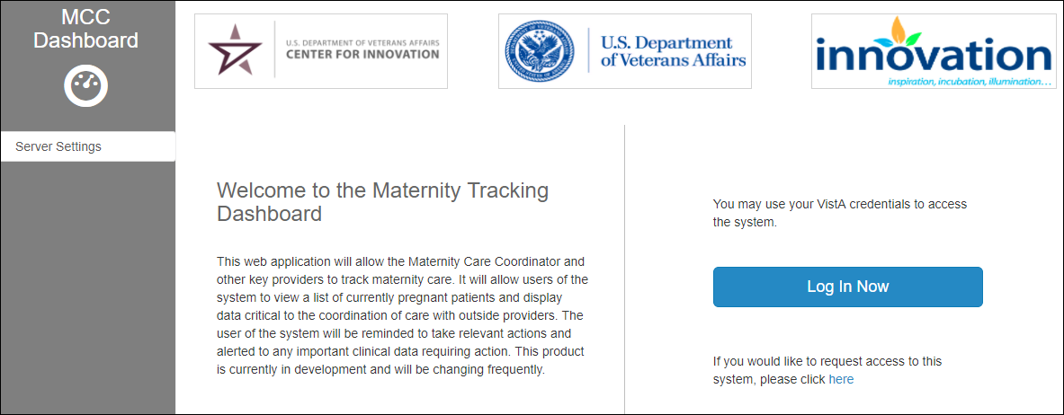

Figure 1: Welcome to the Maternity Tracker Dashboard

Select **“here”** link at the bottom of the page to request first-time access, complete the email message, and send.

Click **Log In Now** button to access the application. This will redirect the user to the **Login** screen.

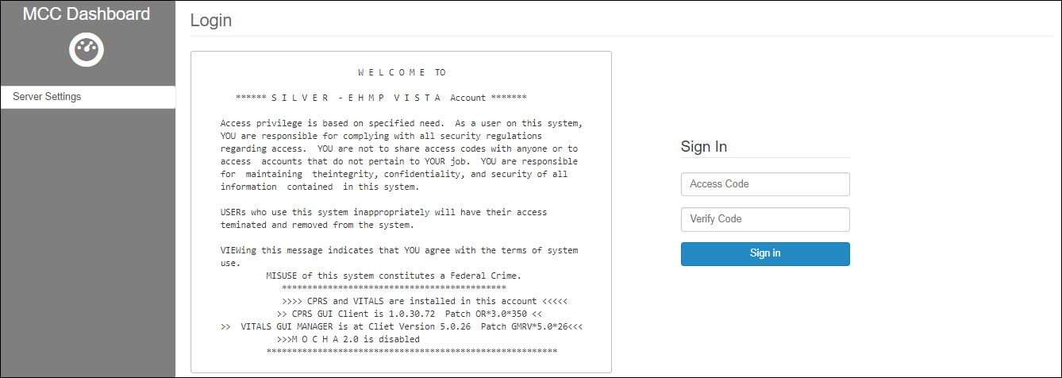

Figure 2: Login screen

## Sign In

To sign in to the application, enter your VistA (CPRS) Access and Verify code provided by the System Administrator, and click **Sign In**.

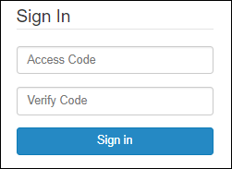

Figure 3: Sign In

The user may be asked to select an appropriate Division. Click the radio button for the correct Division. The user is taken to the MCC Dashboard.



Figure 4: Select Division

When the user is logged in, the user is directed to the default Dashboard screen, presented in section Dashboard of chapter MCC Dashboard Elements and Functionality – Tracking / Configuration.

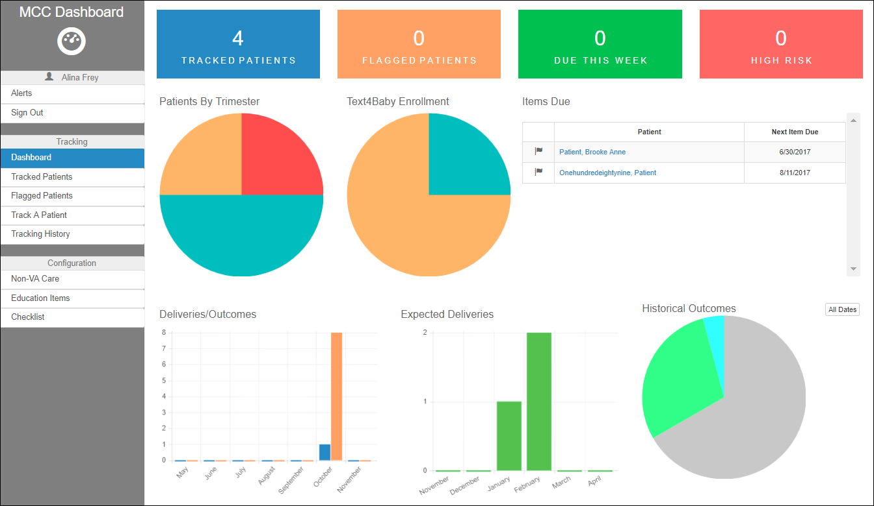

Figure 5: User logged into MCC Dashboard

The application shows two main areas discussed in the subsequent sections:

1. Left side pane: The left side pane changes its structure based on the view the user is in:
   1. Tracking / Configuration view
   2. Patient View – After a patient was selected

|  |  |
| --- | --- |
|  |  |

Figure 6: MCC Dashboard Left Side Panel – 2 views

1. The selected Screen (central area): displaying the details of the screen that was selected on the left side pane. For example, if Checklist tab is selected on the left side pane, the main area will show the Checklist Items screen.

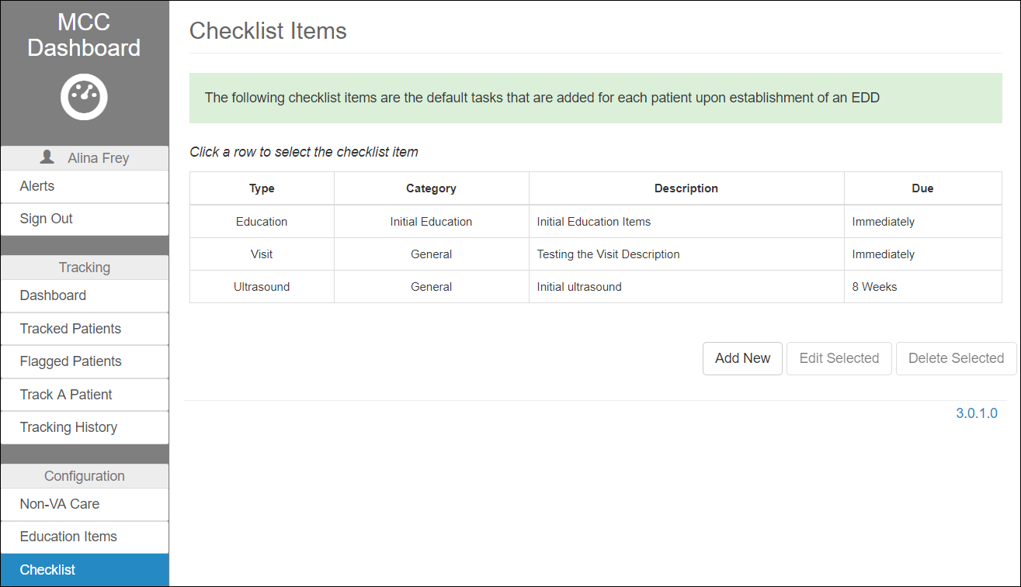

Figure 7: MCC Dashboard – Main area

## Alerts

The user can view their Alerts by selecting the option from the menu. The Alerts window opens to display pending work by patient. Click **Tracked Patients** to exit the Alerts page and navigate to the Tracked Patients screen (section Tracked Patients).

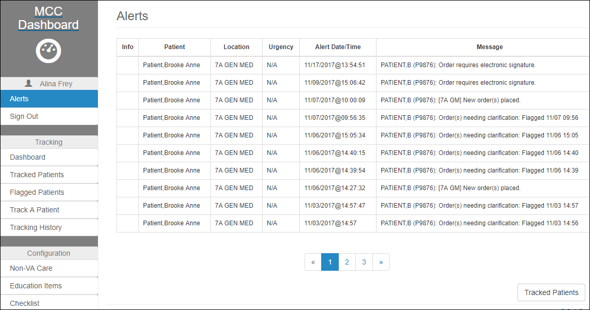

Figure 8: Alerts Display

## Sign Out

To sign out of MT, select the **Sign Out** option from the left side pane under the Dashboard Menu. When clicking on the Sign Out link, the user is logged off and taken back to the MCC Dashboard home screen.

# MCC Dashboard Elements and Functionality – Tracking / Configuration View

Upon logging in, the user is directed to the Maternity Care Coordinator (MCC) Dashboard default screen, with the Dashboard tab selected by default on the left side pane.

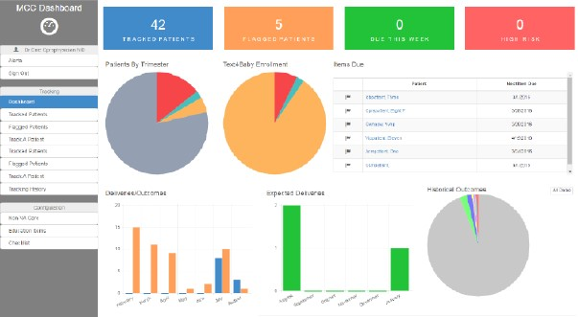

Figure 9: MCC Dashboard – Tracking / Configuration View

The user has access to multiple selections (tabs), available from the Left side pane. Each of the menus are presented in detail in the following sections.

1. The Dashboard Menu:
   1. Link to MCC Dashboard home screen.
   2. Name of the user that is logged in
   3. Link to Alerts
   4. Link for Signing Out
2. Tracking Menu:
   1. Dashboard
   2. Tracked Patients
   3. Flagged Patients
   4. Track A Patient
   5. Tracking History
3. Configuration Menu:
4. Non-VA Care
5. Education Items
6. Checklist

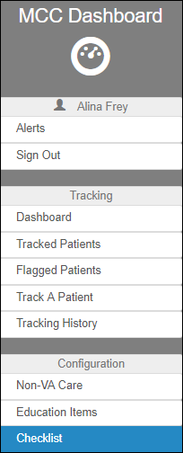

Figure 10: Dashboard Tracking / Configuration View – Left side pane

## Dashboard

The Dashboard page is a graphical representation of statistical information, such as:

1. The number of Tracked Patients, Flagged Patients, Due This Week and High Risk Pregnancies, shown at the top of the page. The first two, Tracked Patients and Flagged Patients, are links to their corresponding screens presented in sections below, which can also be accessed from the left side pane.
2. Pie charts displaying the number of patients grouped by different categories: Patient by Trimester, Text4Baby Enrollment, and Historical Outcomes.
3. Table for Items Due by Patient name and Due Date.
4. Bar charts for the number of Deliveries/Outcomes and Expected Deliveries.
5. Also, the user can choose a date range for this statistical information, by selecting the **All Dates** button:

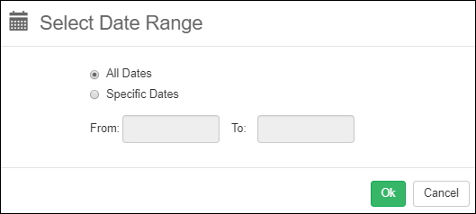

Figure 11: Dashboard – Select Date Range

## Tracked Patients

To see all the patients that are tracked, click on the Tracked Patients tab on the left side pane.

The user is directed to the Tracked Patients screen, which displays an alphabetic list of the patients currently tracked using the MT application. For each patient the list includes: Name, Last 4 (digits of social security numbers), Age, Phone number, Non-VA OB, L&D facility, Pregnant status, Tri (Trimester), GA (Gestational Age), and EDD (Estimated Delivery Date). These fields cannot be edited from this page. Each column is sortable by clicking in the header of the column.

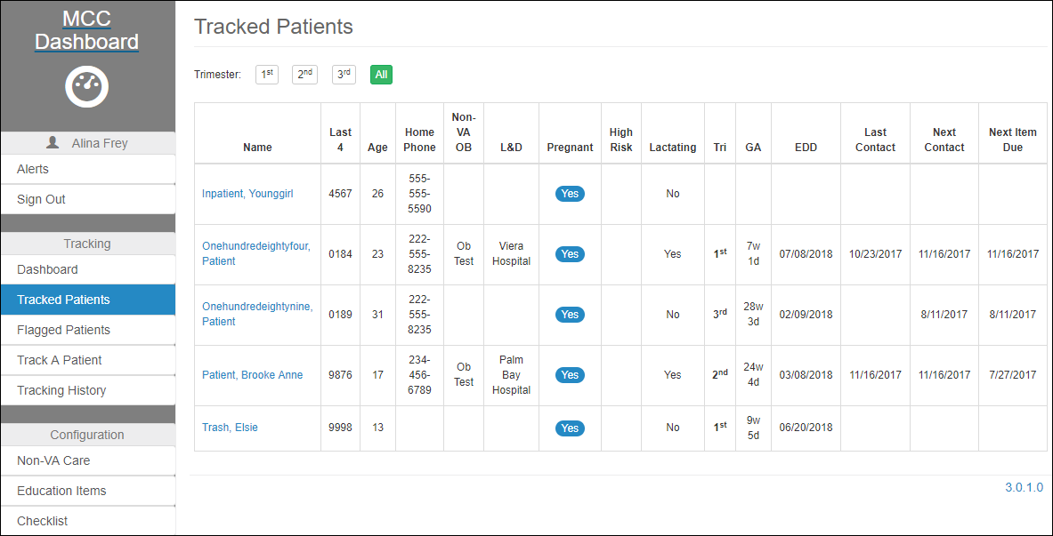

Figure 12: Tracked Patients

The names of the patients are direct links to the Patient Details screen, as presented in section MCC Dashboard Elements and Functionality – Patient.

### Trimester Filters

This list can be filtered based upon Trimester by clicking the one of the buttons at the top of the table: 1st, 2nd, 3rd, or All.



Figure 13: Tracked Patients – Filter Options

## Flagged Patients

In CPRS, a consult request for OB care, an addition of PREGNANT to the Problem List, or a positive lab test for pregnancy triggers that patient into the list of Flagged Patients. From this list, the user can track the patient in MT.

The Flagged Patients table includes Name, SSN, DOB, Flagged On date and time, Details and Action (Accept/ Reject). The Details column contains links to the corresponding Flagged Patient Details screen.

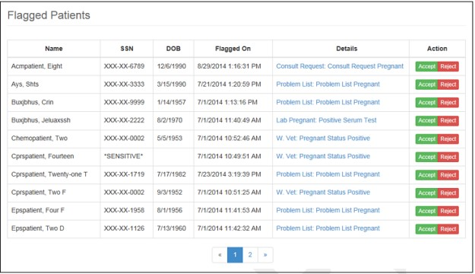

Figure 14: Flagged Patients

### Flagged Patient Details

By selecting the item in the Details column for the patient, the user will get the Flagged Patient Details page that displays the data used to determine flagging and a list of the patient’s most recent progress notes in CPRS.

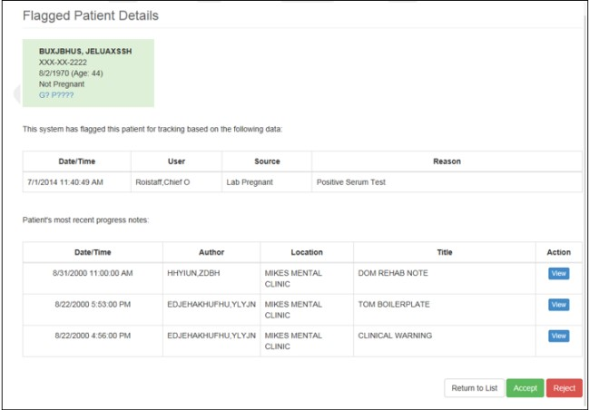

Figure 15: Flagged Patient Details

### Progress Notes

By clicking the **View** action, the progress note will open, and the page will include options to Return to List, Return to Details, Accept, and Reject.

CNT— Clinical Note Templates have been created for users to document patient care in CPRS. The (5) five templates are OB HISTORY NOTE, OB H&P CONSULT, OB FOLLOWUP NOTE, NURSE POSTPARTUM- Delivery, and NURSE POSTPARTUM- Maternal. These notes will be visible in MT.

Another note type in CPRS is the MD POSTPARTUM FOLLOWUP. This will also be visible in MT, but it is not a CNT.

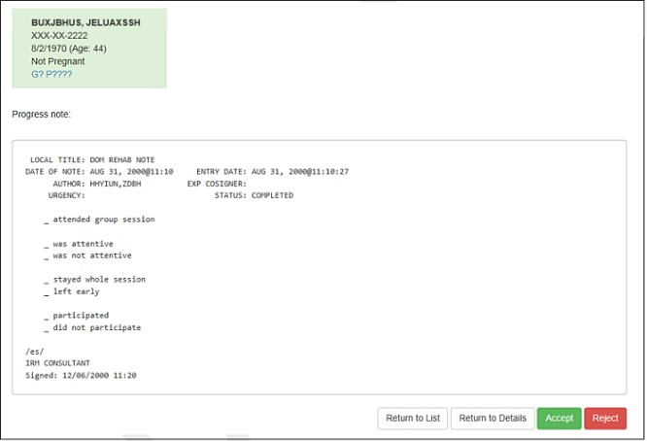

Figure 16: Progress Note View

### Accept/Reject

To accept or reject a patient for tracking in MT, the user may make the selection on either the Flagged Patient List page in the Action column, or the Progress Note page, by choosing from the appropriate command.

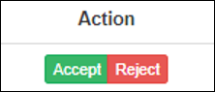

Figure 17: Action Column (Flagged Patients)



Figure 18: Command Buttons (Progress Note View)

By clicking **Accept**, the user will get an Accept Flagged Patient confirmation screen, where a comment can be added to a text box. The user may **Accept Tracking** or select **Back** which will return the user to the previous page without tracking this patient. Once the patient is accepted, the user will be taken to the Tracked Patients Screen and see their patient added to the list.

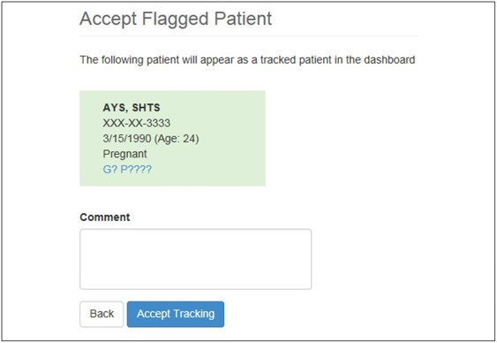

Figure 19: Accept Flagged Patient

## Track A Patient

This option allows the user to find a patient to track, and then edit patient’s details if necessary. The page displays with a search option.

To track a patient, click on Track A Patient tab on the left pane. The user is directed to the Tracked A Patient screen.

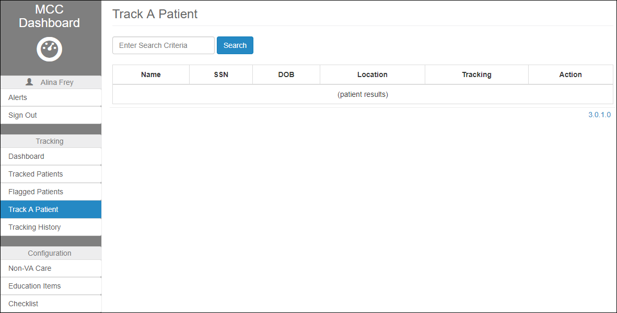

Figure 20: Track A Patient

### Search Patient

To search for a patient from the CPRS directory, type a last name (partial or whole) in the **Enter Search Criteria** field, and click **Search**. The user may also search by last name initial plus the last four digits of the SSN, or by the last name and partial first name. Note: At least the first two letters of the last name are required to perform the search.

The screen will display all the female patients with the last name matching the search criteria. The table includes patient info such as: Name, SSN, DOB, Location, Tracking, and Action.

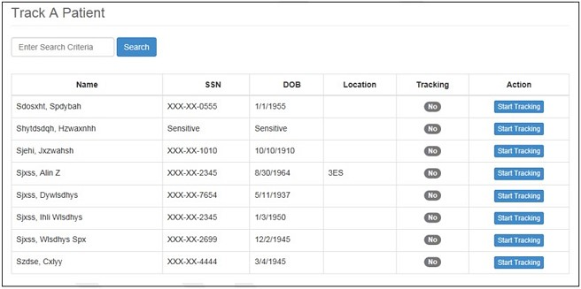

Figure 21: Track A Patient Search

### Start Tracking

The user can choose a patient to track by clicking the **Start Tracking** command from the Action column. The user will get a confirmation page to Start Tracking a patient that requires a Reason to be selected from a drop-down list, a check box to update the pregnancy status in MT and allows for a comment to be added in a text box. If the user selects **Back**, they will get the previous page. By selecting Start Tracking, the user is taken to the Tracked Patients Screen and will see their patient added to the list.

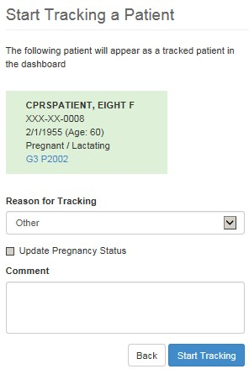

Figure 22: Start Tracking a Patient Confirmation

## Tracking History

The Tracking History screen can be accessed by clicking on the Tracking History tab on the left side pane of the Dashboard.

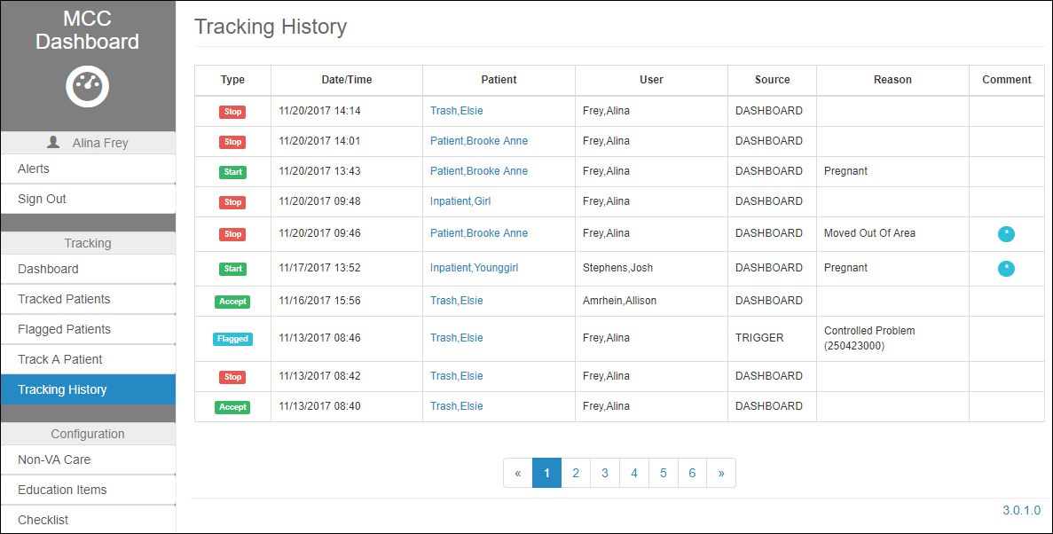

Figure 23: Tracking History

, such as:

1. Type (Start tracking, Stop tracking, Flagged or Accept)
2. Date/Time
3. Patient on which the action was performed
4. User that performed the action
5. Source
6. Reason why the patient was tracked

The names of the patients are direct links to the Patient Details screen, as presented in section MCC Dashboard Elements and Functionality – Patient.

By selecting a patient from the list, the user can view the Tracking History by Patient. From this window, the user can choose to **Return to All Patients**.

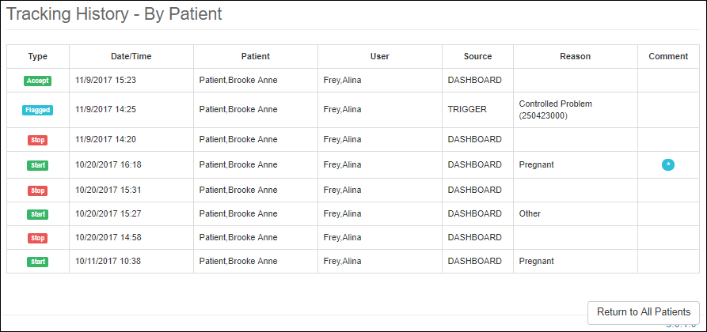

Figure 24: Tracking History – By Patient

## Non-VA Care

The Configuration Menu in the side left side pane, displays three links to: Non-VA Care, Education Items and Checklist.

When clicking on the Non-VA Care tab, the user is directed to the Non-VA Care Items screen. MT maintains a library of Non-VA Care Items (Facilities and Providers) for use on the patient MT record.

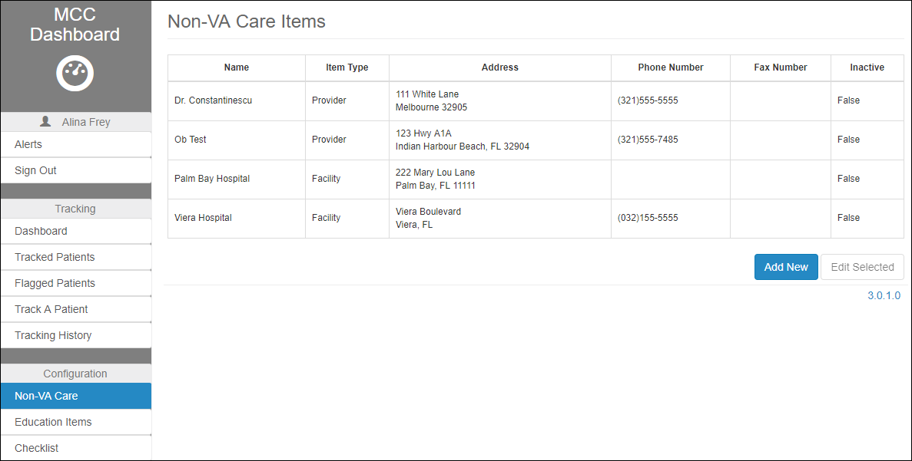

Figure 25: Non-VA Care Items

The items in the list can be edited by highlighting an item and clicking **Edit Selected**.

To add a new Provider or Facility, select the **Add New** button.

At the edit/add window, the user can enter new information in the fields provided and select Save button to store the information. For the Item Type, the user can choose from a drop-down list: Provider or Facility.

By selecting **Cancel** button, the user can return to the previous window without saving.

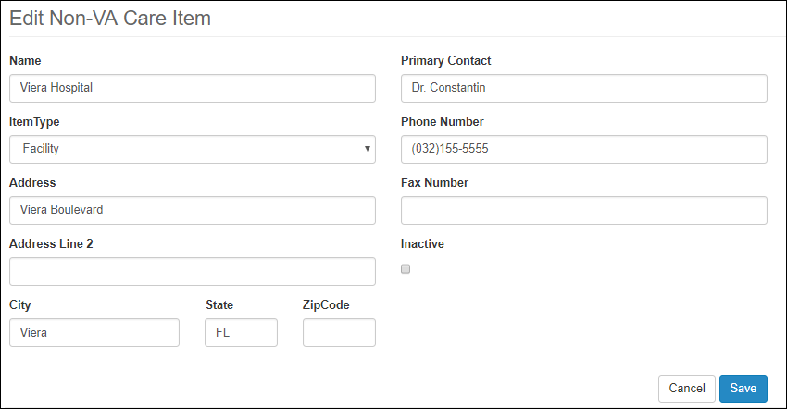

Figure 26: Edit or Add Non-VA Care Items

## Education Items

The Education Items screen can be accessed by selecting the corresponding link on the left side pane. The screen displays a library of Education Items that is stored in MT. The information presented in the table includes:

1. Type
2. Category
3. Description
4. Url
5. Code

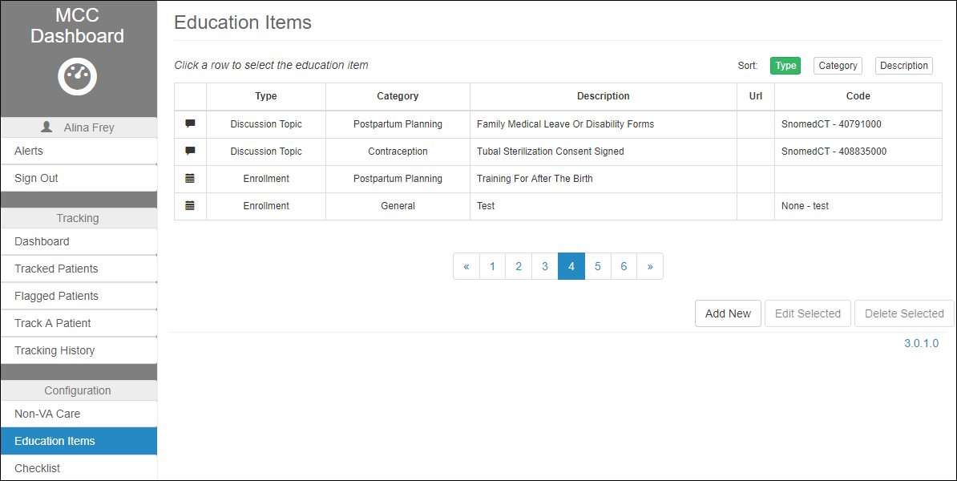

Figure 27: Education Items

The education items that are part of this table are going to be added to the default education items, present on the Edit Screen of the patient’s Education, as shown in section Education.

Within the list of available Education Items, the user can Add, Edit or Delete, by selecting the corresponding button at the bottom of the screen.

### Add New

To add a new Education Item to the list, click **Add New.** The user will be directed to the Add Education Item screen .

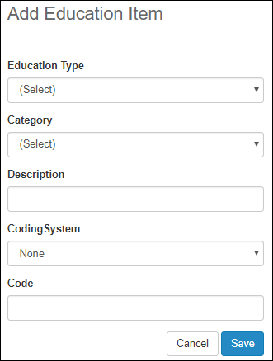

Figure 28: Add Education Item

Enter information into the fields provided:

1. For the Education Type, select an option from the drop-down list. The available default options are Discussion Topic, Link to Material, Printed Material, Enrollment, and Other.

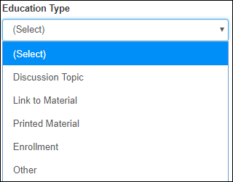

Figure 29: Education Type Drop-down List

1. For the Category, select an option from the drop-down list. The (Enter New) option within the drop-down list allows the user to create a new drop-down item, and a description which is free text.

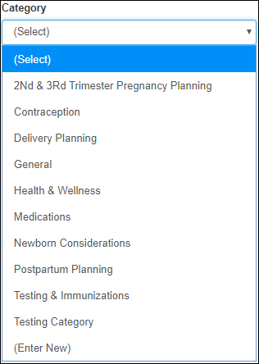

Figure 30: Education Categories

1. The Description is a text field, allowing the user to enter the name of the new Education Item for the selected Category.
2. For the Coding System field, select an option from the drop-down list. The available options are LOINC and SNOMED-CT.

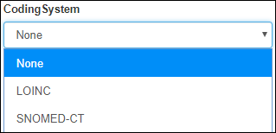

Figure 31: Education Item – Coding System Drop-down List

1. The Code is a text field, allowing the user to enter a code for the selected Coding System.

Click **Save** to store this information, or click **Cancel** to return to the previous page without storing the new item.

### Edit Selected

To edit an item in the list, highlight the item and click **Edit Selected**. Make changes in the fields provided, click **Save** to store the new information, or click **Cancel** to return to the previous page without storing the edits to this item.

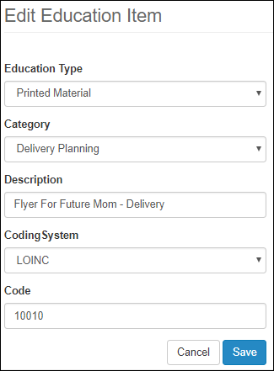

Figure 32: Edit Education Item

### Delete Selected

To delete from the Education Items list, highlight the item and click **Delete Selected** button at the bottom of the screen. A message will be displayed for a successful deletion of an education item.



Figure 33: Education Item Deletion Confirmation

## Checklist

MT maintains a directory of Checklist items for use on the patient’s record. The Checklist Items screen can be accessed by selecting the corresponding link on the left side pane.

TEstimated Delivery Date ().

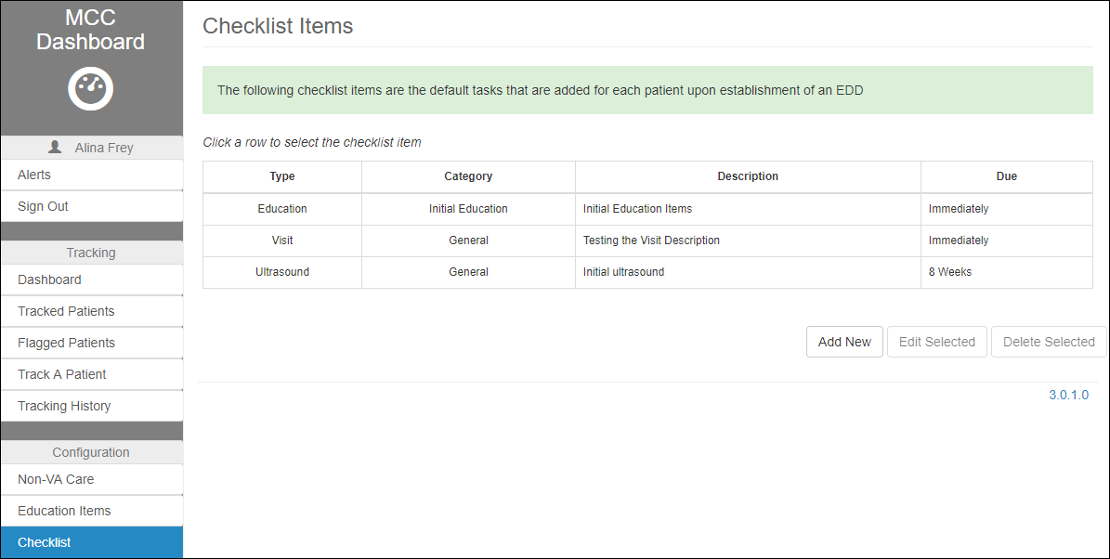

Figure 34: Checklist Items

The user can Add a new Checklist Item, and Edit or Delete an existing Checklist Item, by selecting on one of the buttons at the bottom of the screen.



Figure 35: Checklist Items Commands

### Add New Checklist Item

To add a new item to the Checklist, click the **Add New** command button. The user is prompted to enter the desired information on the Add New Checklist Item screen.

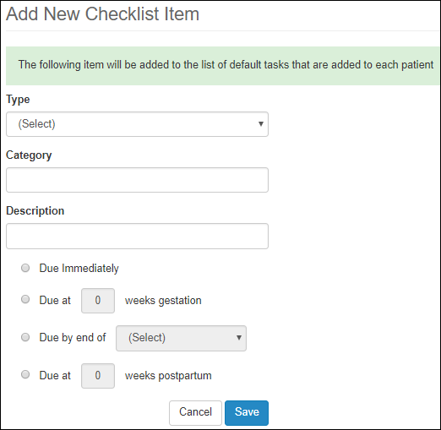

Figure 36: Add New Checklist Item

The following info can be edited:

1. Type – drop box with the following options:

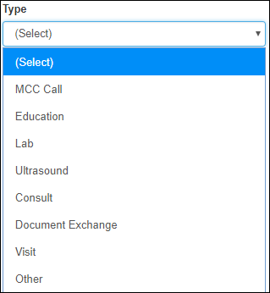

Figure 37: Add New Checklist Item – Type Drop-down List

1. Note – Added when the Type selected is MCC Call. Drop down list with the following options:

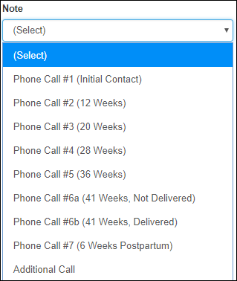

Figure 38: Add New Checklist Item – Note Dropdown List

1. Education Item – Added when the Type selected is Education. Drop down list with the following options:

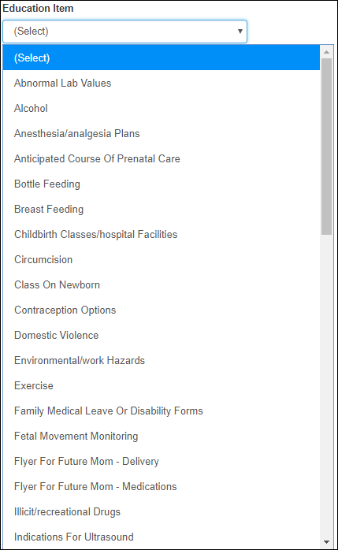

Figure 39: Add New Checklist Item – Education Item Dropdown List

1. Category field
2. Description field
3. Due – group of radio buttons with only one option for selection

Click **Cancel** to return to the previous page without saving. Click **Save** to store the entry and return to the previous page. The newly created item should be visible on the patient’s Checklist.

Also, the new items should be visible in the patient’s details screen under the Pregnancy Checklist table, after the default items were added (Add Default Items button), as shown in section Pregnancy Checklist.

### Edit Selected Checklist Item

To edit entries of an existing Checklist Item, highlight the item and click **Edit Selected**. Make changes as necessary. Click **Save** to store the entry and return to the previous page. Click **Cancel** to return to the previous page without storing any changes.

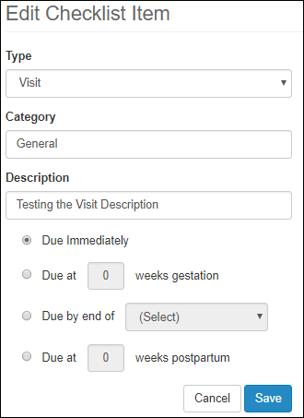

Figure 40: Edit Selected

### Delete Selected Checklist Item

To delete an existing Checklist Item, highlight the item and click **Delete Selected**. For a successful deletion, message will be displayed at the top of the screen.



Figure 41: Deleted Checklist Item message

# MCC Dashboard Elements and Functionality – Patient View

Upon selecting a patient from the Tracked Patients screen, the user is directed to the Patient View of the application, with the Summary tab selected by default on the left side pane.

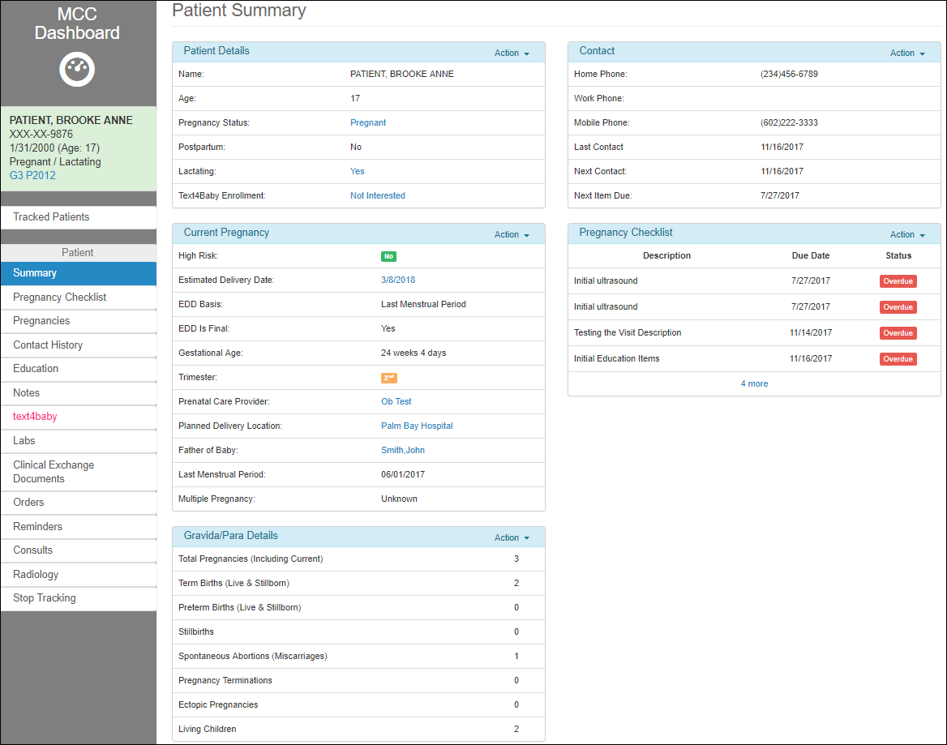

Figure 42: MCC Dashboard – Patient View

The user has access to multiple selections (tabs), available from the Left side pane. Each of the menus are presented in detail in the following sections.

1. The Dashboard Menu containing the selected patient’s details:
   1. Link to MCC Dashboard home screen.
   2. Name of the patient that was selected from Tracking Patients screen
   3. SSN
   4. Date of Birth – Age
   5. Status regarding pregnancy and lactation
   6. GP history
2. Link to Tracked Patients (presented in section Tracked Patients)
3. Patient Menu:
4. Summary
5. Pregnancy Checklist
6. Pregnancies
7. Contact History
8. Notes
9. text4baby
10. Labs
11. Clinical Exchange Documents
12. Orders
13. Reminders
14. Consults
15. Radiology
16. Stop Tracking.

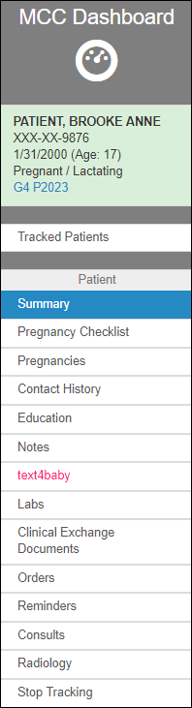

Figure 43: Dashboard Patient View – Left side pane

## Tracked Patients

Selecting this option will redirect the user to the Tracked Patients screen (see the Tracked Patients section of the MCC Dashboard Elements and Functionality – Tracking / Configuration View chapter).

## Patient Summary

The Patient Summary screen is the default screen that the user is directed to when switching to the Patient View, upon selecting a patient from the Tracked Patients screen. The user can enter and edit all the information concerning this patient’s pregnancy.

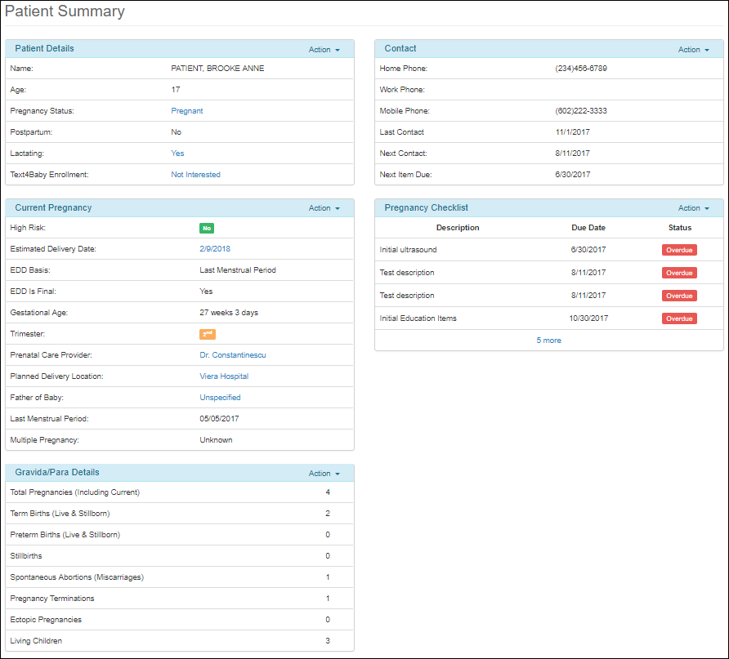

Figure 44: Patient Summary

### Patient Details

As part of the Patient Summary screen, the Patient Details panel displays information about the patient: Name, Age, Pregnancy Status, Postpartum and Lactating, Text4Baby Enrollment, and allows the user to edit the Pregnancy Status, Lactating status and Text4Baby status. In addition, the Action drop down at the top right corner of the panel, allows the user to update the Pregnancy Status or Lactating status.

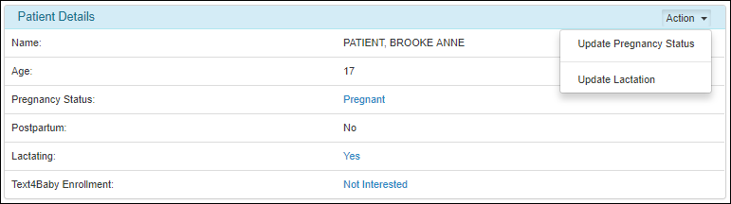

Figure 45: Patient Details Panel

#### Pregnancy Status

To edit or update the patient’s pregnancy status, click on the **Pregnancy Status** link in the Patient Details panel, or select **Update Pregnancy Status** from the drop-down Action list. This redirects the user to the Pregnancy Status dialog.

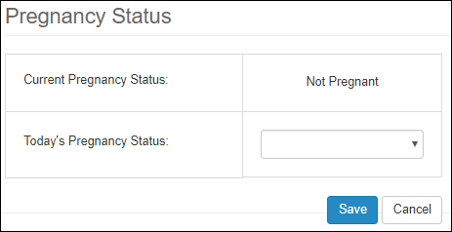

Figure 46: Patient Details – Pregnancy Status

The user has two possibilities to choose from: Pregnant or Not Pregnant.

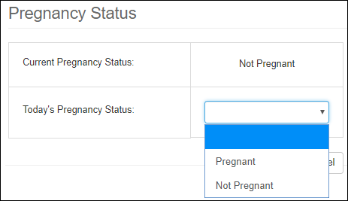

Figure 47: Patient Details – Update Pregnancy Status

If choosing Pregnant, assuming that the patient was not pregnant before, the user will be redirected back to the Patient Summary screen, showing the new Pregnancy Status in the Patient Details panel. Also, as a side note, a Current Pregnancy table will be added to the Pregnancies screen, with the details on top of the table of Past Pregnancies, as shown in section Pregnancies.

If the Pregnancy Status was previously set to Pregnant, and the user updates it to Not Pregnant, a new field is added to the dialog, Outcome/Delivery Date:

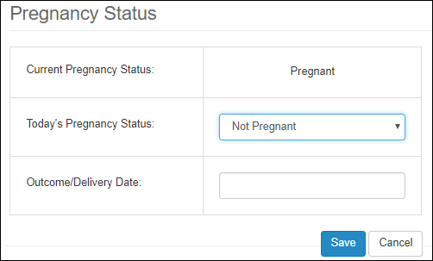

Figure 48: Patient Details – Pregnancy Status updated to Pregnant

Add date then click Save button. This will prompt the user to add details about the pregnancy in the Pregnancy Outcome Details screen:

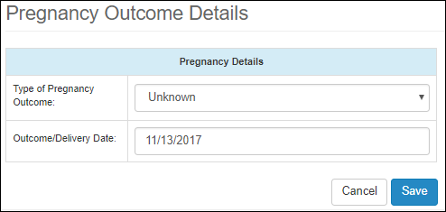

Figure 49: Pregnancy Outcome Details

The user has many outcome options to choose from in the drop-down list:

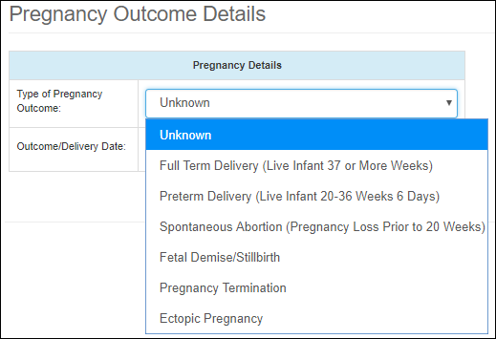

Figure 50: Type of Pregnancy Outcome

Each option redirects the user to a corresponding Pregnancy Outcome Details screen, which contains relevant information corresponding to the selected type of outcome. Each of them will be described in section Pregnancies.

As a side note, if the patient was Pregnant before, and was marked as Not Pregnant, after saving the data on the Pregnancy Outcome Details screen, it moves Current Pregnancy to the table of Past pregnancies.

#### Lactation Status

To edit or update the patient’s lactating status, click on the **Lactating** link in the Patient Details panel or select **Update Lactation** from the drop-down Action list. This redirects the user to the **Lactation Status** dialog.

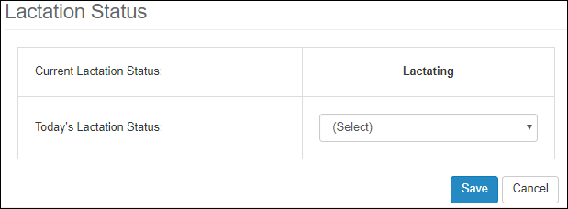

Figure 51: Patient Details – Lactation Status

The user has two possibilities to choose from: Pregnant or Not Pregnant.

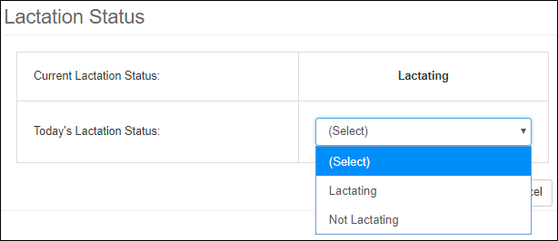

Figure 52: Patient Details – Update Lactation Status

Click **Save** to store or **Cancel** to exit without saving. After Saving, the user is redirected back to the Patient Summary screen, showing the new status under the Lactating field.

#### Text4Baby Enrollment

To edit or update the patient’s Text4Baby Enrollment status, click on the **Text4Baby Enrollment** link in the Patient Details panel. This redirects the user to the **text4baby** screen, which gives the option to enroll or go back to the Patient Summary screen. Enrolling the patient in **text4baby** is presented in detail in section Text4Baby Enrollment.

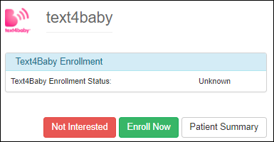

Figure 53: Patient Details – text4baby Status

### Current Pregnancy

As part of the Patient Summary screen, the Current Pregnancy panel is visible only when the current Pregnancy Status in the Patient Details panel is set to Pregnant.

This panel shows the main details related to a patient’s pregnancy, such as:

1. High Risk (yes or no)
2. Estimated Delivery Date (EDD)
3. EDD Basis (the name of the field that the EDD computation was based on)
4. EDD is final (yes or no)
5. Gestational Age
6. Trimester
7. Prenatal Care Provider
8. Planned Delivery Location
9. Father of the Baby
10. Last Menstrual Period
11. Multiple Pregnancies

High Risk, EDD Basis, EDD Is Final, Gestational Age, Trimester, Last Menstrual Period and Multiple Pregnancy fields are view-only.

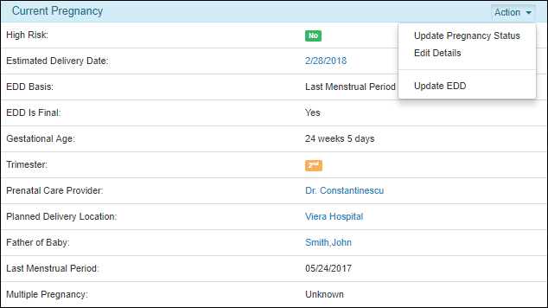

Figure 54: Current Pregnancy Section

To update information on this panel, the user has two options:

1. Click on the links of the editable fields, to update one field at a time:
   1. Estimated Delivery Date
   2. Parental Care Provider
   3. Planned Delivery Location
   4. Father of Baby
2. Click on the Action button on the top right corner of the panel, and select one of the available options:
   1. Update Pregnancy Status
   2. Edit Details – if multiple
   3. Update EDD

The following sections are presenting each of the updating options mentioned above.

#### Estimated Delivery Date (EDD)

To update the Estimated Delivery Date (EDD), click on the link next to the corresponding field. This redirects the user to the EDD Observation History screen:

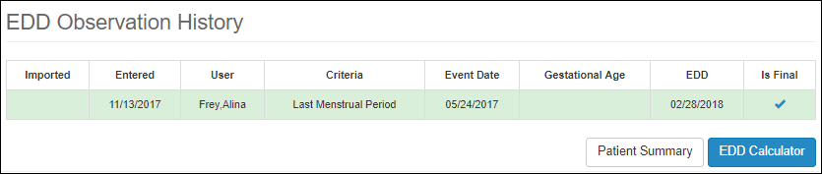

Figure 55: EDD Observation History

The Estimated Delivery Date (EDD) History displays any entries made when calculating the EDD. The screen includes a table that shows the name of the field that the EDD computation was based on:

1. The Last Menstrual Period or
2. The Estimated Conception Date

The screen gives the option to either go back to the Patient Summary screen, by selecting the corresponding button, or, if the dates need to be changed, to re-compute the EDD, by selecting the EDD Calculator button.

When selecting the EDD Calculator button, the user is prompted to the EDD Calculator screen, with blank fields:

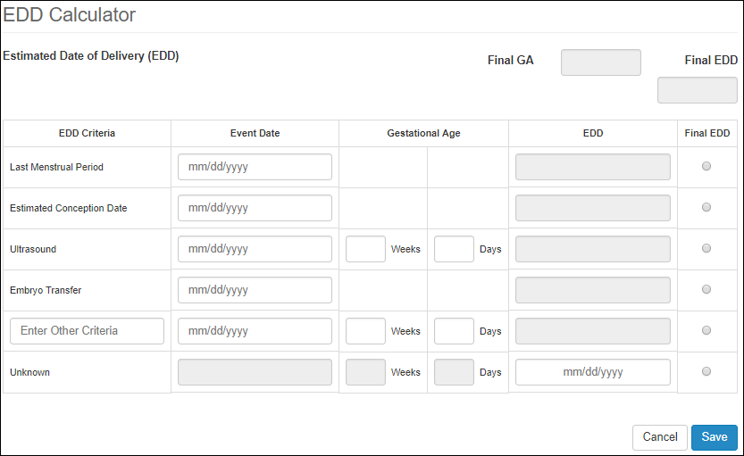

Figure 56: EDD Calculator

To update the EDD:

1. Enter new values for the desired fields.
2. EDD values are computed automatically for all the fields, except for the last filed, Unknown. The EDD depends on the Entered Date or the Gestational Age.
3. In the Final EDD column, select the radio button corresponding to the field that is the desired to be the final EDD.
4. If a value for Embryo Transfer field is entered, then the Final EDD is going to be by default the one associated with this field, and no other radio buttons could be selected.
5. Click Save.

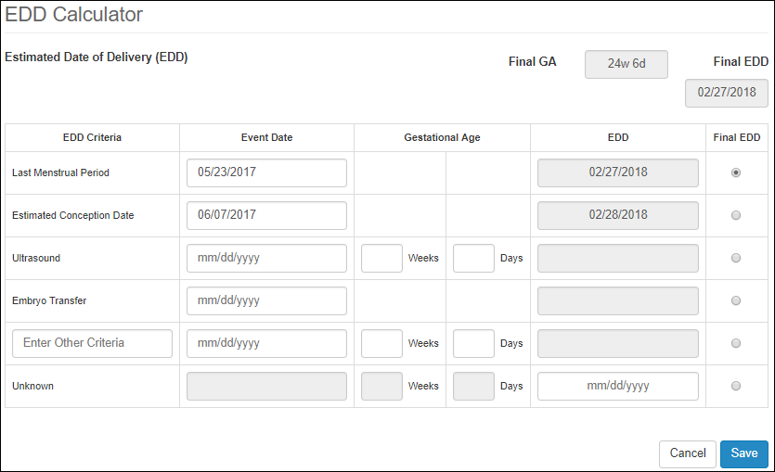

Figure 57: EDD Calculator – Updating EDD

The user is prompted back to the Patient Summary Screen. If EDD was saved successfully, a message will be displayed at the top of the screen, and the new chosen EDD is displayed in the Current Pregnancy panel.



Figure 58: Updated EDD – Confirmation Notice

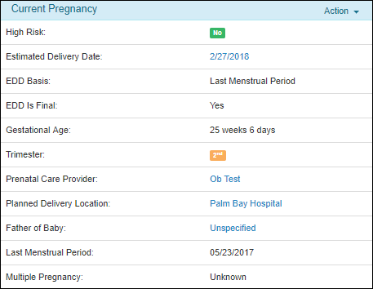

Figure 59: Current Pregnancy panel – Updated EDD

The user will be able see the new changes related to the selection of the EDD in the EDD Observation History (by clicking again on the EDD link):

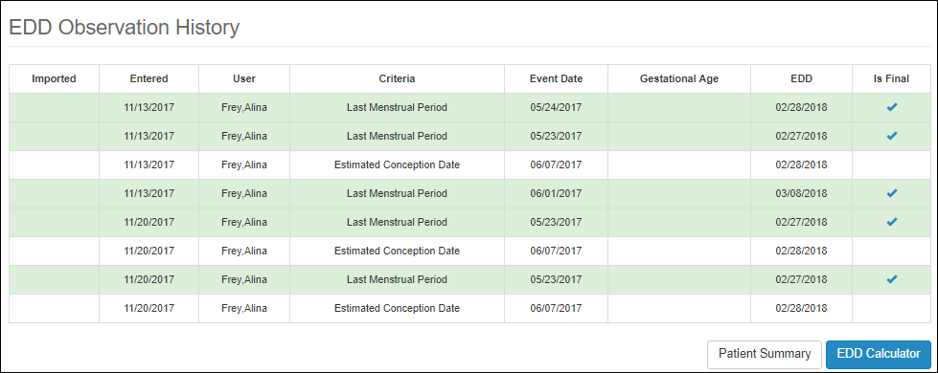

Figure 60: EDD Observation History Updated

#### Prenatal Care Provider

To update the Parental Care Provider, click on the link next to the corresponding field. This redirects the user to the Select Non-VA Care Provider (OB/GYN) screen, which shows all the available Providers (no Facilities). The available Providers are extracted from the Non-VA Care Items table, in section Non-VA Care.

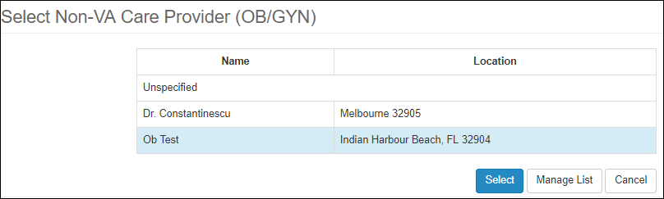

Figure 61: Edit Prenatal Care Provider

The user has the option to select one of the Providers in the table, manage the list or cancel the update (using the corresponding buttons).

To manage the list of available providers, select the **Manage List** button, which redirects the user to the Non-VA Care Items table, presented in section Non-VA Care.

If the provider is in the available list, then select the row with the desired provider, then click **Select** button.

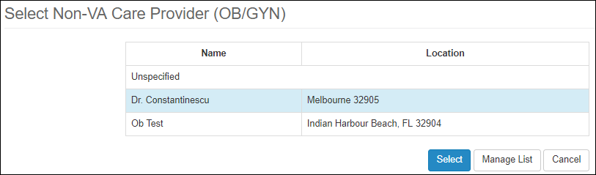

Figure 62: Selecting new Prenatal Care Provider

This redirects the user back to the Patient Summary screen, showing the new selected provider in the Current Pregnancy panel.

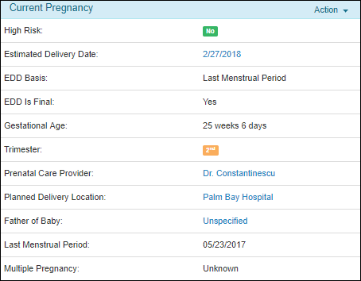

Figure 63: Updated Prenatal Care Provider

#### Planned Delivery Location

To update the Planned Delivery Location, click on the link next to the corresponding field. This redirects the user to the Planned Delivery Facility screen, which shows all the available Facilities (no Providers). The available Facilities are extracted from the Non-VA Care Items table, in section Non-VA Care.

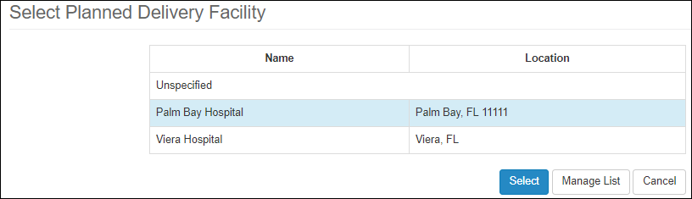

Figure 64: Edit Planned Delivery Facility

The user has the option to select one of the Facilities in the table, manage the list or cancel the update (using the corresponding buttons).

To manage the list of available facilities, select the Manage List button, which redirects the user to the Non-VA Care Items table, presented in section Non-VA Care.

If the facility is in the available list, select the row with the desired facility, then click Select button.

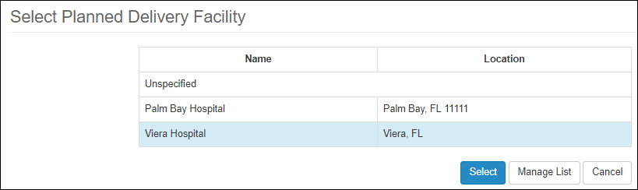

Figure 65: Selecting new Planned Delivery Facility

This redirects the user back to the Patient Summary screen, showing the new selected facility in the Current Pregnancy panel.

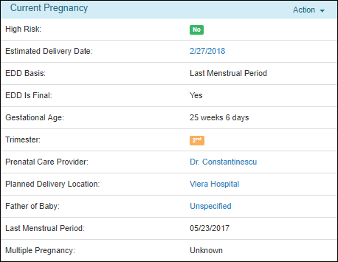

Figure 66: Updated Planned Delivery Location

#### Father of Baby

To update the Father of Baby, click on the link next to the corresponding field. This redirects the user to the Select Father of Baby screen:

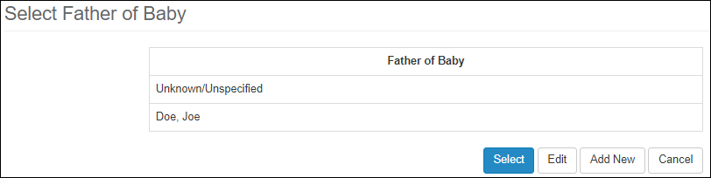

Figure 67: Selecting Father of Baby

The user has the option to Select a father from the list of names if any, to Edit an existing entry, to Add New names or Cancel the update.

To add a new name to the list of fathers, select Add New button. To Edit an existing entry, select Edit button. Both actions redirect the user to the Father of the Baby Details screen:

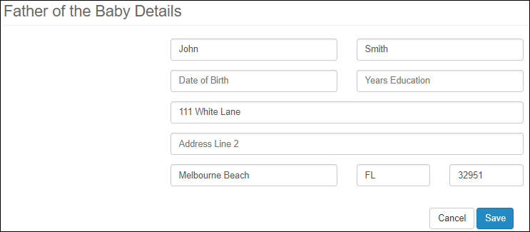

Figure 68: Adding/Editing new Father of Baby

Enter the desired info, then click the Save button. If a new name was added, new person should display in the table of fathers.

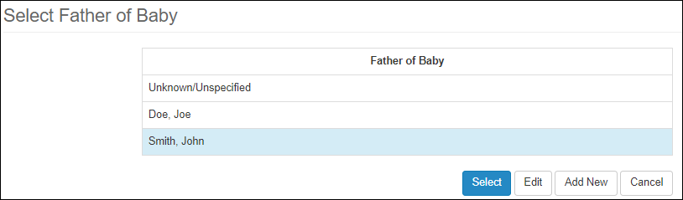

Figure 69: Updated Father of Baby

Select the name of the father, then click Select button. The updated father name should be reflected in the Current Pregnancy panel.

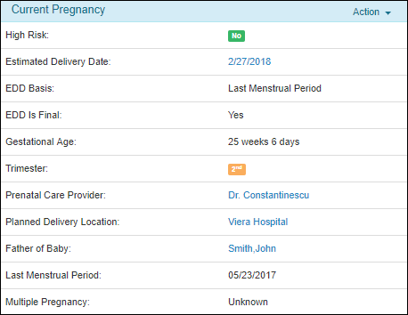

Figure 70: Father of Baby updated

#### Update Pregnancy Status Menu

The user can update the Pregnancy Status from the Current Pregnancy panel, using the **Update Pregnancy Status** option in the Action drop-down menu at the top-right corner of the panel. Follow the same steps previously described in section Pregnancy Status under Patient Details.

#### Edit Details Menu

The user can update more than one field at once on the Current Pregnancy panel by using the **Edit Details** option in the Action drop-down menu at the top-right corner of the panel. This redirects the user to the Add/Edit Pregnancy Details screen.

The Add/Edit Pregnancy Details screen includes details related to the Current Pregnancy, such as:

1. Estimated Delivery Date – editable using the Calculator
2. Gestational Age – computed when setting EDD
3. EDD Basis – computed when setting EDD
4. EDD Is Final – computed when setting EDD
5. High Risk – checkbox
6. Trimester – computed when setting EDD
7. Multiple Gestation
8. Prenatal Care Provider
9. Planned Delivery Location
10. Father of Baby
11. Last Menstrual Period
12. LMP Date

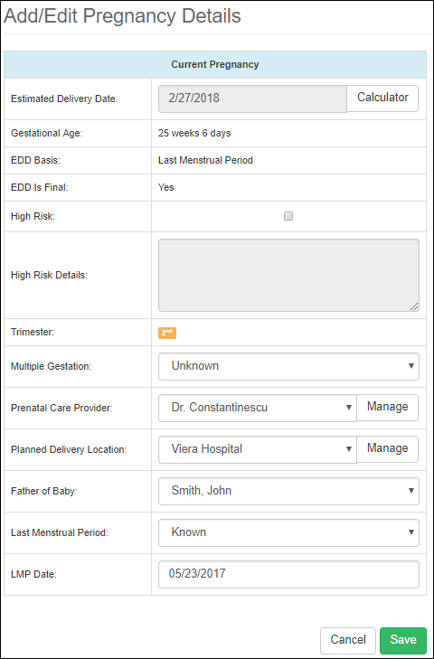

Figure 71: Edit Current Pregnancy

To update the **Estimated Delivery Date**, use the **Calculator**, as described previously in section Estimated Delivery Date (EDD). If Last Menstrual Period was used in the calculation of the delivery date, the value is reflected of Last Menstrual Period and LMP Date fields.

The fields **Gestational Age**, **EDD**, **EDD Is Final** and **Trimester** are computed when setting EDD using the Calculator.

The **High Risk** checkbox, when selected, enables the text area under the **High Risk Details** field.

**Multiple Gestations** is a drop-down list, allowing the user to choose one of the following options:

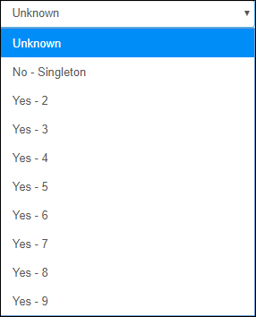

Figure 72: Editing Current Pregnancy – Multiple Gestations field

**Prenatal Care Provider** is a drop-down list allowing the user to choose from a list of previously added providers. The list can be modified by clicking on **Manage** button next to the field, which redirects the user to the Non-VA Care Items screen. To add providers, follow the same steps as presented previously in Non-VA Care section.

**Planned Delivery Location** is a drop-down list allowing the user to choose from a list of previously added facilities. The list can be modified by clicking on **Manage** button next to the field, which redirects the user to the Non-VA Care Items screen. To add facilities, follow the same steps as presented previously in Non-VA Care section.

**Father of Baby** is a drop-down list allowing the user to choose from a list of previously added fathers. To add names to the list, follow the steps described in section Father of Baby.

**Last Menstrual Period** is a drop-down list, allowing the user to choose from three options: Known, Unknown, or Approximate.

**LMP Date** is a text field that is updated during the computation of the EDD using the Calculator, or it can be changed ad-hoc.

Click **Cancel** to exit and return to the previous page without saving the information. Click **Save** to store the information and return to the previous page.

#### Update EDD Menu

The user can update the Estimated Delivery Date (EDD) on the Current Pregnancy panel by using also the **Update EDD** option in the Action drop-down menu at the top-right corner of the panel. This redirects the user to the EDD Observation History screen. Updating the panel was described in detail in the previous section Estimated Delivery Date (EDD).

### Gravida/Para Details

The Gravida/Para Details panel represents a summary of patient’s pregnancies. This panel can be updated the same way as all the other panels, by clicking on the Action button at the top right corner of the panel.

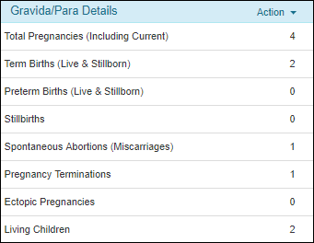

Figure 73: Gravida / Para Details

This redirects the user to the Pregnancy History screen:

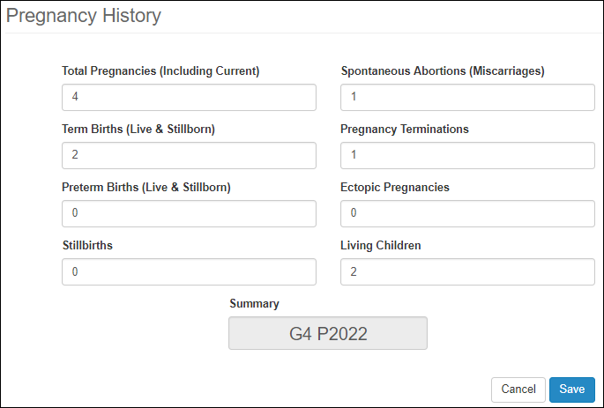

Figure 74: Gravida/Para Details / Edit

To update the values, enter the desired numbers in each field, and click **Save** to store the entries or **Cancel** to exit without saving. Every time a field has a new value, the Summary field at the bottom is updated to represent the new values.

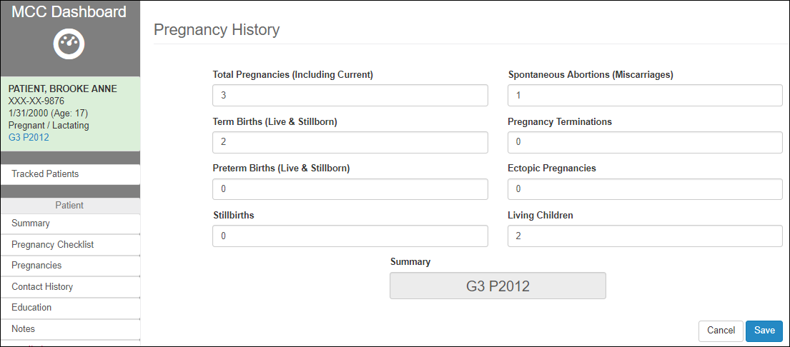

Figure 75: Updated G/P Summary

If the user saves the values, the Summary is updated as well under the patient details section under the Dashboard Menu in the left side pane. When this link is clicked, the user is prompted back to Update the Gravida/Para Details values under the Pregnancy History screen.

### Contact

As part of the Patient Summary screen, the Contact panel displays the contact information from the patient’s CPRS record.

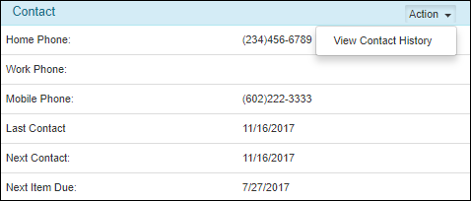

Figure 76: Patient’s Contact Info Panel

This panel gives the user the ability to View Contact History, by clicking on the Action button at the top right corner of the panel. This redirects the user to the Patient Contact History screen. Details about editing the information on this screen is described in detail in the section Contact History.

### Pregnancy Checklist (Patient Summary View)

As part of the Patient Summary screen, the Pregnancy Checklist panel is a view-only display of required examinations, tests, education or consults for the patient (only items that are not complete).

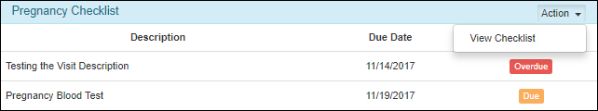

Figure 77: Pregnancy Checklist (Summary Page View)

’ This redirects the user to the Pregnancy Checklist screen, presented in next section Pregnancy Checklist.

## Pregnancy Checklist

To access the Pregnancy Checklist screen, click on the Pregnancy Checklist link on the left side pane, under the Patient section.

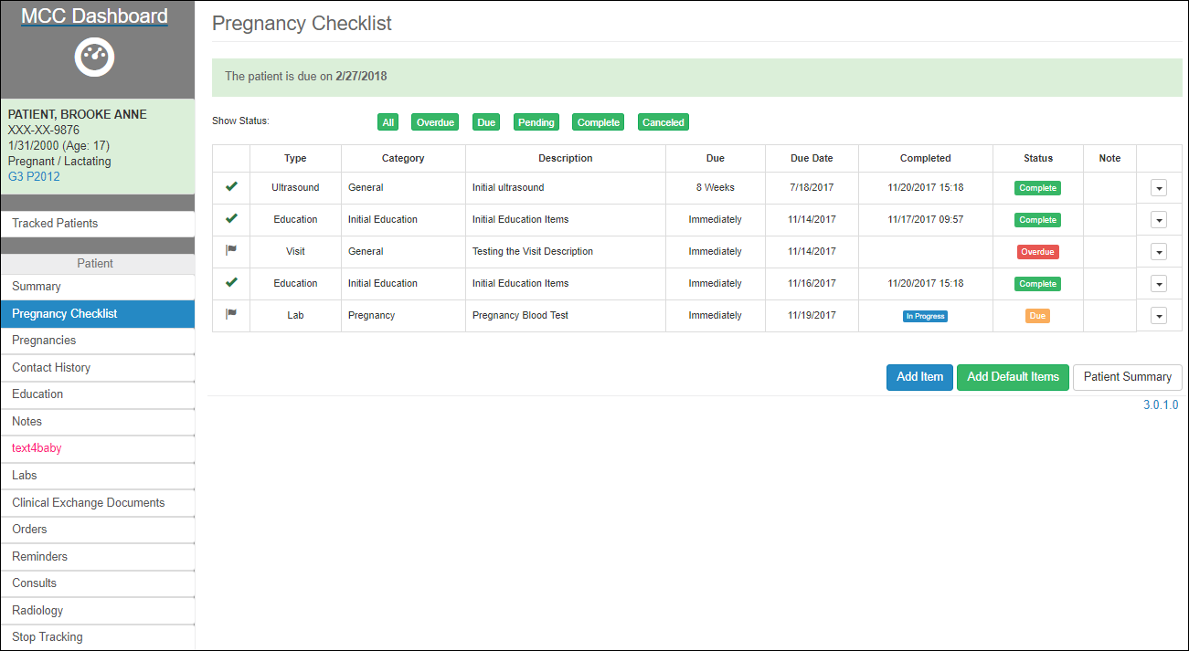

Figure 78: Pregnancy Checklist

The Pregnancy Checklist screen shows all the pregnancy items (tasks) that have been Completed, are In Progress, that are Due, or Overdue.

At the top of the page, an alert is presented in a green box showing the patient’s Due Date.



Figure 79: Pregnancy Checklist – Due Date Alert

The screen is presented with multiple filters at the top of a table, which enables the user to see only the items of interest, based on Status.



Figure 80: Pregnancy Checklist Filter

The table displays only items that have the Status corresponding to the green the filters, and data is shown in the following columns:

1. Symbol of the item’s Status: flag if the item is due, x if the item is Cancelled, checkmark if the item is Completed.
2. Type
3. Category
4. Description
5. Due
6. Due Date
7. Completed: Based on the completion Status, the value in the column Completed could be either an empty cell, the date when the item was Completed, or In Progress if not completed.
8. Status: The possible values that could be displayed on the Status column are: Due, Overdue, Pending, Cancelled and Completed.
9. Note: Showing a pop-up icon if there is a Note associated with the item
10. Action column (drop-down).

The actions that the user can take on this screen are as follow, and presented in the subsequent sections:

1. Take an action on an existing pregnancy item, by clicking on the drop-down option at the end of the item row:
   1. Change the status of the item without editing
   2. Edit the item
   3. Or Delete it

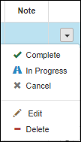

Figure 81: Pregnancy Checklist – Action on an existing item

1. Add a new item (by selecting **Add Item** button at the bottom of the screen)
2. Add the default items (by selecting **Add Default Items** button at the bottom of the screen)
3. Navigate back to the **Patient Summary** screen (by selecting the corresponding button at the bottom of the screen)

### Edit Status

To change the status of a Pregnancy Checklist item without editing it, select the pregnancy item and use the options of the drop-down list in the last column:

1. Select **Complete**: Marks the item as completed and adds a date under the Completed column.
2. Select **In Progress**: Marks the item as In Progress
3. Select **Cancel**: Marks the item as Canceled

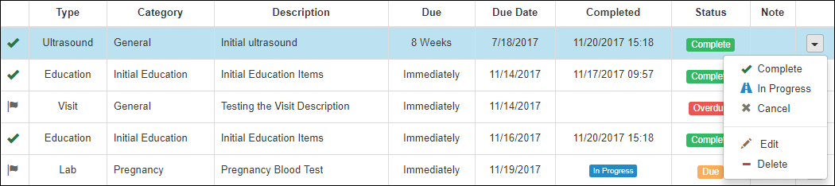

Figure 82: Edit the Status of an existing Pregnancy Checklist Item

### Edit Item

To edit a Pregnancy Checklist item, click on the arrow at the end of the item row, then select **Edit** from the drop-down list in the last column. This redirects the user to the Edit Pregnancy Checklist Item screen.

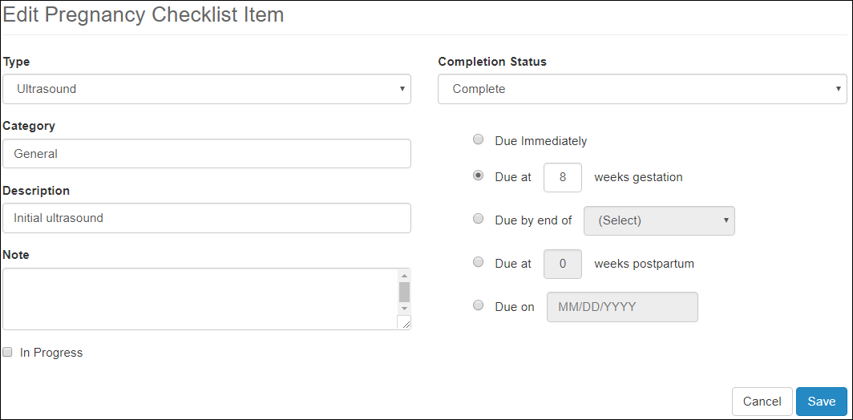

Figure 83: Edit Pregnancy Checklist Item

The user can add or edit the following fields:

1. Type: Drop-down list showing the following options:

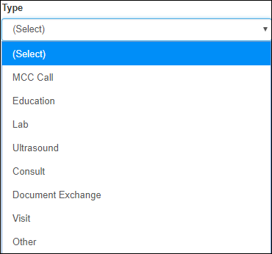

Figure 84: Add/Edit Pregnancy Checklist Item – Type field

1. Note (Call Note): Field added only when the selected Type is MCC Call, showing the following options:

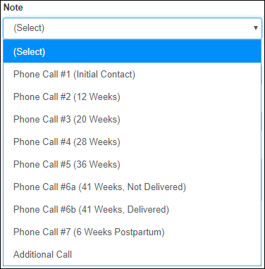

Figure 85: Add/Edit Pregnancy Checklist Item – Note field

1. Education Item: Field added only when the selected Type is Education, showing all the education items that come by default, plus the ones added in the Education Items, presented in section Education Items:

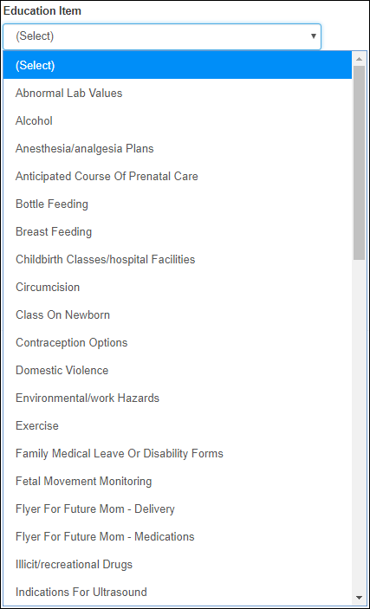

Figure 86: Add/Edit Pregnancy Checklist Item – Education field

1. Category
2. Description
3. Note
4. In Progress: checkbox
5. Completion Status: Drop-down list with the following options:

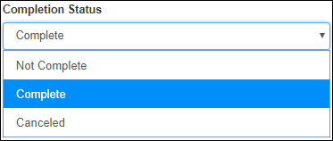

Figure 87: Add/Edit Pregnancy Checklist Item – Completion Status field

1. Due: one option radio button group

After editing the existing task, the user can click **Save** to store the entry, or **Cancel** to return to the previous screen without saving. Upon a successful save, the user is presented with the success message at the top of the screen:



Figure 88: Editing existing Pregnancy Checklist item success message

### Delete Item

To delete a Pregnancy Checklist item, click on the arrow at the end of the item row, then select **Delete** from the drop-down list in the last column.

Upon a successful deletion, the user is presented with the message at the top of the screen, and the new task will be removed from the Pregnancy Checklist table.



Figure 89: Deleting an existing Pregnancy Checklist item message

### Add Item

To add an item to the Pregnancy Checklist, click **Add Item** button at the bottom of the Pregnancy Checklist screen. This redirects the user to the Add Pregnancy Checklist Item screen.

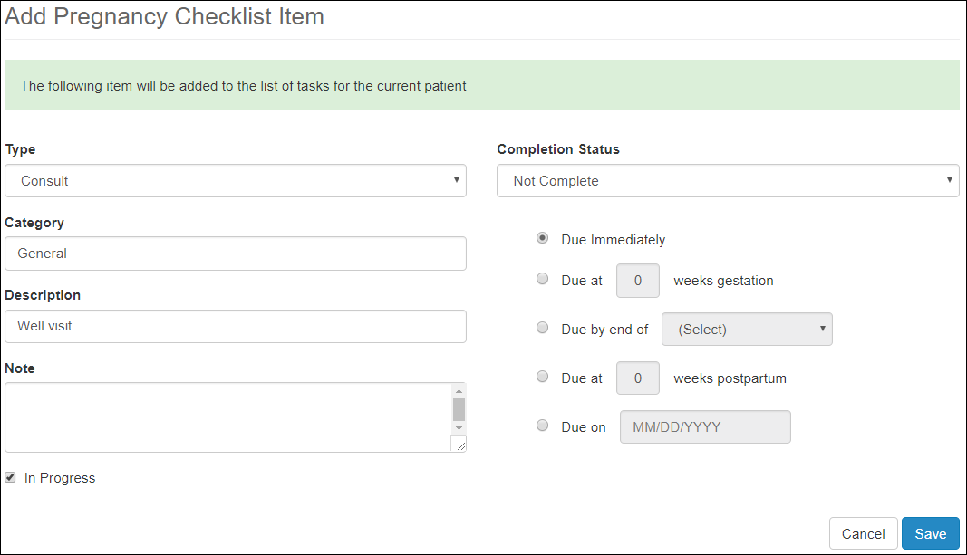

Figure 90: Add Pregnancy Checklist Item

The user can edit the same fields as presented in the previous section Edit Item.

After editing the existing task, the user can click **Save** to store the entry, or **Cancel** to return to the previous screen without saving. Upon a successful save, the user is presented with the success message at the top of the screen:



Figure 91: Adding new Pregnancy Checklist item success message

The new task will be displayed in the Pregnancy Checklist table, along the other tasks. If the added item was an MCC Call, it will display on both the Pregnancy Checklist and the Contact History pages.

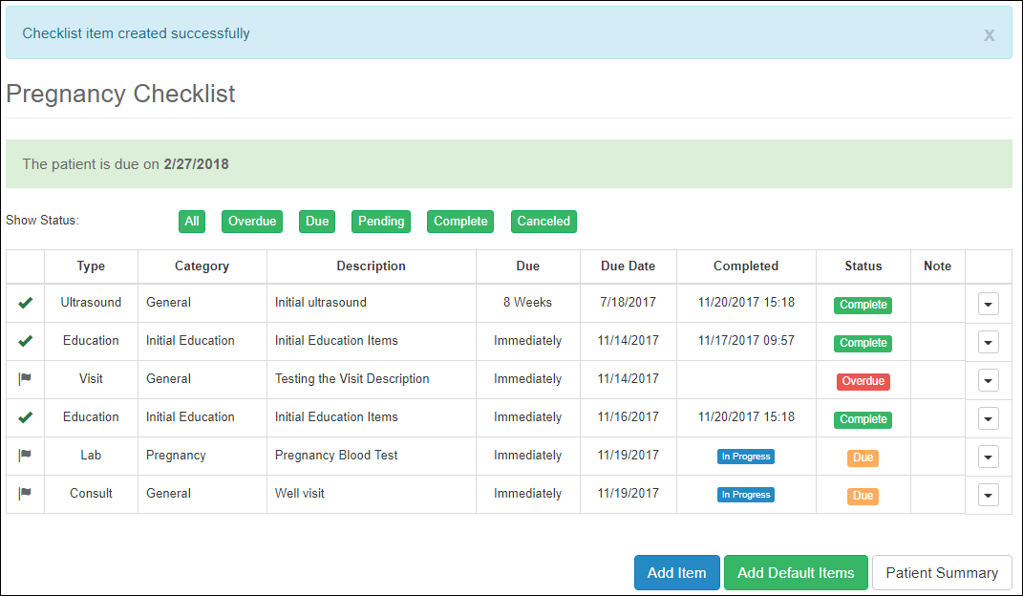

Figure 92: New Pregnancy Checklist Item saved successfully

### Add Default Items

Selecting the **Add Default Items** button at the bottom of the Pregnancy Checklist screen, allows the user to add the default tasks that were added to the general Checklist, as presented in section Checklist of the MCC Dashboard Elements and Functionality – Tracking / Configuration View chapter.

The user is presented with a confirmation prompt.

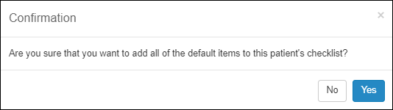

Figure 93: Add Default Items to Pregnancy Checklist – Confirmation Prompt

Clicking **No** returns return the user to the Pregnancy Checklist screen. Clicking **Yes** adds the entire list of default checklist items to the patient record.

Upon a successful addition, the user is presented with the success message at the top of the screen:



Figure 94: Adding Default Items to Pregnancy Checklist – Success message

## Pregnancies

To access the Pregnancies screen, click on the Pregnancies tab on the left side pane, under the Patient section. The Pregnancies screen allows the user to view and add to the patient’s current and past pregnancies.

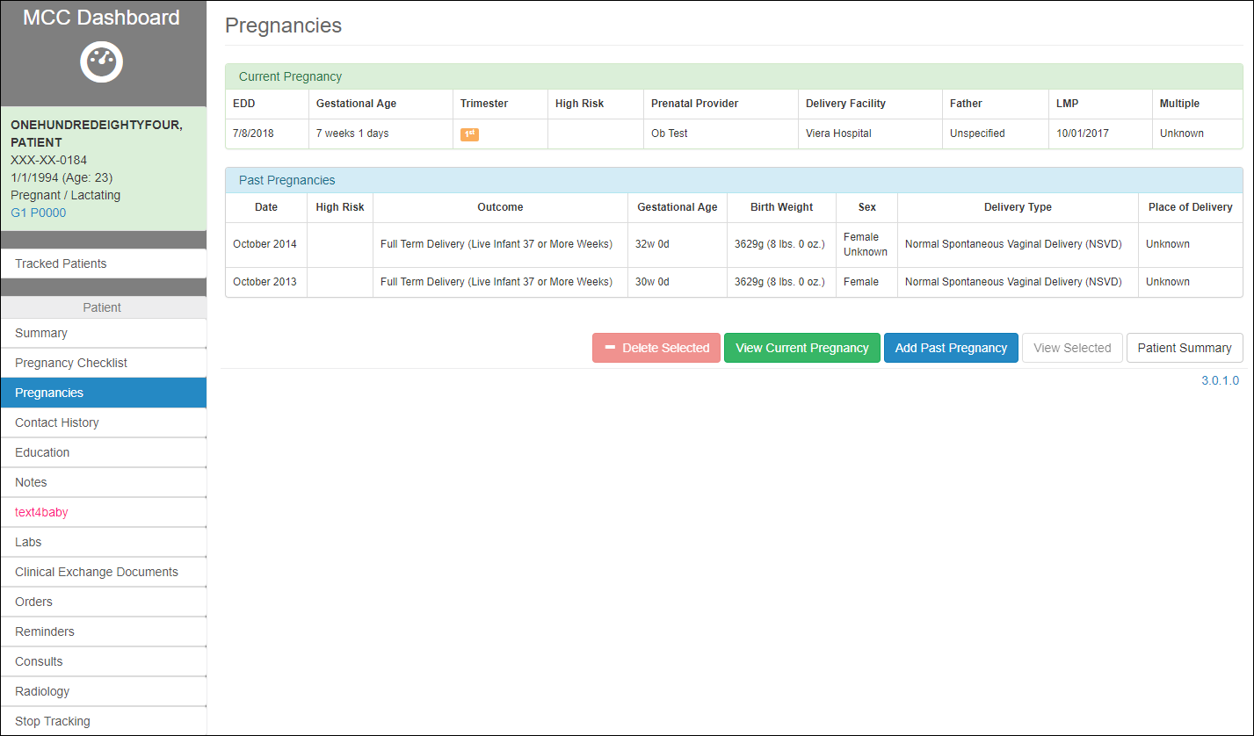

Figure 95: Pregnancies

The screen shows two different tables:

1. Current Pregnancy
2. Past Pregnancies

The user can take different actions based on the selected button at the bottom of the screen:

1. View Current Pregnancy
2. View Selected past pregnancy
3. Add Past Pregnancy
4. Delete Selected past pregnancy
5. Go back to the Patient Summary screen



Figure 96: Pregnancies Action Buttons

### View Current Pregnancy

To view the current pregnancy, the user needs to access the Pregnancies screen first, then select the button View Current Pregnancy at the bottom of the Pregnancies screen. This redirects the user to the Pregnancy Outcome Details screen.

The screen shows the Current Pregnancy panel, containing the same information as in the Current Pregnancy panel of the Patient Summary screen.

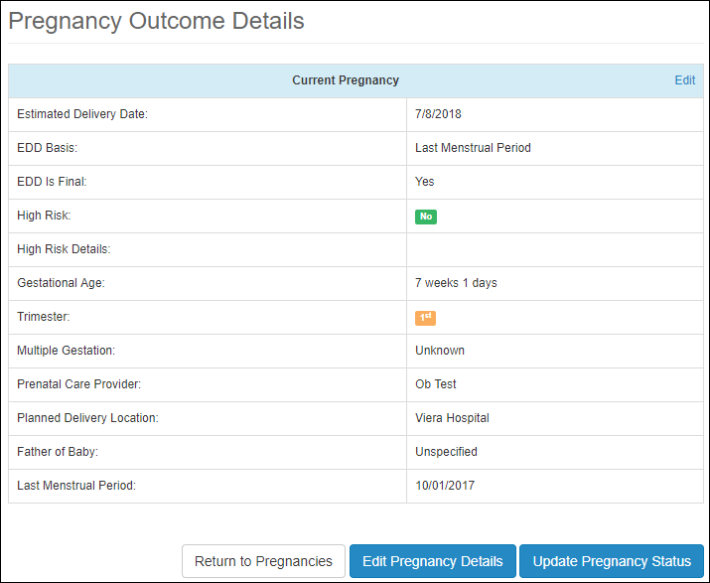

Figure 97: Current Pregnancy

To edit and update the current pregnancy info, the user can take three actions, by selecting the corresponding button at the bottom of the screen:

1. Return to Pregnancies screen
2. Edit Pregnancy Details
3. Update the Pregnancy Status

#### Edit Pregnancy Details

Editing the current pregnancy can be done by either selecting the Edit link at the top right corner of the Current Pregnancy panel, or the Edit Pregnancy Details button at the bottom of the screen. Either one, redirects the user to the Add/Edit Pregnancy Details screen.

Updating the panel is described in detail in section Current Pregnancy – Edit Details Menu.

#### Update Pregnancy Status

To update the Pregnancy Status, select the corresponding button at the bottom of the Pregnancy Outcome Details screen. This redirects the user to the Pregnancy Status screen. Here the user can set the status to Pregnant or Not Pregnant, just as described previously in section Pregnancy Status under Patient Details.

### View Selected past pregnancy

To view and edit a past pregnancy, select a row in the Past Pregnancies, then click **View Selected** button at the bottom of the Pregnancies screen. This redirects the user to the Pregnancy Outcome Details screen. The Pregnancy Outcome Details screen has different layout depending on the type of the outcome. This is presented in detail in section Pregnancy Outcome Types.

### Delete Selected past pregnancy

To delete a past pregnancy, select a row in the Past Pregnancies table, then click **Delete Selected** button. This should remove the selected row from the table of Past Pregnancies. Before deleting the row, the user is presented with an alert, to confirm his deletion action:

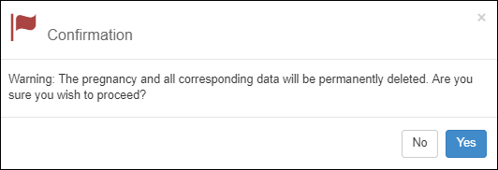

Figure 98: Delete Pregnancy Alert

### Add Past Pregnancy

To add a past pregnancy, select the **Add Past Pregnancy** button at the bottom of the Pregnancies screen. This will prompt the user to add details about the pregnancy in the Pregnancy Outcome Details screen:

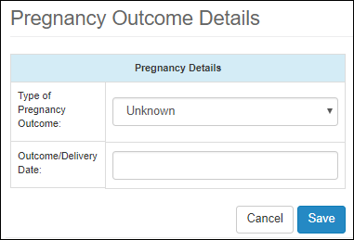

Figure 99: Pregnancy Outcome Details

The user has many outcome options to choose from in the drop-down list:

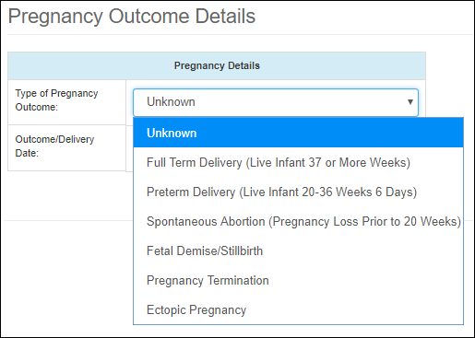

Figure 100: Pregnancy Outcome Details -Pregnancy Outcome Types

Each option redirects the user to a corresponding Pregnancy Outcome Details screen, which contains relevant information corresponding to the selected type of outcome. There are six types of pregnancy outcomes that the user can choose from when adding a new pregnancy to a patient, or editing an existing or past pregnancy:

1. Full Term Delivery (Live Infant 37 or More Weeks)
2. Preterm Delivery (Live Infant 20-36 Weeks 6 Days)
3. Spontaneous Abortion (Pregnancy Loss Prior to 20 Weeks)
4. Fetal Demise/Stillbirth
5. Pregnancy Termination
6. Ectopic Pregnancy

Screenshots for each of them will be presented in the next section, Pregnancy Outcome Types.

Click **Save** button to save the data or **Cancel** to navigate back to the Pregnancies screen.

Regardless the Type of Pregnancy Outcome chosen, when saving the added pregnancy, the user is prompted to enter Other Details related to the same past pregnancy. This info will be added to the summary screen for the newly add pregnancy.

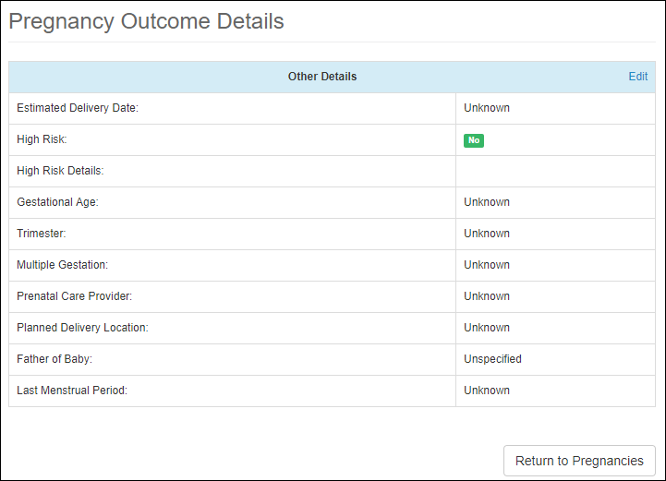

Figure 101: Add Past Pregnancy – Other Details

The user has the option to **Edit** the past pregnancy or return to the table of pregnancies, by selecting the **Return to Pregnancy** button.

To edit the details, click on the Edit link at the top right corner of the Other Details panel. This redirects the user to the Add/Edit Pregnancy Details screen for a Past Pregnancy:

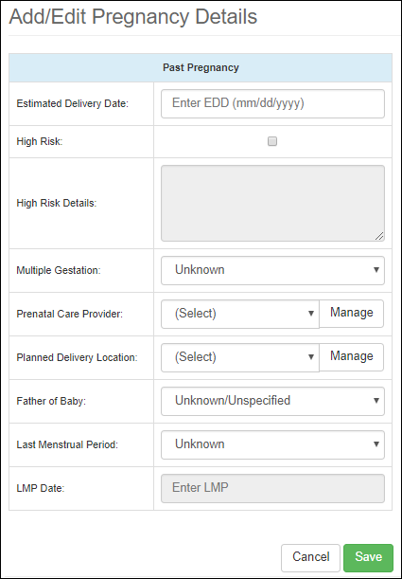

Figure 102: Add Past Pregnancy – Add/Edit Details

After entering the desired data in the Past Pregnancy details screen, select the **Save** button. The user will be redirected back to the Pregnancy Outcome Details screen, which includes a summary of all the data added for the new pregnancy. The screen includes two panels and a button at the bottom of the screen:

1. Pregnancy Details panel
2. Other Details panel at the bottom of the screen
3. Return to Pregnancies button
4. For the cases of Full Term and Preterm Deliveries, the screen has an extra button, Add Baby button, and an extra panel for each baby that is added. This is presented in detail in the next section Pregnancy Outcome Types.

The user can edit both panels, the Pregnancy Details and the Other Details by selecting either Edit link at the top right corners of the corresponding panel. Selecting Return to Pregnancies button, will direct the user back to the Pregnancies screen.

### Pregnancy Outcome Types

When adding a past pregnancy, or editing an existing or past pregnancy, or when changing the status of a current pregnancy to Not Pregnant, the user is prompted to add details about the outcome of the pregnancy. There are six types of pregnancy outcomes that the user can choose from:

1. Full Term Delivery (Live Infant 37 or More Weeks)
2. Preterm Delivery (Live Infant 20-36 Weeks 6 Days)
3. Spontaneous Abortion (Pregnancy Loss Prior to 20 Weeks)
4. Fetal Demise/Stillbirth
5. Pregnancy Termination
6. Ectopic Pregnancy

Screenshots for each of them will be presented below.

#### Full Term Delivery (Live Infant 37 or More Weeks)

Pregnancy Outcome Details screen:

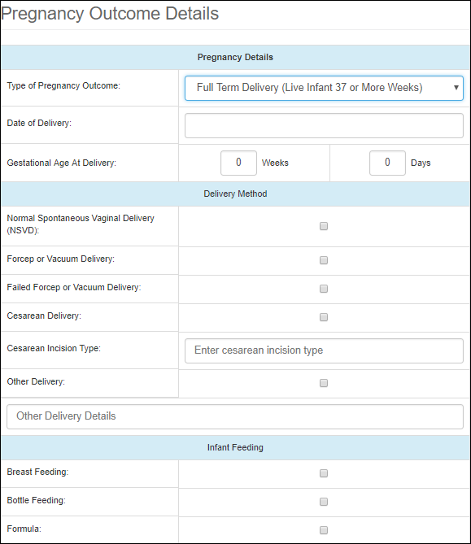

Figure 103: Full Term Delivery (Live Infant 37 or More Weeks) – Edit Details

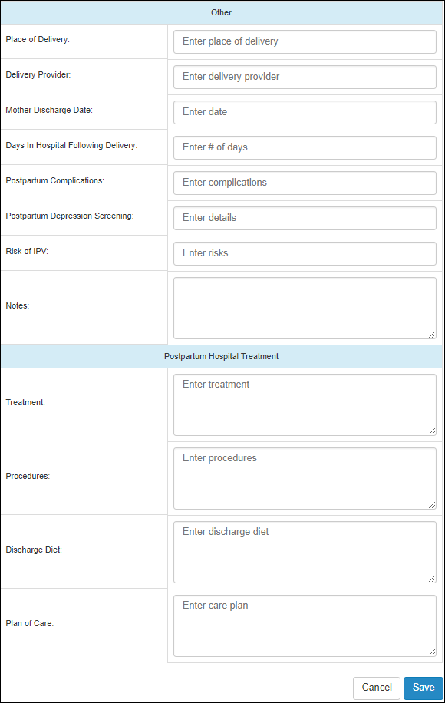

Figure 104: Full Term Delivery (Live Infant 37 or More Weeks) – Edit Details (continued)

Pregnancy Details panel:

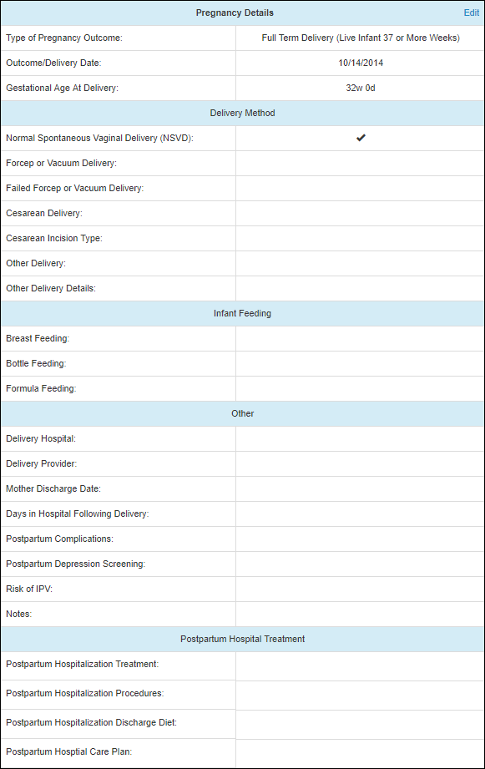

Figure 105: Full Term Delivery (Live Infant 37 or More Weeks) – Pregnancy Details Panel

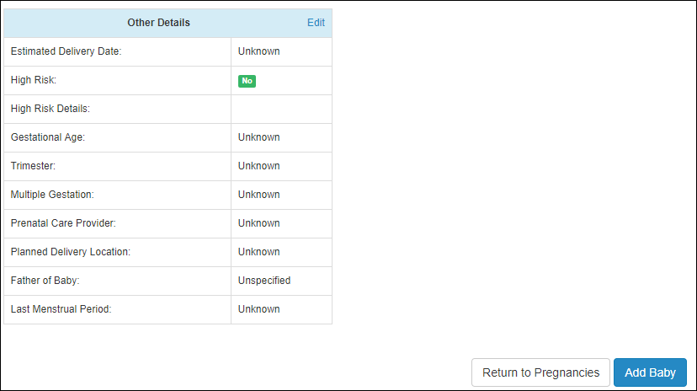

Figure 106: Full Term Delivery (Live Infant 37 or More Weeks) – Pregnancy Details Panel (continued)

The user has also the option to associate a baby to a past pregnancy, by selecting Add Baby button at the bottom of the summary screen.

This redirects the user to the Baby Details screen.

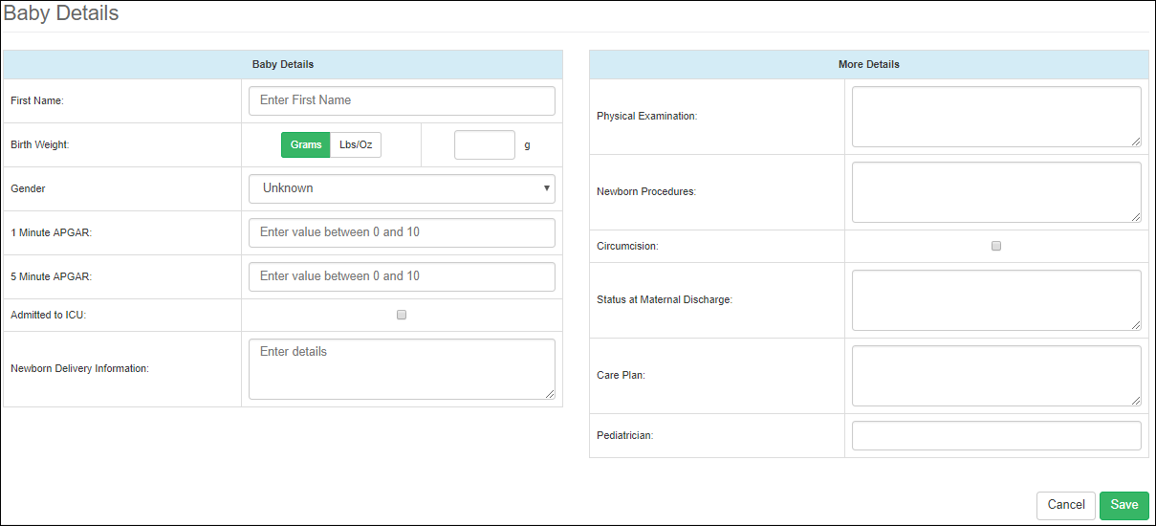

Figure 107: Edit Baby Details

After the baby’s details are saved, the info is presented in a new panel on the Pregnancy Outcome Details summary screen:

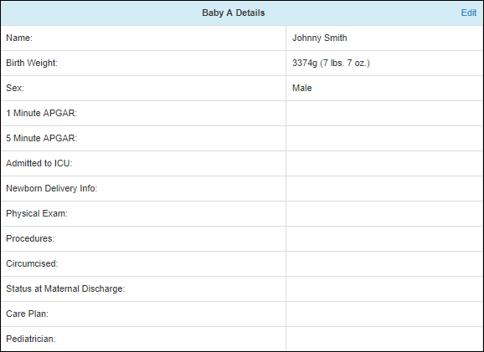

Figure 108: Baby Details panel

The Baby Details panel can be edited the same way as the other two panels, by selecting the Edit button at the top right corner of the panel.

The user can continue to add multiple babies to the past pregnancy, just as shown above. For each baby that is added, there will be a corresponding panel in the Pregnancy Outcome Details summary screen.

#### Preterm Delivery (Live Infant 20-36 Weeks 6 Days)

Pregnancy Outcome Details screen:

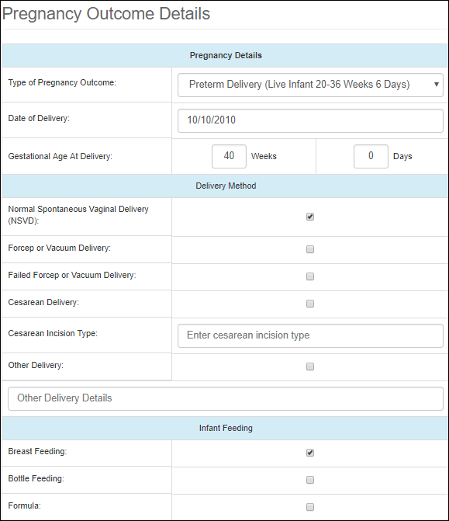

Figure 109: Preterm Delivery (Live Infant 20-36 Weeks 6 Days) – Edit Details

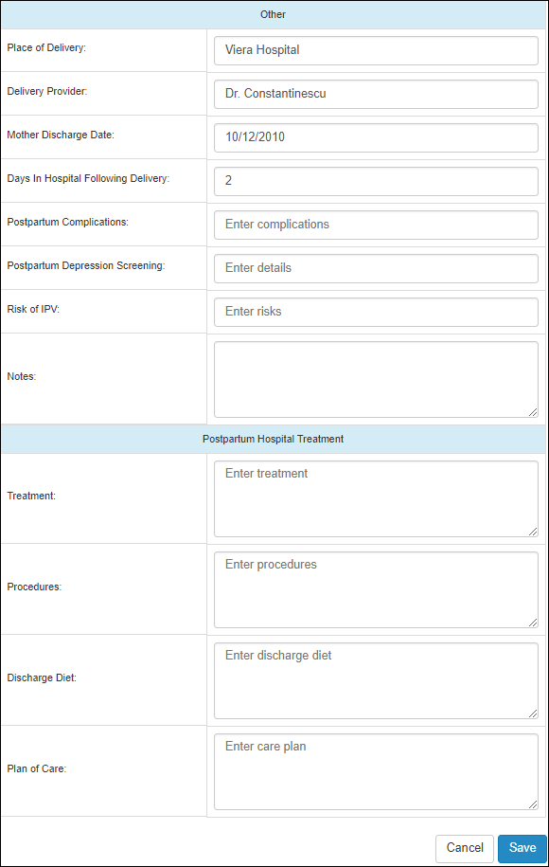

Figure 110: Preterm Delivery (Live Infant 20-36 Weeks 6 Days) – Edit Details (continued)

Pregnancy Details panel:

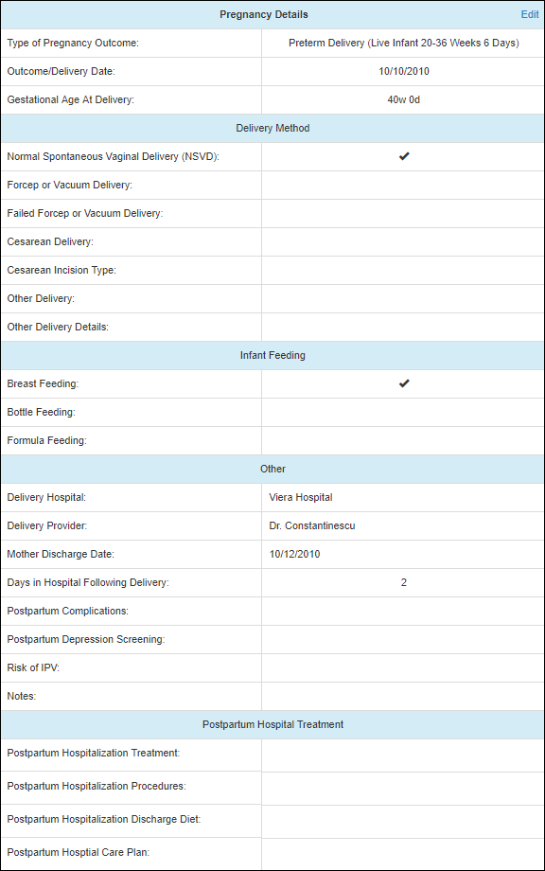

Figure 111: Preterm Delivery (Live Infant 20-36 Weeks 6 Days) – Pregnancy Details Panel

The user has also the option to associate a baby to a past pregnancy, by selecting Add Baby button at the bottom of the summary screen. To add a baby, follow the instructions in previous section Full Term Delivery (Live Infant 37 or More Weeks).

#### Spontaneous Abortion (Pregnancy Loss Prior to 20 Weeks)

Pregnancy Outcome Details screen:

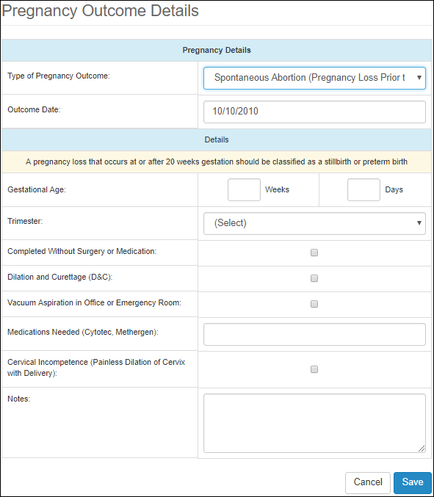

Figure 112: Spontaneous Abortion (Pregnancy Loss Prior to 20 Weeks) – Edit Details

Pregnancy Details panel:

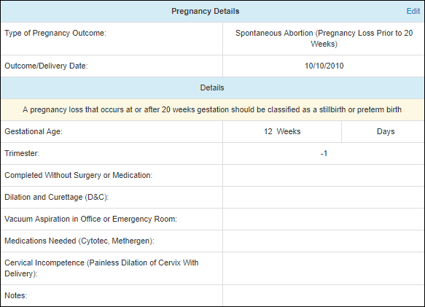

Figure 113: Spontaneous Abortion (Pregnancy Loss Prior to 20 Weeks) – Pregnancy Details Panel

#### Fetal Demise/Stillbirth

Pregnancy Outcome Details screen:

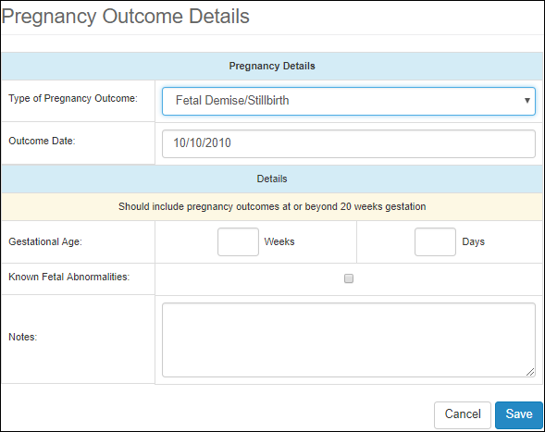

Figure 114: Fetal Demise/Stillbirth – Edit Details

Pregnancy Details panel:

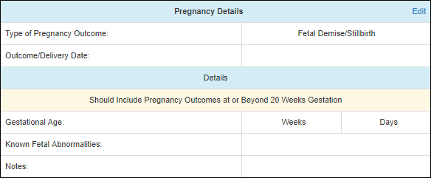

Figure 115: Fetal Demise/Stillbirth – Pregnancy Details Panel

#### Pregnancy Termination

Pregnancy Outcome Details screen:

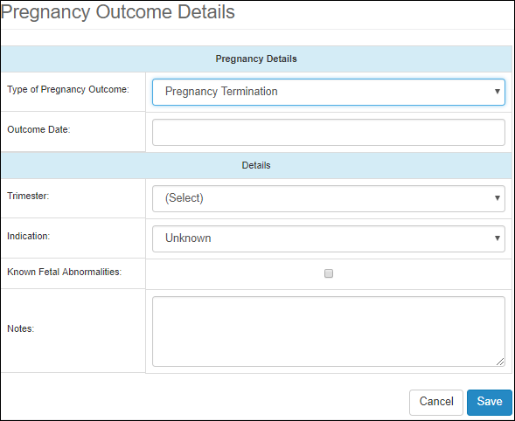

Figure 116: Pregnancy Termination – Edit Details

Pregnancy Details panel:

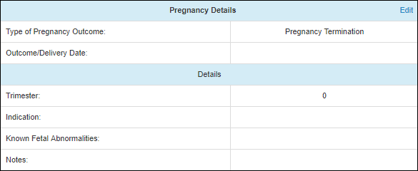

Figure 117: Pregnancy Termination – Pregnancy Details Panel

#### Ectopic Pregnancy

Pregnancy Outcome Details screen:

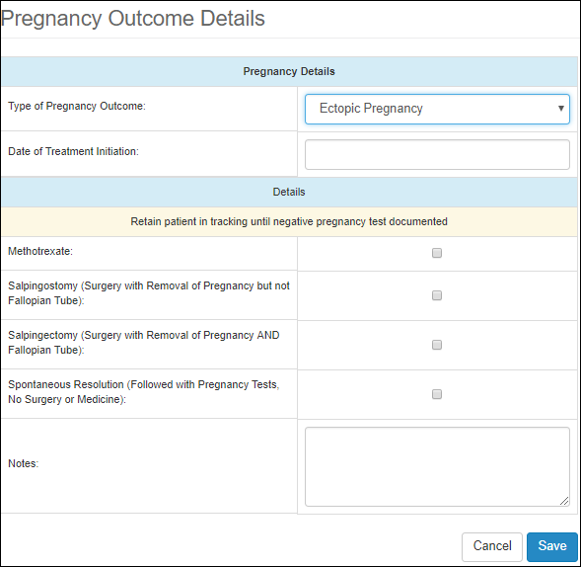

Figure 118: Ectopic Pregnancy – Edit Details

Pregnancy Details panel:

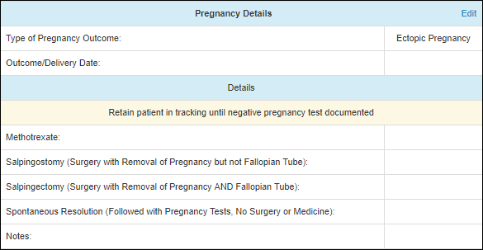

Figure 119: Ectopic Pregnancy – Pregnancy Details Panel

## Contact History

To access the Patient Contact History screen, click on the Contact History tab on the left side pane, under the Patient section.

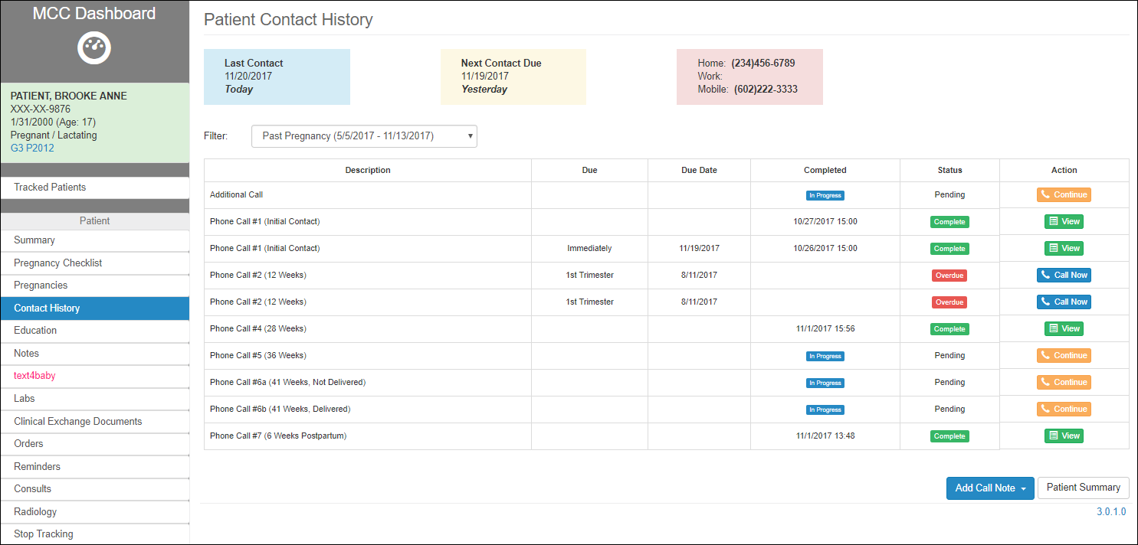

Figure 120: Contact History screen

The Contact History screen allows the user to view, edit and add patient contact events.

The screen shows at the top of the screen contact details such as:

1. Last Contact
2. Next Contact Due
3. Contact info

The screen displays a table of all the Notes related to the calls that were made to the patient regarding related pregnancies. These call notes are also visible in the table of notes presented in section Notes.

The table includes the following info related to each note:

1. Description
2. Due
3. Due Date
4. Completed
5. Status: Pending, Complete, Overdue
6. Action: action that the user can take
7. Continue
8. View
9. Call Now

The information on the table can be filtered by Pregnancy, which can be selected from the Filter drop-down list, right above the table:

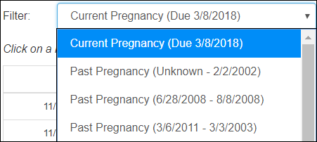

Figure 121: Contact History Pregnancy Filter

The user can navigate back to the Patient Summary screen or add a new note by selecting the **Add Call Note** button.

### Add a Call Note

Adding a call note can be done in two ways:

1. Add an MCC Call Item (default item or new item) to the current Pregnancy Checklist, (see sections Add Item and Add Default Items under Pregnancy Checklist). The item will display on both the Pregnancy Checklist and the Contact History pages.
2. Selecting the Add Call Note button at the bottom of the Contact History screen. This will add a call note to the selected pregnancy from the Filter drop-down.

To add a note from the Contact History screen, select the Add Call Note button. The button presents multiple options for the type of a note the user desires to add.

1. Phone Call #1 (Initial Contact)
2. Phone Call #2 (12 Weeks)
3. Phone Call #3 (20 Weeks)
4. Phone Call #4 (28 Weeks)
5. Phone Call #5 (36 Weeks)
6. Phone Call #6a (41 Weeks, Not Delivered)
7. Phone Call #6b (41 Weeks, Delivered)
8. Phone Call #7 (6 Weeks Postpartum)
9. Additional Call

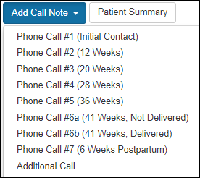

Figure 122: Call Note Types

Based on the selection, the user is redirected to the screen corresponding to the type of the note that was selected, presented in next section Call Note. Whenever a note is created, it will be added to the Contact History, even when the note was not signed.

### Call Note Details

There are two ways to access the Call Note Details screen:

1. Create a new note (as described in the previous section Add a Call Note)
2. Open a previously added call note by clicking **Continue** or **Call Now** action at the end of the call note row in the Contact History table.



Figure 123: Open previously added Call Note

The call note presents a standardized way to conduct a call with a patient and a way to capture all the information from the conversation with the patient.

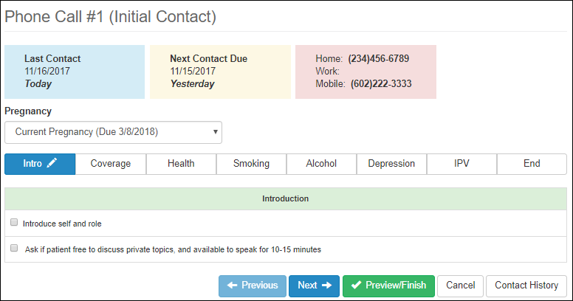

Figure 124: Call Note Details

The call note screen contains the following information:

1. The title refers to the type of the Call Note that was selected: for example, Phone Call #1 (Initial Contact).
2. At the top of the screen the user can see details about patient contact:
   1. Last Contact
   2. Next Contact Due
   3. Contact info

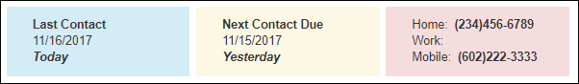

Figure 125: Call Note – Contact Info

1. Each call note can be associated to a specific pregnancy, available in the Pregnancy drop-down list.
2. Call Note Tabs described in the next section Call Note Tabs.
3. Navigation buttons:
   1. **Previous**: allows to navigate to the previous tab
   2. **Next**: allows to navigate to the next tab
   3. **Cancel**: allows the user to cancel capturing the call notes
   4. **Contact History**: allows the user to navigate back to the table of calls made.



Figure 126: Call Note Buttons

* 1. As soon as the user navigates through the sections, away from the first tab (Intro), the call note gets recorded, and Cancel button changes to a **Delete** button, which allows to delete the call note recorded so far.



Figure 127: Call Note Buttons (continued)

* 1. **Preview/Finish**: allows the user to preview the note and finish it at any point during the call.
  2. **Contact History**: gives the user the option to navigate back to the Contact History screen.

When the call is ended, the user can decide to save the captured notes by selecting the **Preview/Finish** button. The user will be redirected to the Contact Note screen, text note version of the call event, showing a summary of all the fields that were checked and comments that were added.

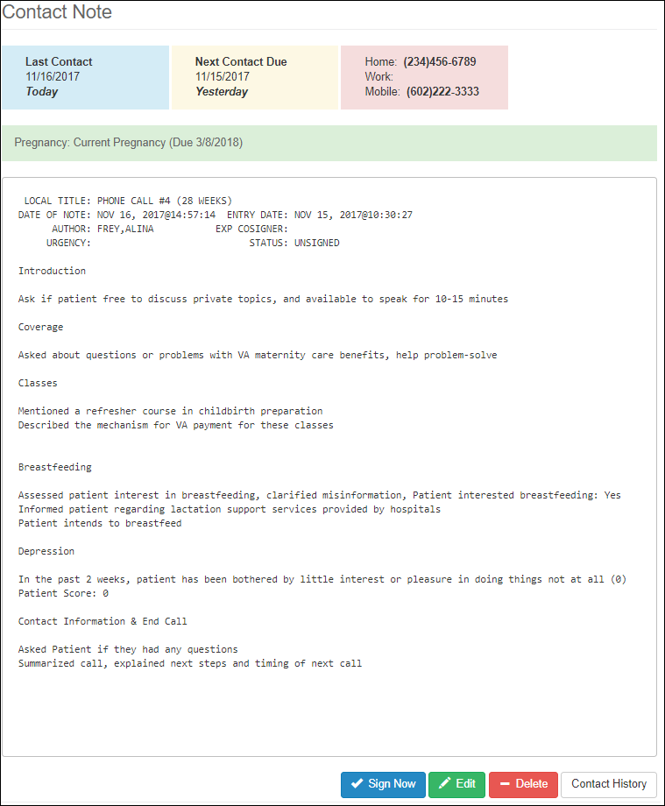

Figure 128: Preview/Finish – Call Note Summary

The user can take different actions from the note summary screen, by selecting the corresponding buttons at the bottom of the screen:

1. **Edit**: still modify the call note if necessary.
2. **Delete**: delete the call note totally.
3. Navigate back to **Contact History**
4. **Sign Now**: allows the user to signing the note, which prompts to Sign Note dialog box.

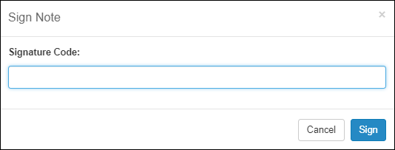

Figure 129: Signing Call Note

To Sign the note, the user should enter their Electronic Signature Code. Contact the System Administrator for setting up the Electronic Signature Code in VistA.

Once the Call Note is signed, no more changes could be made to it, nor it could be deleted.

The signed task should display in the Contact History table with Complete Status and the View Action, as the only action that could be taken on the note.

### Call Note Tabs

Depending on the type of the call, the Call Note will present different tabs in which the caller can enter info discussed with the patient. In general, the same tab, if part of a call note, contains the same information, no matter the type of the call.

The following are all the possible tabs.

1. Intro
2. Coverage
3. Classes
4. Breastfeeding
5. WIC
6. Contraception
7. Health
8. Smoking
9. Alcohol
10. Depression
11. IPV
12. PP Visit
13. VA Primary
14. End

#### Phone Call #1 (Initial Contact)

This type of Call Note includes the following tabs:

1. Intro
2. Coverage
3. Health
4. Smoking
5. Alcohol
6. Depression
7. IPV
8. End

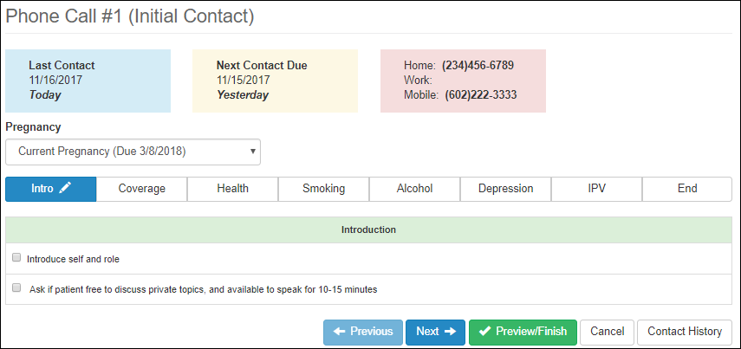

Figure 130: Phone Call #1 (Initial Contact)

#### Phone Call #2 (12 Weeks)

This type of Call Note includes the following tabs:

1. Intro
2. Coverage
3. Health
4. Smoking
5. End

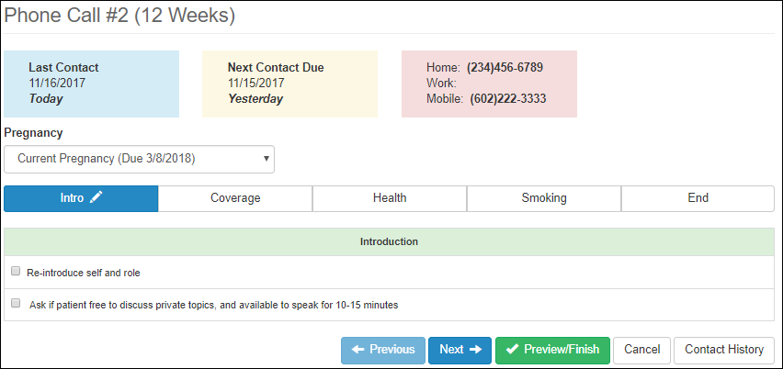

Figure 131: Phone Call #2 (12 Weeks)

#### Phone Call #3 (20 Weeks)

This type of Call Note includes the following tabs:

1. Intro
2. Coverage
3. Classes
4. Health
5. Smoking
6. Depression
7. IPV
8. End

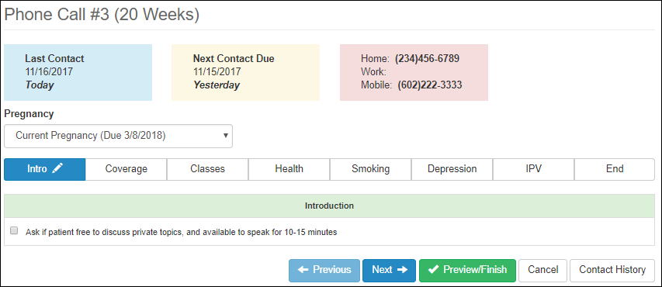

Figure 132: Phone Call #3 (20 Weeks)

#### Phone Call #4 (28 Weeks)

This type of Call Note includes the following tabs:

1. Intro
2. Coverage
3. Classes
4. Breastfeeding
5. WIC
6. Contraception
7. Health
8. Depression
9. End

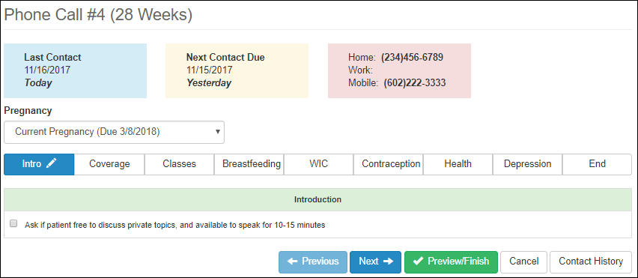

Figure 133: Phone Call #4 (28 Weeks)

#### Phone Call #5 (36 Weeks)

This type of Call Note includes the following tabs:

1. Intro
2. Coverage
3. Breastfeeding
4. Contraception
5. Health
6. Depression
7. IPV
8. End

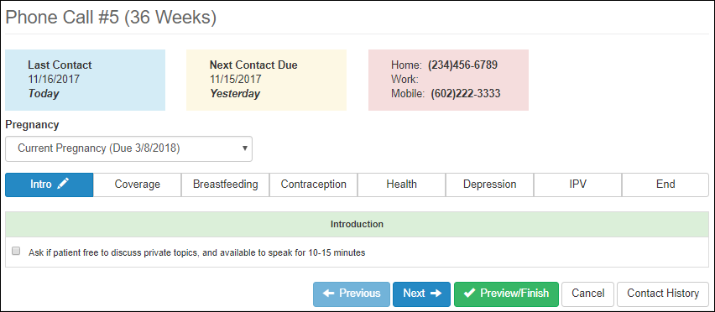

Figure 134: Phone Call #5 (36 Weeks)

#### Phone Call #6a (41 Weeks, Not Delivered)

This type of Call Note includes the following tabs:

1. Intro
2. Coverage
3. Health
4. Depression
5. Breastfeeding
6. End

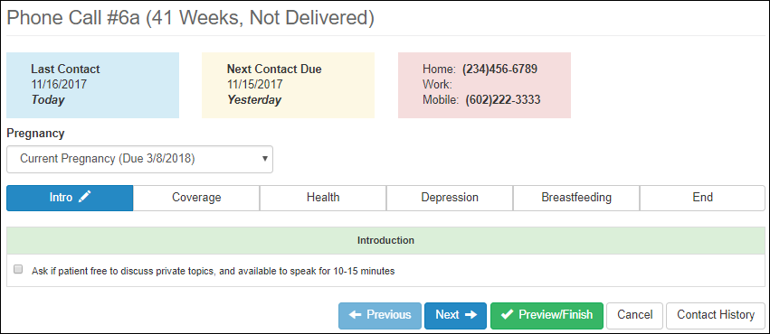

Figure 135: Phone Call #6a (41 Weeks, Not Delivered)

#### Phone Call #6b (41 Weeks, Delivered)

This type of Call Note includes the following tabs:

1. Intro
2. Coverage
3. Health
4. Depression
5. IPV
6. Breastfeeding
7. Contraception
8. PP Visit
9. End

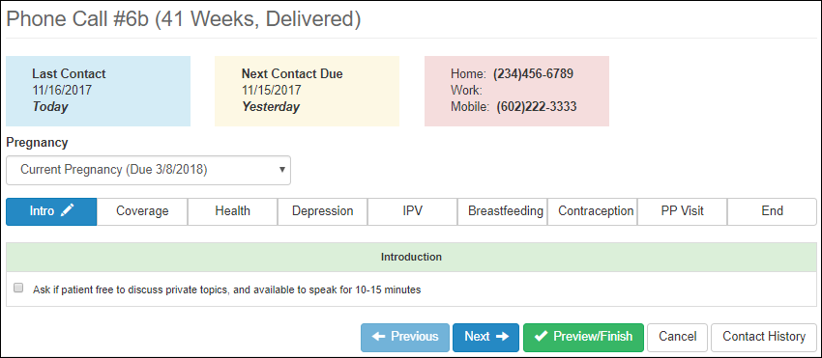

Figure 136: Phone Call #6b (41 Weeks, Delivered)

#### Phone Call #7 (6 Weeks Postpartum)

This type of Call Note includes the following tabs:

1. Intro
2. Coverage
3. Health
4. Breastfeeding
5. Depression
6. PP Visit
7. VA Primary
8. End

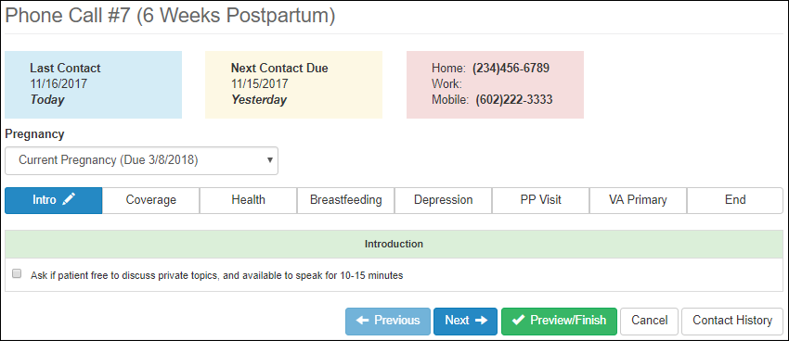

Figure 137: Phone Call #7 (6 Weeks Postpartum)

#### Additional Call Note

This type of Call Note includes the following tabs:

1. Subject
2. Dashboard Note Text

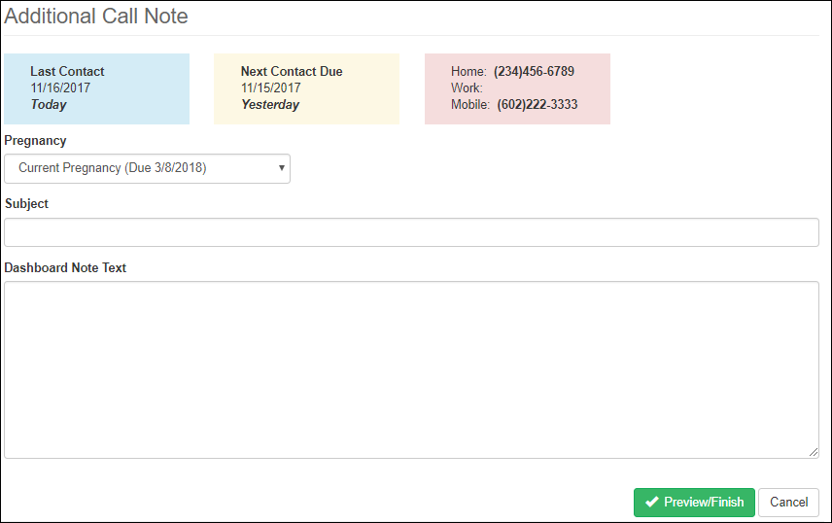

Figure 138: Additional Call Note

From the Contact History page, select **Add Call Note**. Enter the Subject and add any notes in the Dashboard Note Text section. Click **Preview/Finish** to sign the note. At the Sign Note Signature Code page, enter an electronic signature. Click **Cancel** to exit without saving the note and return to the previous page.

### Call Note Tabs Details

Each of the tabs that could be part of a Call Note will be presented below, and where different, it will be pointed out. For each of the tabs, t

#### Intro

Used in Phone Call #1:

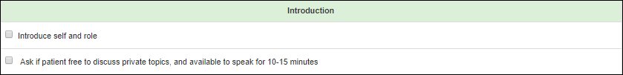

Figure 139: Intro Tab 1

Used in Phone Call #2:

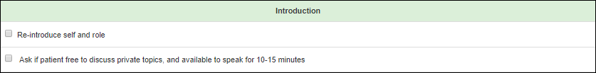

Figure 140: Intro Tab 2

Used in Phone Call #3 – Phone Call #7:



Figure 141: Intro Tab 3-7

#### Coverage

The Coverage tab instructs the user to confirm information with the patient regarding their VA maternity benefits.

Used in Phone Call #1:

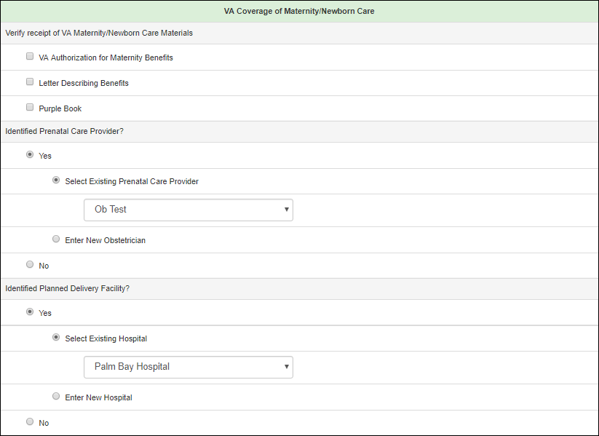

Figure 142: Coverage Tab 1

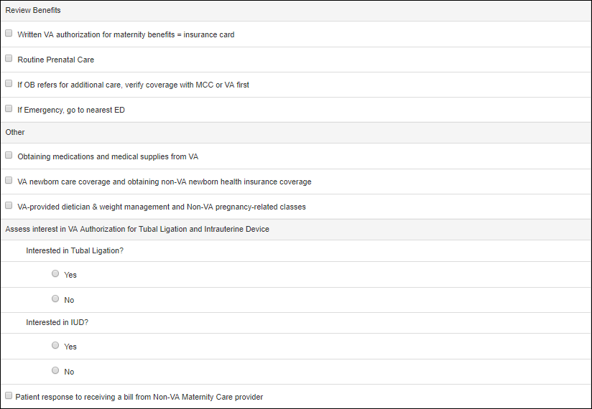

Figure 143: Coverage Tab 1 (continued)

Used in Phone Call #2:

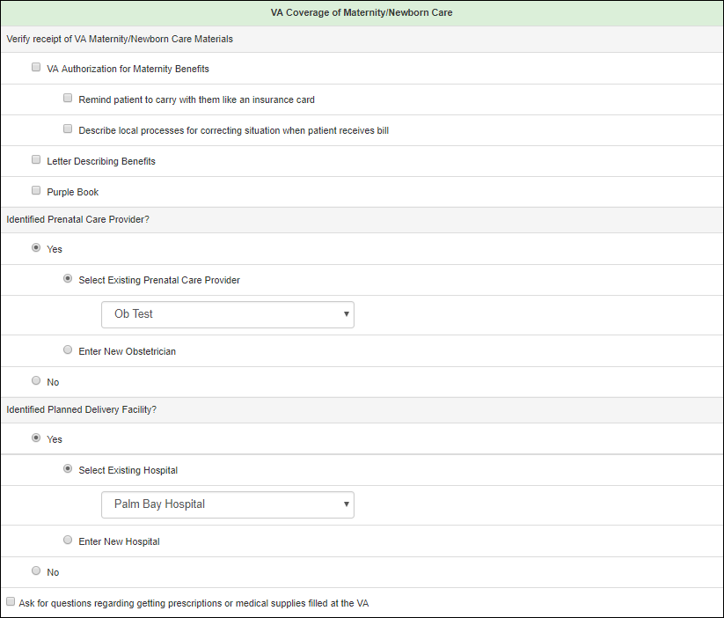

Figure 144: Coverage Tab 2

Used in Phone Call #3:

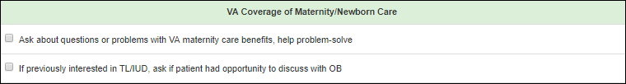

Figure 145: Coverage Tab 3

Used in Phone Call #4 – Phone Call #7:



Figure 146: Coverage Tab 4-7

#### Classes

The user is instructed to discuss appropriate classes with the patient, assess their interest and record any notes.

Used in Phone Call #3, Phone Call #4:

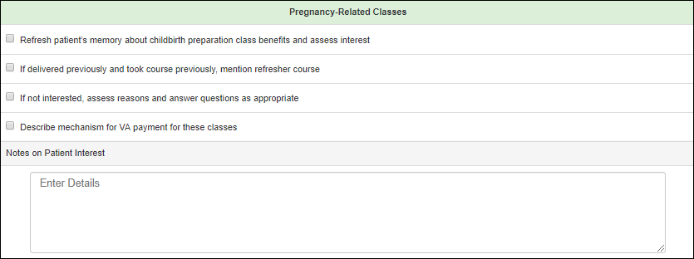

Figure 147: Classes Tab 3, 4

#### Breastfeeding

The user is instructed to discuss and record the patient’s plans for infant feeding and inquire about the patients need for supplies.

Used in Phone Call #4:

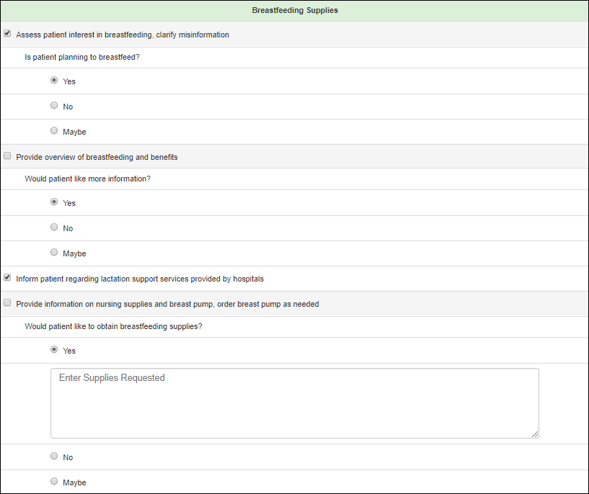

Figure 148: Breastfeeding Tab 4

Used in Phone Call #5:

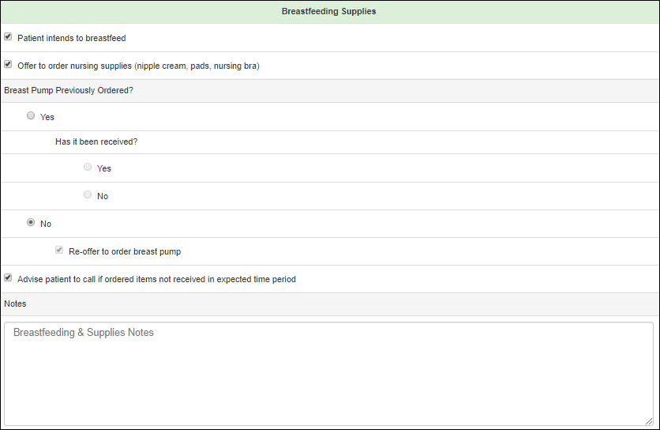

Figure 149: Breastfeeding Tab 5

Used in Phone Call #6a:

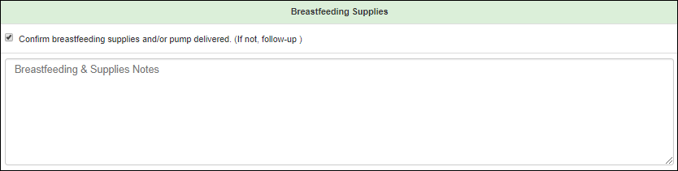

Figure 150: Breastfeeding Tab 6a

Used in Phone Call #6b:

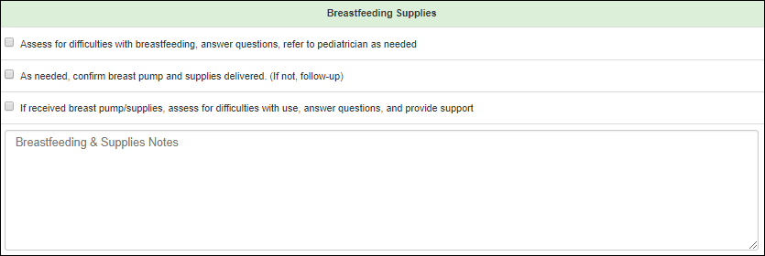

Figure 151: Breastfeeding Tab 6b

Used in Phone Call #7:

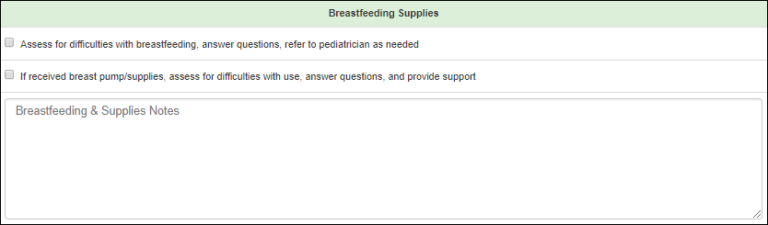

Figure 152: Breastfeeding Tab 7

#### WIC (Women, Infants and Children)

The user is instructed to educate the patient on resources available through the WIC program.

Used in Phone Call #4:

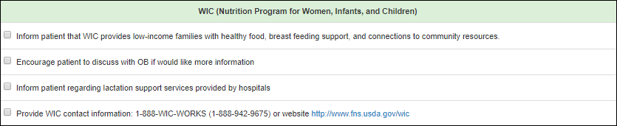

Figure 153: WIC Tab 4

#### Contraception

The user is instructed to assess and record the patient’s contraceptive plans.

Used in Phone Call #4:

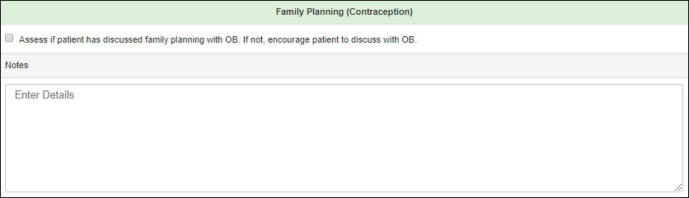

Figure 154: Contraception Tab 4

Used in Phone Call #5:

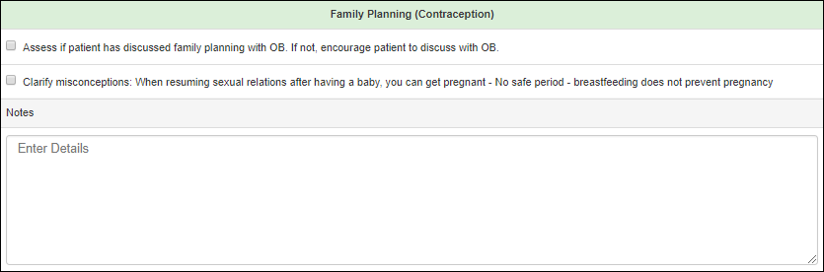

Figure 155: Contraception Tab 5

Used in Phone Call #6b:

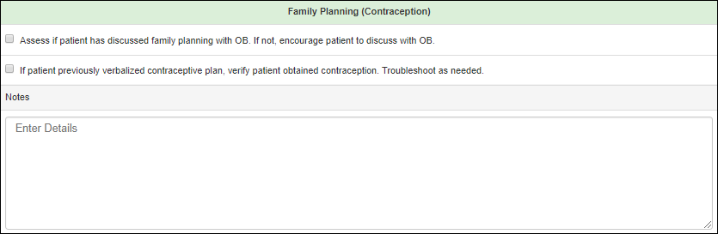

Figure 156: Contraception Tab 6b

#### Health

The Health tab instructs the user to report any new health issues and new medications.

Used in Phone Call #1 – Phone Call #6a, Phone Call #7:

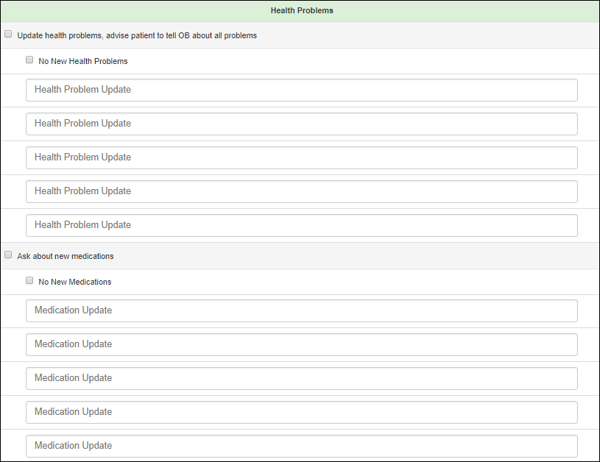

Figure 157: Health Tab 1-6a, 7

Used in Phone Call #6b:

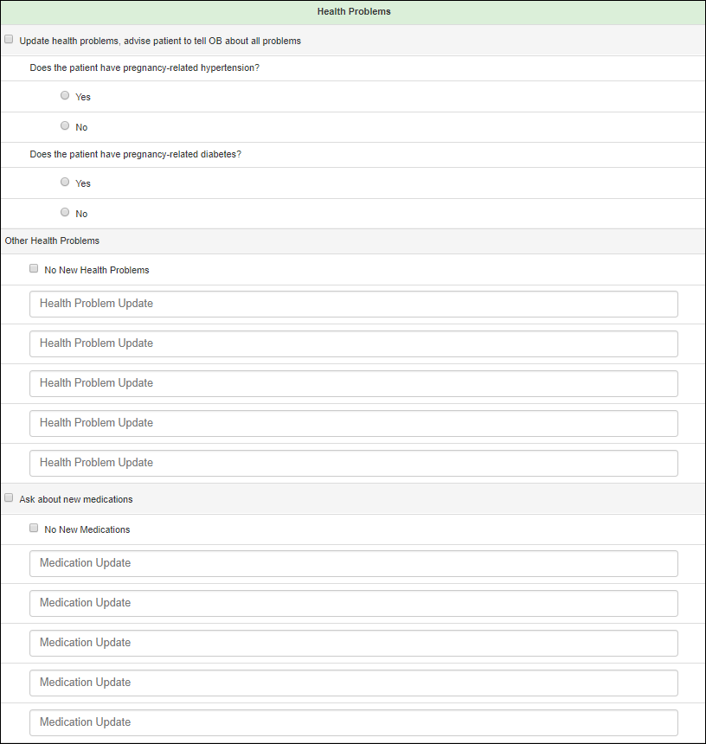

Figure 158: Health Tab 6b

#### Smoking

The user is instructed to complete an assessment of the patients smoking status.

Used in Phone Call #1:

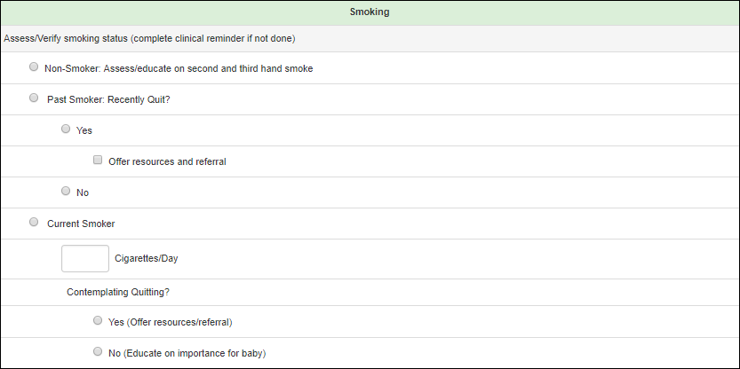

Figure 159: Smoking Tab 1

Used in Phone Call #2, Phone Call #3:

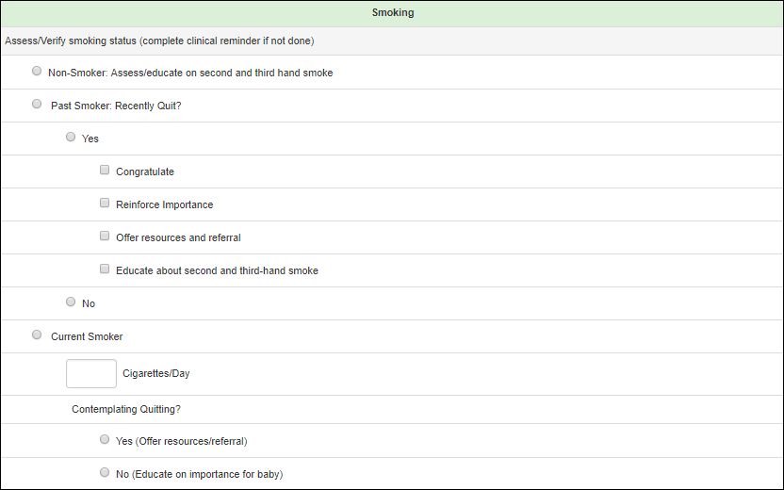

Figure 160: Smoking Tab 2, 3

#### Alcohol

The user is instructed to record and educate the patient regarding alcohol consumption.

Used in Phone Call #1:

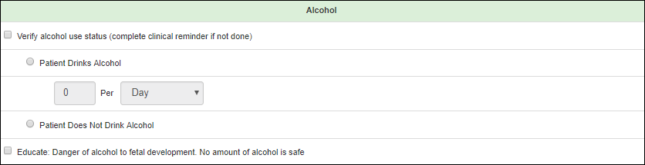

Figure 161: Alcohol Tab

#### Depression

The user is instructed to assess and record the patient’s depression status. Every time one of the radio buttons is selected, the Total Score at the bottom of the screen is updated. If the score is greater than 3, then the user is advised to flag the patient for the suicide screen.

Used in Phone Call #1, Phone Call #3 – Phone Call #7:

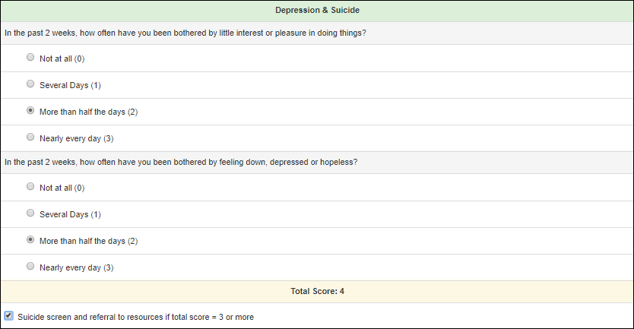

Figure 162: Depression Tab 1, 3-7

#### IPV (Interpersonal Violence):

The user is instructed to assess the patient’s interpersonal violence status, record any incidents and offer referral assistance.

Used in Phone Call #1, Phone Call #3, Phone Call #5, Phone Call #6b:

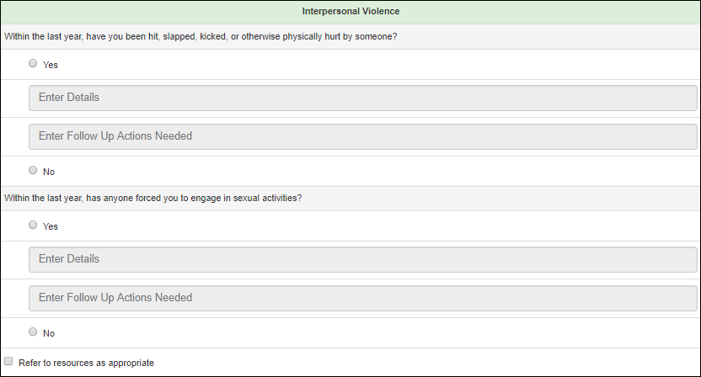

Figure 163: IPV Tab 1, 3, 5, 6b

#### PP Visit (Postpartum Visit)

The user is instructed to assess the patient’s postpartum appointment status, review importance and purpose, and record any notes.

Used in Phone Call #6b, Phone Call #7:

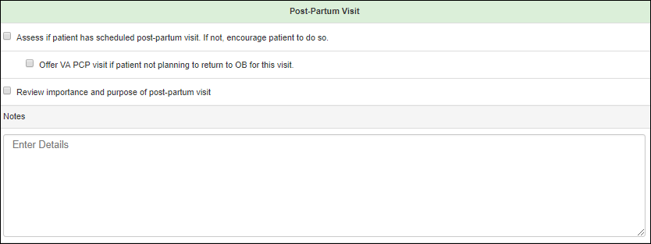

Figure 164: PP Visit Tab 6b, 7

#### VA Primary

Used in Phone Call #7:

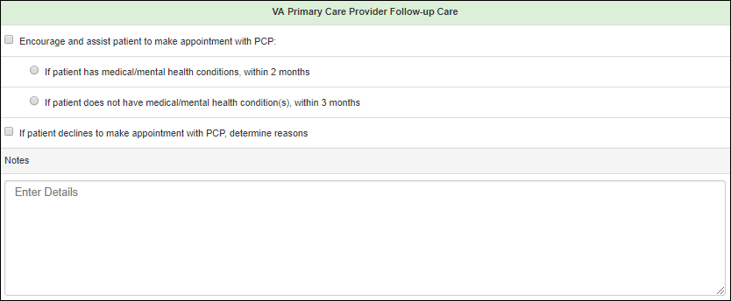

Figure 165: VA Primary Tab 7

#### End

Used in Phone Call #1 – Phone Call #7:

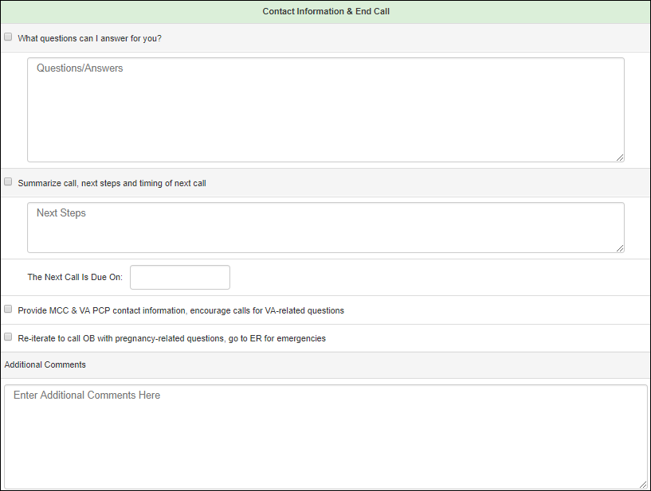

Figure 166: End Tab

## Education

To access the Patient Education Items screen, click on the Education tab on the left side pane, under the Patient section.

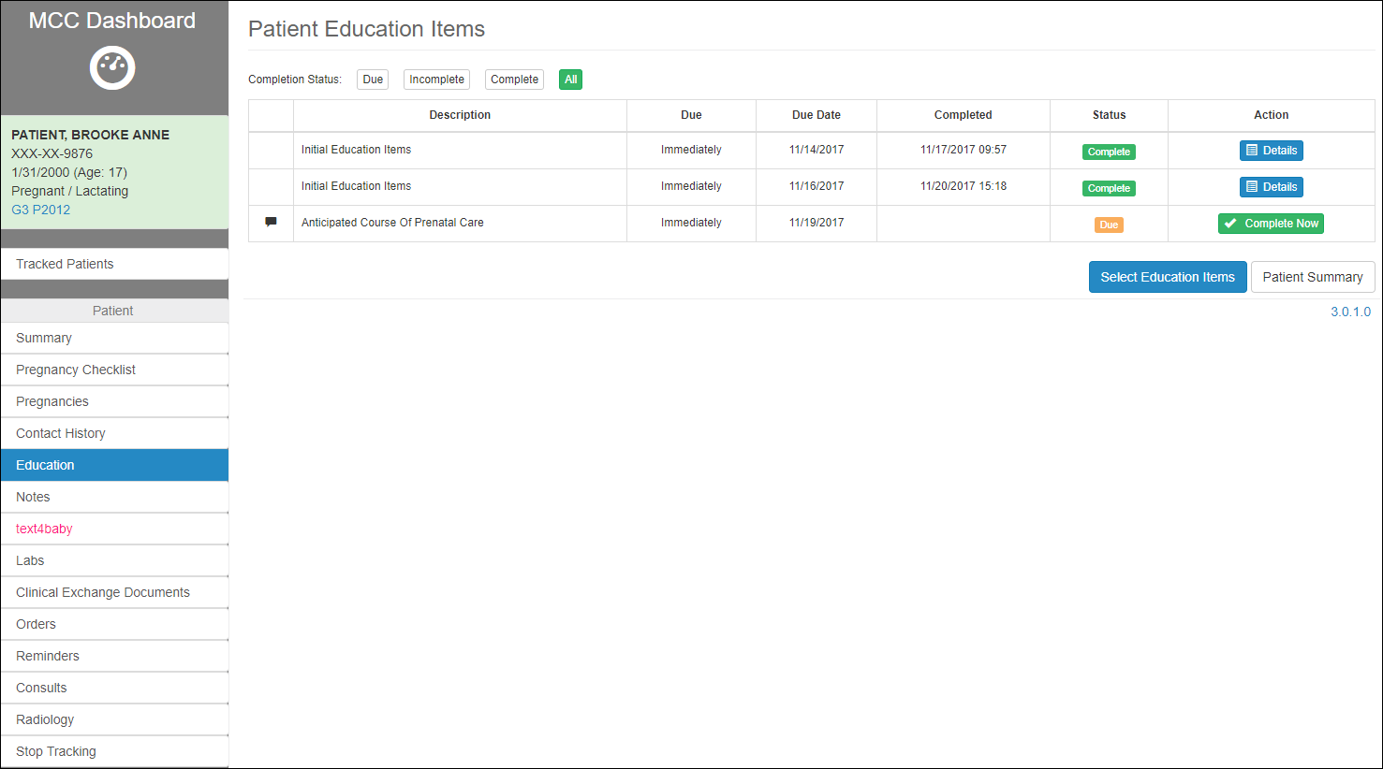

Figure 167: Patient Education Items

The Education screen shows a table of all the Education tasks that the Patient is recommended to complete. Completed education items added here do not appear on the Pregnancy Checklist.

Some education items may be displayed by default for every patient. That is due to the tasks being added in the Checklist tasks required for all the patients, as presented in section Checklist.

The information on the table can be filtered by selecting one of the Completion Status buttons at the top of the table:

1. Filter by tasks that are Due
2. Filter by tasks that are Incomplete
3. Filter by tasks that are Complete
4. Show All the tasks



Figure 168: Education Items Filter

The screen presents two buttons as well:

1. **Select Education Items**: for adding new tasks to the table
2. **Patient Summary**: to navigate back to the Summary

information in the table is ed in the following columns:

1. of the task
2. status (Immediately, etc.)
3. : date when the task was completed, available only for the completed tasks
4. **:** Completed, Due, etc.
5. :
   1. Complete Now: Allows the user to mark the task as completed
   2. Details: Allows the user to view the details of the completed task

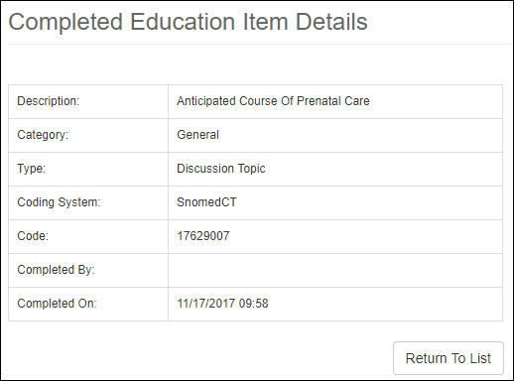

Figure 169: View Details of Completed Task

### Add

(tasks to complete) This redirects the user to Select Patient Education Items screen.

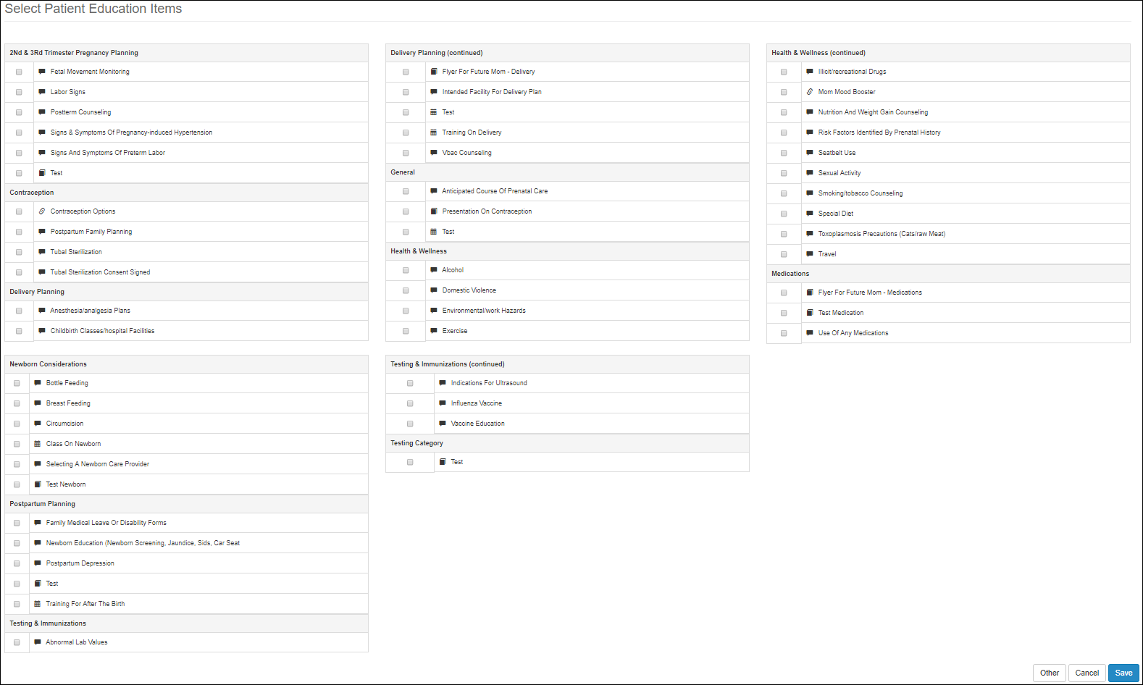

Figure 170: Add Education Items to patient's Education

Select Patient Education Items screen shows multiple educational checkboxes for tasks that a patient could be recommended to complete. The tasks are grouped by different categories, such as:

1. 2nd & 3rd Trimester Pregnancy Planning
2. Contraception
3. Delivery Planning
4. General
5. Health & Wellness
6. Medications
7. Newborn Considerations
8. Postpartum Planning
9. Testing & Immunizations

Also, new categories could be added:

1. For an individual patient, by selecting **Other** button at the bottom of the screen
2. For all the patients, as presented in section Education Items.

Selecting **Other** button redirects the user to the Add New Patient Education Item screen:

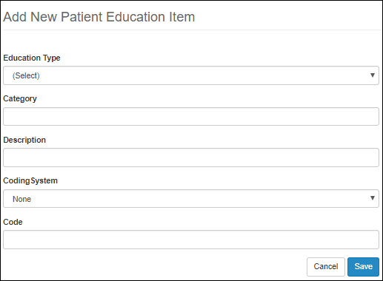

Figure 171: Add New Patient Education Item

The user has the option to create a new Category, just as it was presented in section Education Items.

Select Save button at the bottom of the screen. The user should be redirected back to the Select Patient Education Items screen, which should show the new Category created specifically for the selected patient.

Select the checkboxes for the recommended tasks that the patient should complete.

Click **Cancel** to exit without saving and return to the previous page. Click **Save** to store the checked items and return to the Patient Education Items screen. The items that were selected should display.

## Notes

To access the Dashboard Notes screen, click on the Notes tab on the left side pane, under the Patient section.

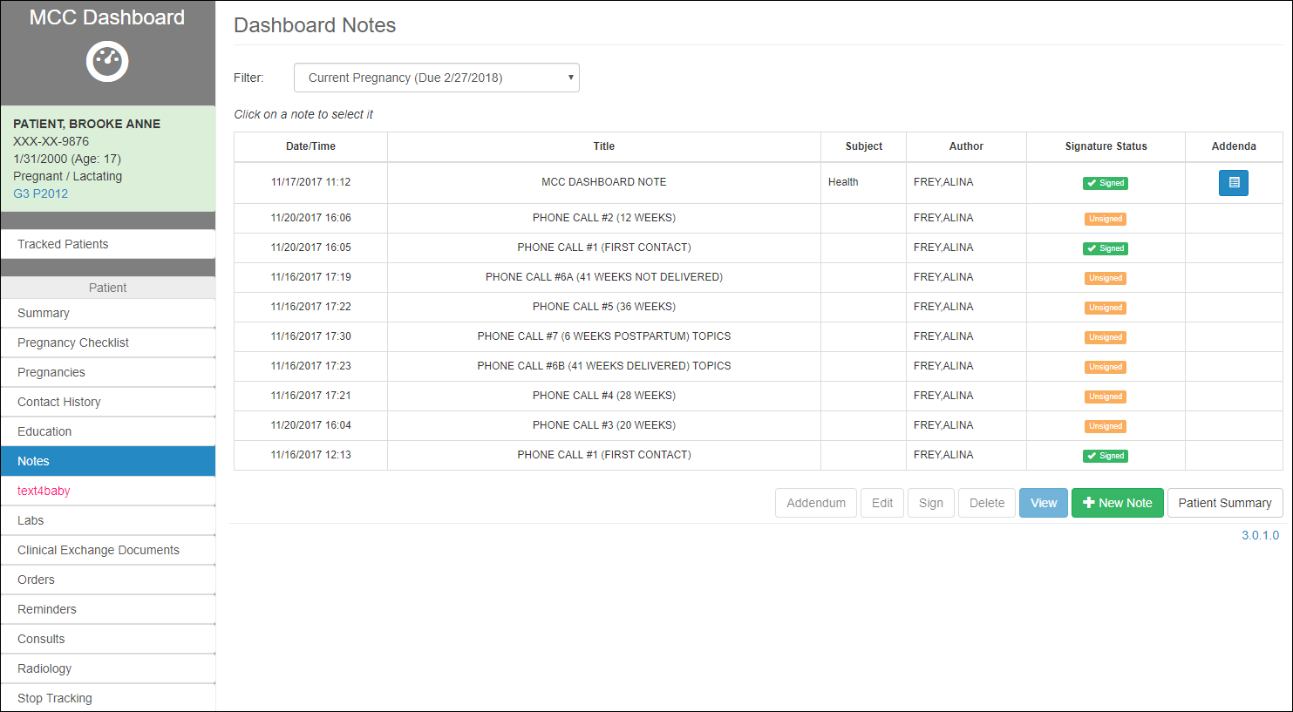

Figure 172: Dashboard Notes

Dashboard Notes allow the user to document in MT any activities deemed appropriate. These notes populate into the patient’s CPRS record.

The screen displays different notes:

1. Dashboard Notes created from this screen
2. Call Notes that were created by different users, as presented in section Contact History.

The notes can be filtered by the pregnancy Filter at the top of the table.

The Note’s information in the table includes:

1. Date/Time
2. Title
3. Subject
4. Author
5. Signature Status
6. Addenda

The user has the multiple action options on a note, by selecting the corresponding button at the bottom of the screen:

1. Addendum
2. Edit
3. Sign
4. Delete
5. View
6. Create a New Note
7. Navigate back to the Patient Summary screen



Figure 173: Action options on a note

### Edit a Dashboard Note

Only MCC Dashboard Notes that are not Signed can be edited. The Call Notes described in section Contact History, can only be viewed.

To edit an existing note, highlight and select the note from the list and choose the **Edit** option. An edit window opens and allows the user to edit text in the fields provided. Click **Save** to store the edits or **Cancel** to return to the previous page without saving.

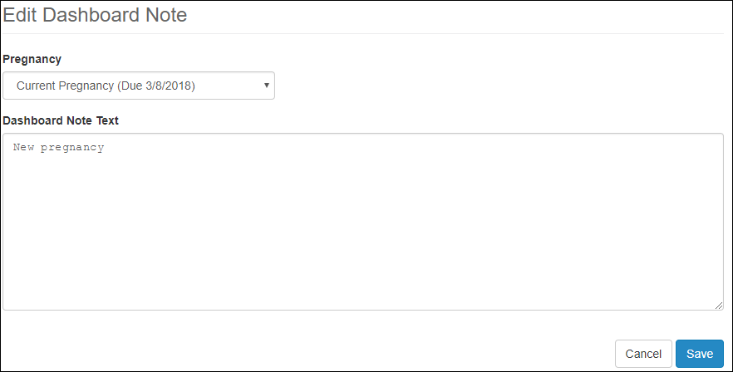

Figure 174: Edit Dashboard Note

### Sign a Dashboard Note

Only MCC Dashboard Notes can be signed from this screen. To sign the other notes, follow instructions in section Contact History.

To sign a Note, select a note from the Dashboard Notes table and click **Sign** button at the bottom of the screen. At the Sign Dashboard Note window, type in the CPRS electronic signature code in the field provided. Click **Cancel** to return to the previous page without signing.

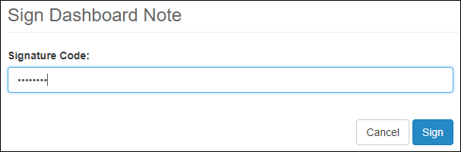

Figure 175: Sign Dashboard Note

Back in the Dashboard Notes Screen, the field Signature Status should now be updated to Signed.

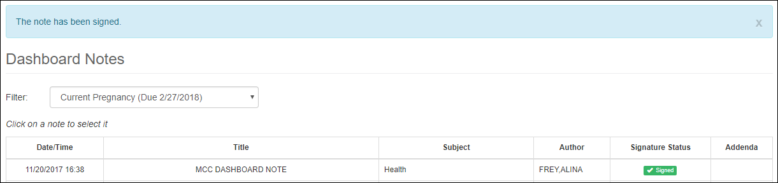

Figure 176: Updated Signed Status

### Add Addendums to a Dashboard Note

The user may make an addendum to a signed Dashboard Note. Only the MCC Dashboard Notes that are signed could have an Addendum added.

To add an addendum to the signed note, highlight an MCC Dashboard Note from the Notes table, and click **Addendum**.

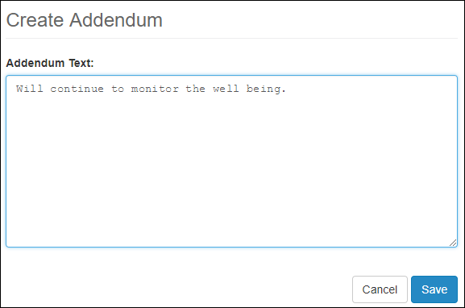

Figure 177: Create Addendum

The Create Addendum page opens with a free-text box for the user to type additional information. Click **Cancel** to exit without saving and return to the previous page. Click **Save** to store the addendum text to the Dashboard Note. The saved note now displays the **Addendum** button at the end of the note’s row.

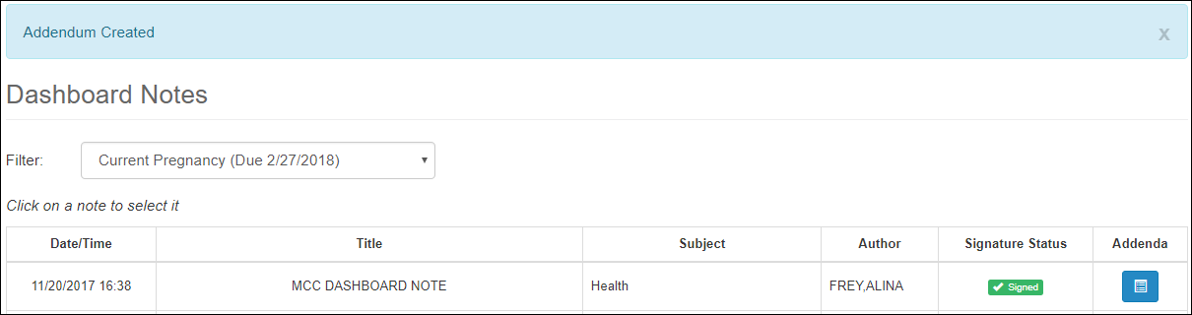

Figure 178: Note – Addendum added

To view the addenda from the Dashboard Notes screen, click the blue Addendum button. This redirects the user to the Dashboard Note Addenda screen, showing a list of addendums, along with the original note.

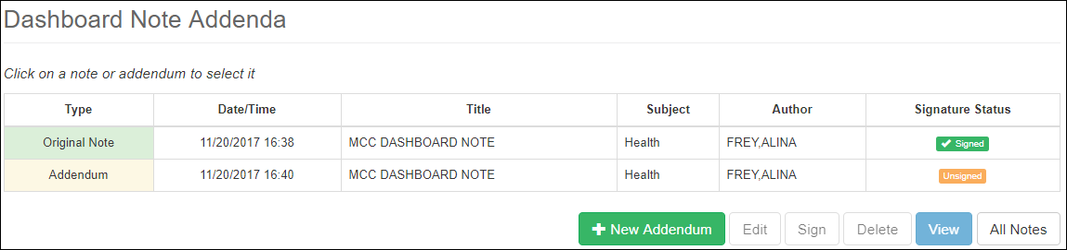

Figure 179: Adding Addendum to MCC Dashboard Note

From the Dashboard Note Addenda screen, the user has multiple options, by selecting the corresponding button at the bottom of the screen:

1. Add a **New Addendum** to the selected MCC Dashboard Note. Follow the same steps as adding the first addendum. Every added addendum is displayed in the table in the Dashboard Note Addenda screen.

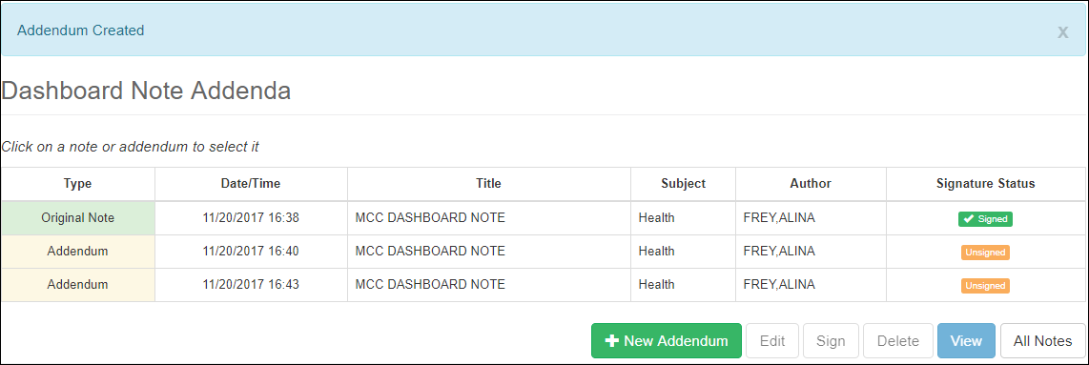

Figure 180: More Addendums Added to the note

1. **Edit** an Addendum that was not signed yet
2. **Sign** an Addendum that was not signed yet
3. **Delete** an Addendum that was not signed yet. To delete an addendum, highlight the corresponding row, and select Delete button. The user will be prompted to enter a reason for why the addendum is being deleted. Select Cancel to cancel the deletion of the note, or Delete, to remove the addendum from the note.

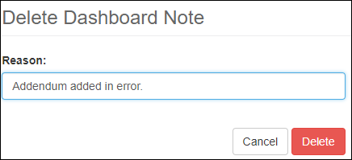

Figure 181: Delete Addendum

1. **View** the details of the selected addendum.

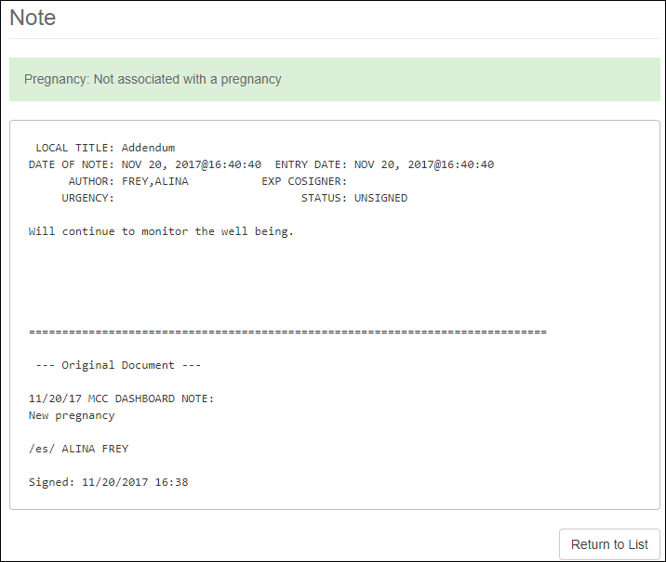

Figure 182: View Addendum Details

1. Navigate back to the Dashboard Notes screen by selecting **All Notes** button.

### View the details of a Note

To view the details of a Note, highlight the Note row from the Dashboard Notes screen and select View button at the bottom of the screen. The note opens for review but cannot be edited. Any note can be viewed: Call Notes and MCC Dashboard Notes.

The Note details page should show all the details of the note, including all the Addendums made to that note, in order they were added, if any.

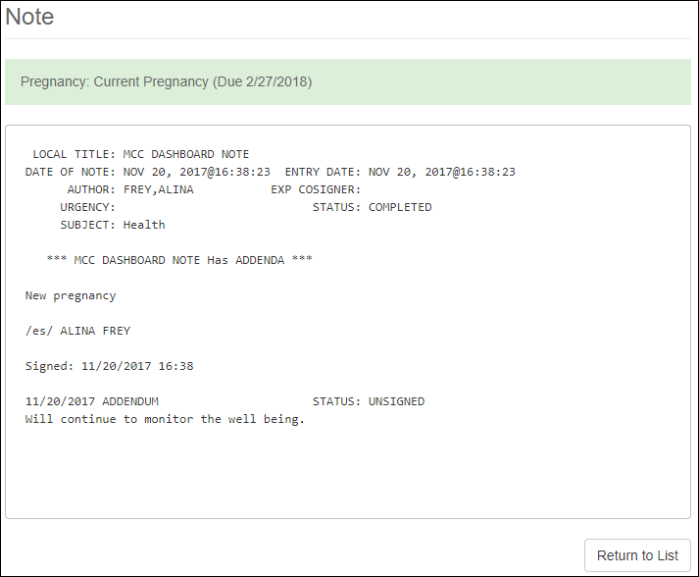

Figure 183: View Dashboard Note

Select **Return to Lis**t to return to the Dashboard Notes screen.

### Create a new note

To add a Dashboard Note, click **New Note** at the bottom of the Dashboard Notes screen.

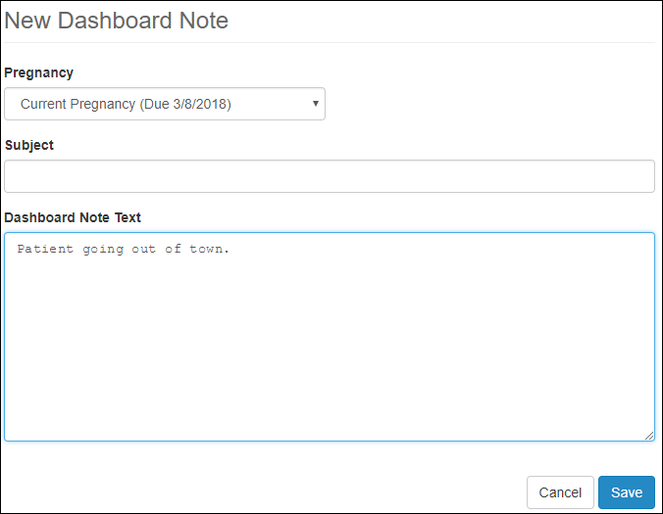

Figure 184: New Dashboard Note

At the New Dashboard Note, select the Pregnancy (if any), which this note should be associated with, enter text in the provided fields: Subject and Dashboard Note text.

Click **Cancel** to return to the previous page without saving. Click **Save** to store the note and return to the previous page.

The user should see the New Note added to the list of Dashboard Notes, with the Title MCC Dashboard Note. The note crosses into CPRS as unsigned.

To return to the patient summary, click Patient Summary button at the bottom of the screen.

### Delete

Only the MCC Dashboard Notes that are not signed could be deleted. Highlight the unsigned note and click **Delete**. A window displays requiring the user to indicate a reason for deleting this note. Click **Cancel** to return to the previous page without deleting. Click **Delete** to return to the previous page that no longer displays the note.

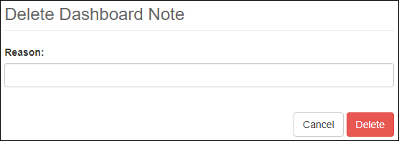

Figure 185: Delete Dashboard Note

## Text4Baby Enrollment

To access the Text4Baby screen, click on the Text4Baby link on the left side pane, under the Patient section.

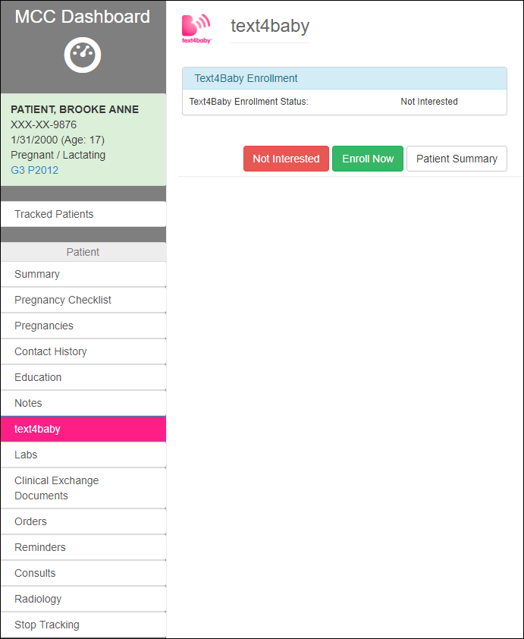

Figure 186: Text4baby Enrollment

The user has options for three actions, by selecting the corresponding button at the bottom of the screen:

1. Navigate back to **Patient Summary**
2. Not enroll, by selecting **Not Interested** button. That should update the status of the field Text4Baby Enrollment in the Patient Summary.
3. Enroll, by selecting the button **Enroll Now**.

When selecting to Enroll, the user is prompted to the text4baby – Enroll Patient screen:

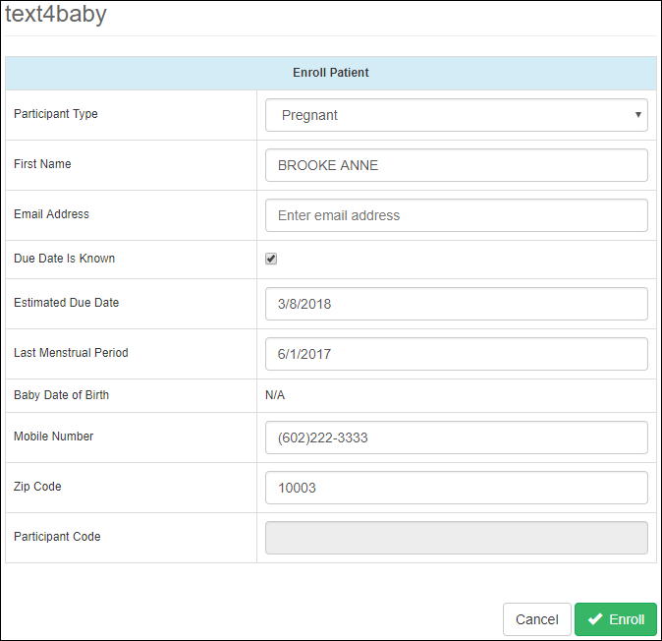

Figure 187: Text4Baby Patient Enrollment Form

The included fields in the enrollment form are:

1. Participant Type
2. First Name
3. Email Address
4. Due Date is Known checkbox
5. Estimated Due Date
6. Last Menstrual Period
7. Baby Date of Birth
8. Mobile Number
9. Zip Code
10. Participant Code

The field Pregnant Type is a dropdown list with two options:

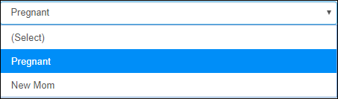

Figure 188: Text4Baby Patient Enrollment – Participant Type Field

The information in the fields is already pre-populated, but it can be edited if anything needs to be changed.

Also, the information changes based on the selection of the Pregnant Type field. Depending on the selection for **Participant Type**, different fields will be unavailable. For instance, selecting **Pregnant** (for Participant Type) will result in the field **Baby Date of Birth** being set to N/A. By selecting **New Mom**, the fields **Due Date Is Known**, **Estimated Due Date**, and **Last Menstrual Perio**d will be set to **N/A**.

After specifying the requested information, clicking **Enroll** will submit the request for registration, for the text4baby service. If registration was successful, then the following window will display.

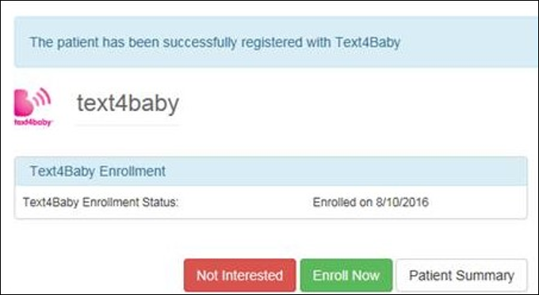

Figure 189: Text4Baby successful enrollment

To edit or update the patient’s Text4Baby Enrollment status, can be done also as described in Patient Details panel of Patient Summary screen, by clicking on the **Text4Baby Enrollment** link.

## Labs

To access the Labs screen, click on the Labs link on the left side pane, under the Patient section. The Labs option from the Dashboard allows the user to view lab results from the patient’s CPRS record.

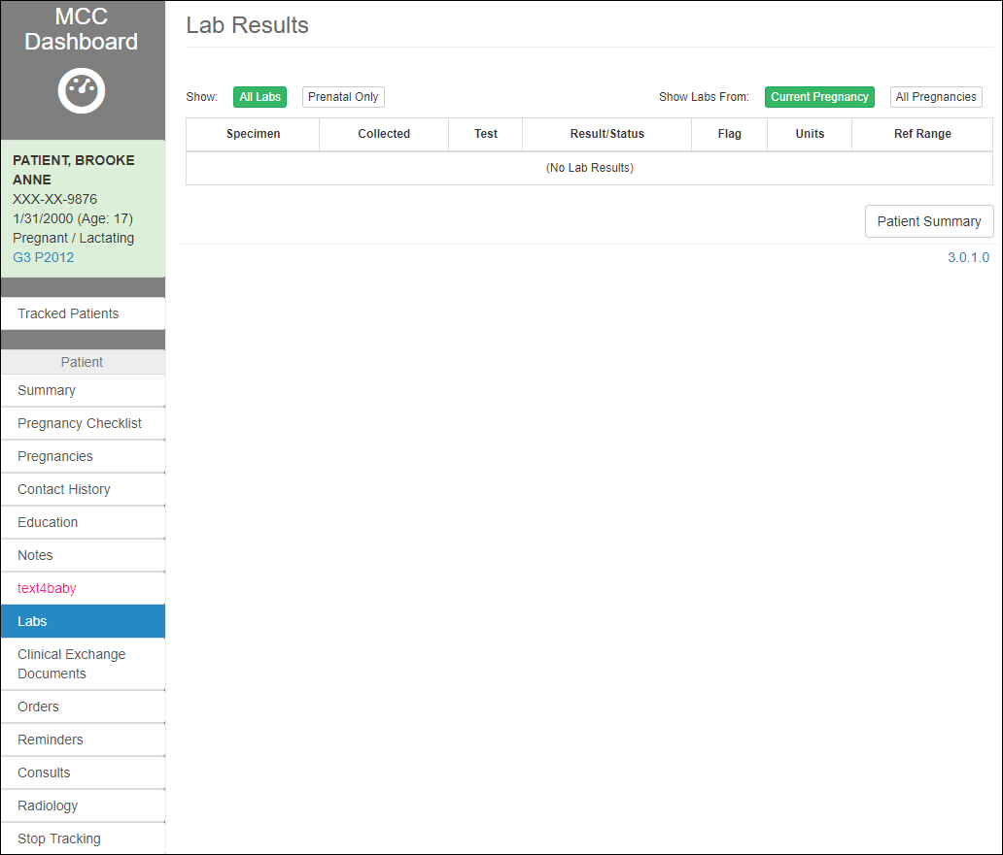

Figure 190: Lab Results

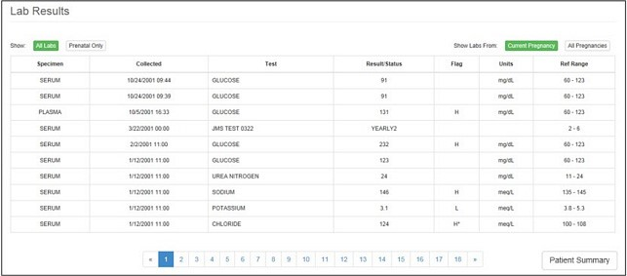

Figure 191: Lab Results (continued)

The Labs can be filtered by the one of the Filters at the top of the table:

1. All Labs/Prenatal Only
2. Current Pregnancy/All Pregnancies



Figure 192: Labs – Filters

The Lab’s information in the table includes:

1. Specimen
2. Collected
3. Test
4. Result/Status
5. Flag
6. Units
7. Ref Range

The user has two options, by selecting the corresponding buttons at the bottom of the Labs screen:

1. **View Selected** lab
2. Navigate to back to **Patient Summary** screen

To view the Lab’s details, select the corresponding row in the Labs table and click View Selected.

## Clinical Exchange Documents

To access the Clinical Exchange Documents screen, click on the Clinical Exchange Documents link on the left side pane, under the Patient section.

This menu option allows the user to share documents with and retrieve documents from outside providers. Inbound documents are stored as a TIU note in CPRS.

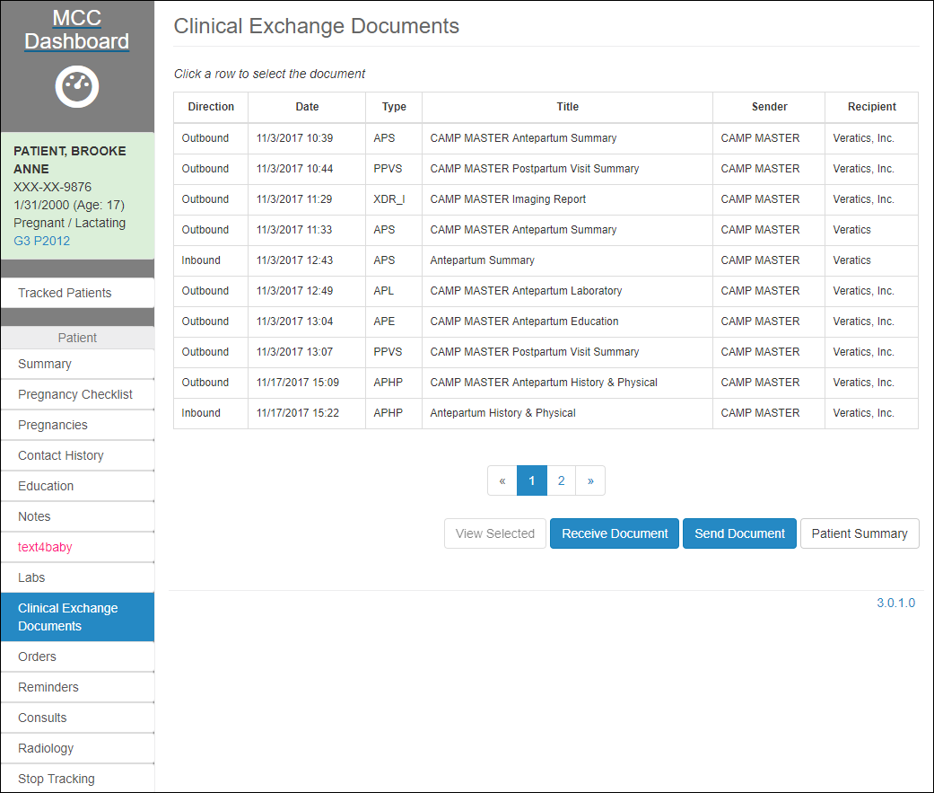

Figure 193: Clinical Exchange Documents

The screen shows a table of all the shared clinical documents that were generated or imported, containing the following info:

1. Direction:
   1. Outbound: if the document was sent
   2. Inbound: if the document was received
2. Date when it was generated
3. Type of document. The available types are:
   1. Antepartum History & Physical (APHP)
   2. Antepartum Summary (APS)
   3. Antepartum Laboratory (APL)
   4. Antepartum Education (APE)
   5. Postpartum Visit Summary (PPVS)
   6. Imaging Report (XDR-I)
   7. Newborn Discharge Summary (NDS) *** Receiving Only ***
   8. Maternal Discharge Summary (MDS) *** Receiving Only ***
4. Title of the document
5. Sender
6. Recipient

The user has the following options, by selecting the corresponding button at the bottom of the screen:

1. View Selected document
2. Receive a Document
3. Send a Document
4. Navigate back to the Patient Summary screen.



Figure 194: Clinical Exchange Documents Options

To be able to Export documents (after sending/generating one or after viewing an existing one), the user needs to make sure that the CDA export folder exists. By default, the path to the CDA export folder is set **c:\cda\outgoing**, but it can be changed to be anywhere on the local machine, as long as the user creates the corresponding folders.

### View a Clinical Exchange Document

To view details of a clinical document that was already created, select the document row from the table, then click **View Selected** button.

This redirects the user to the Summary page of the document.

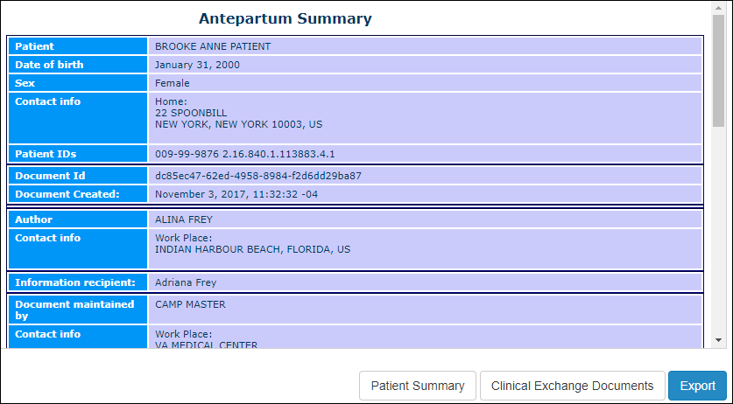

Figure 195: Document View

The user has the following options:

1. **Export** the viewed document
2. Navigate back to the **Patient Summary** screen
3. Navigate back to **Clinical Exchange Documents** screen

To Export the viewed document, select the corresponding button. Also, the user needs to make sure that the export folder exists, as specified above. Clicking **Export** allows the user to store the document locally.

The user should see an info message where the file was exported to:

The document has been saved to 'c:\cda\outgoing\XDR-I-PATIENT, BROOKE ANNE-11-03-17.xml'

### Receive a Clinical Exchange Document

This option is available for the cases where the user would like to import a clinical document that is not loaded in the Clinical Exchange Documents table. Documents from outside providers will be placed in a pre-arranged location.

By Selecting the **Receive Document** option, the user can upload a locally stored document into MT.

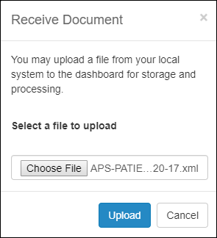

Figure 196: Receive Document

Select the appropriate clinical document from the location on filesystem where it was saved previously and select **Upload** to store the document. **Cancel** to return to the previous page without storing the document.

Just as a note, any file that was exported to the CDA export folder (**c:\cda\outgoing**) can be uploaded as well. That will create a duplicate record in the table of Clinical Exchange Documents.

Upload will first enable the viewing of the document.

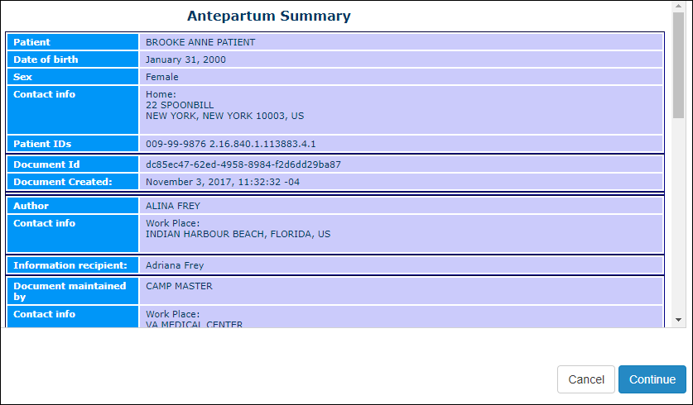

Figure 197: Clinical Exchange Documents – Review uploaded document

Clicking **Continue** will then allow the conformation of the current patient with the patient in the document.

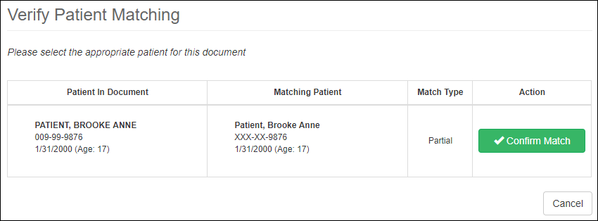

Figure 198: Clinical Exchange Documents – Confirm Patient on upload

The user is redirected to the **Select Data To Import** window, which allows the selection of the data elements to import, either by clicking on Select All, or checking the individual elements. Clicking **Finish** will then import the selected data elements into a note.

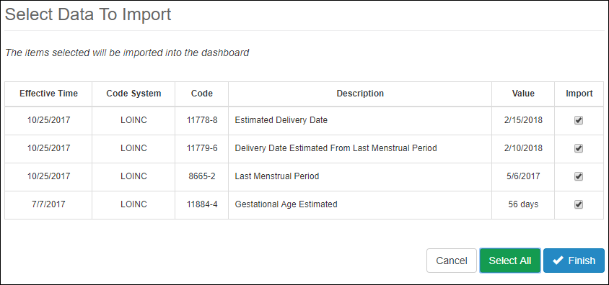

Figure 199: Select Data to Import

The user is asked to enter the electronic signature to Sign the document.

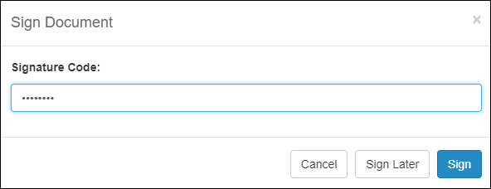

Figure 200: Electronic Signature for uploading clinical document

Upon a successful upload, the user is redirected back to Clinical Exchange Documents screen, which displays a success message, and the imported document shows in the table of clinical documents, with the Direction set to Inbound.

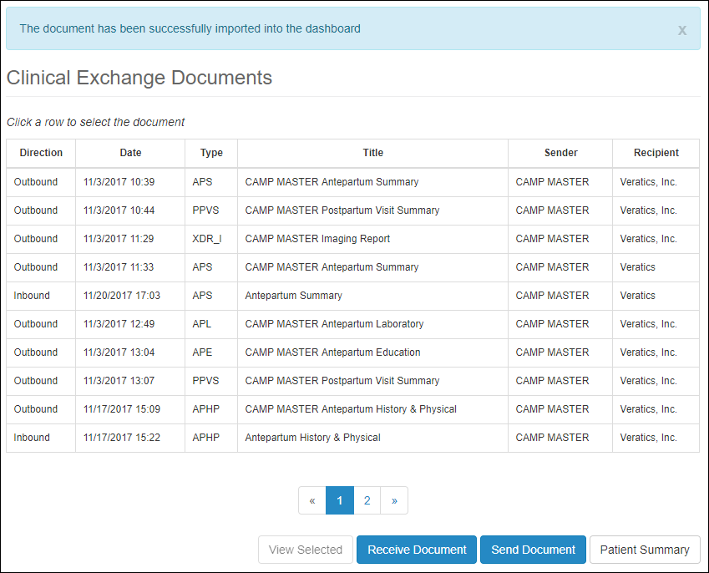

Figure 201: Clinical Exchange Documents – successful upload

### Send a Clinical Exchange Document

Clicking **Send Document** (from the Clinical Exchange Documents page**)** allows the user to choose a document by title then by source (Note or Date range) and enter the recipient information in the fields provided. Clicking **Patient Summary** returns the user to the Summary page.

To send/generate a Clinical Document, click **Send Document** button at the bottom of the screen.

The user has multiple options to select from for the type of document to send.

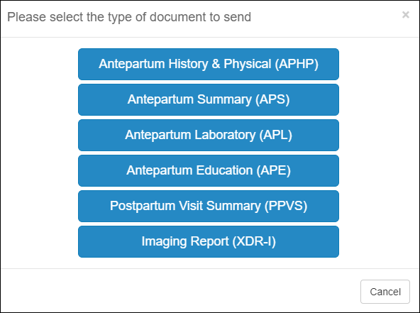

Figure 202: Clinical Exchange Documents – Send Documents Types

This redirects the user to their corresponding Options screens.

1. Antepartum History & Physical
2. Antepartum Summary
3. Antepartum Laboratory
4. Antepartum Education
5. Postpartum Visit Summary
6. Imaging Report

All the screens have the same initial layout, with two panels:

1. Source Panel: for choosing the Source of the document data
2. Recipient Information Panel: for the Information about the recipient.

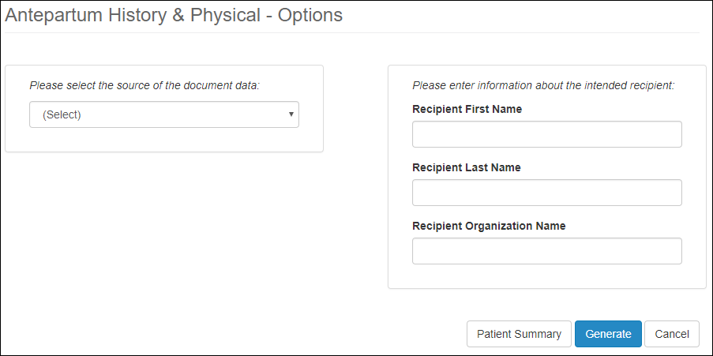

Figure 203: Clinical Exchange Documents – Send Documents Options

For each of the IHE documents available to send, this screen will be similar. The source is what differs between the various IHE documents. While the Recipient Info panel doesn’t change, the Source panel changes its layout based on the selected Source.

The following are the layouts for the Source panel for every Options screen:

1. Antepartum History & Physical – same as Antepartum Summary
2. Antepartum Summary – Source panel layout:

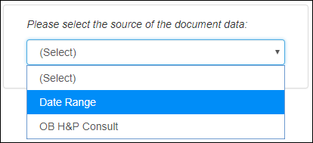

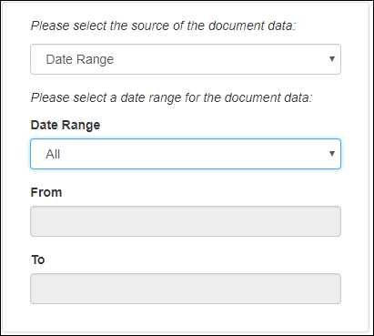

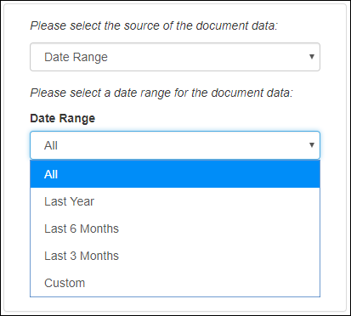

Figure 204: Sending Clinical Documents – APHP and APS – Source Panel – Selecting Date

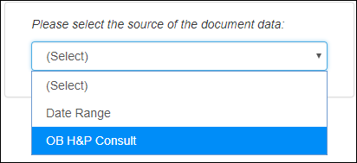

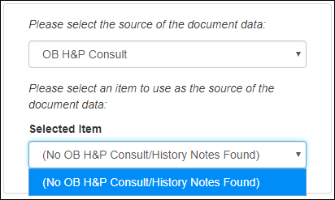

Figure 205: Sending Clinical Documents – APHP and APS – Source Panel – Selecting Consult

1. Antepartum Laboratory – same as Antepartum Education
2. Antepartum Education – Source panel layout:

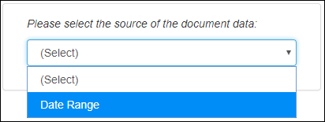



Figure 206: Sending Clinical Documents – APL and APE – Source Panel

1. Postpartum Visit Summary – Source panel layout:

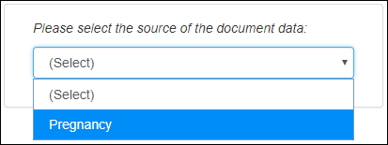

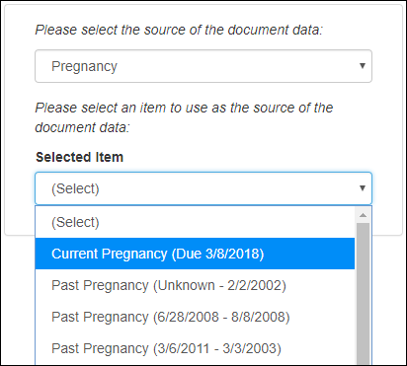

Figure 207: Sending Clinical Documents – PPVS – Source Panel

1. Imaging Report – Source panel layout:

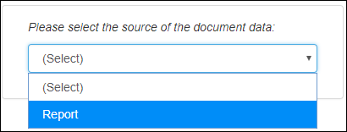

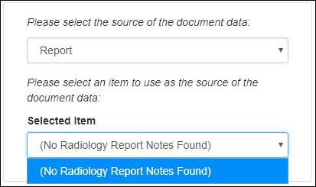

Figure 208: Sending Clinical Documents – XDR-I – Source Panel

Select the options from the dropdown lists in the Source Panel, and enter the Recipient Info, then select **Generate** button.

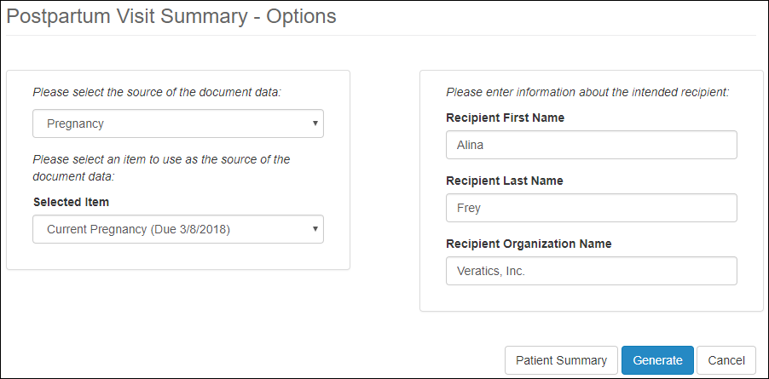

Figure 209: Generate Clinical Documents

At any point in time the user has the option to **Cancel** the process or navigate back to the Patient Summary, by selecting the corresponding buttons at the bottom of the screen.

If no style sheet has been selected before generating a document, the user has the option to select one in the alert screen, by clicking on **Style Sheet** button:

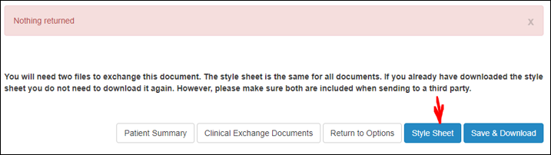

Figure 210: Clinical Documents – Style Sheet

The following is an example of generating a document. Use similar steps for generating documents for all the other options:

1. Choose the Source and the Recipient:

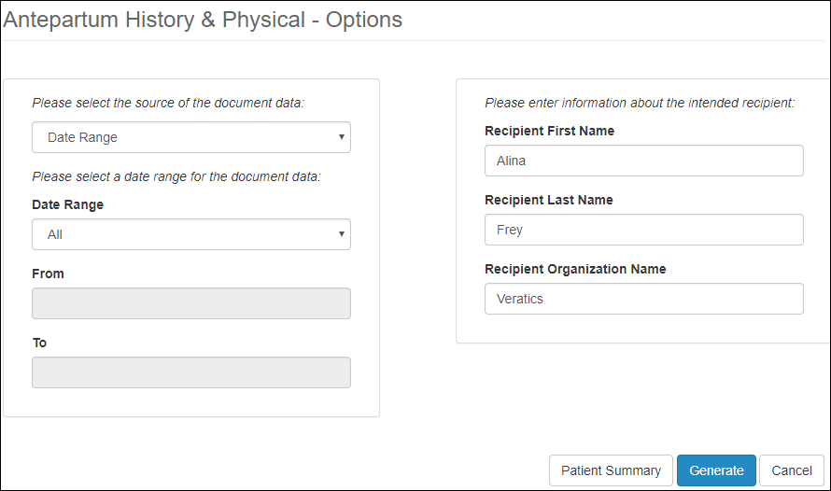

Figure 211: Generating Clinical Document

1. Generate the document:

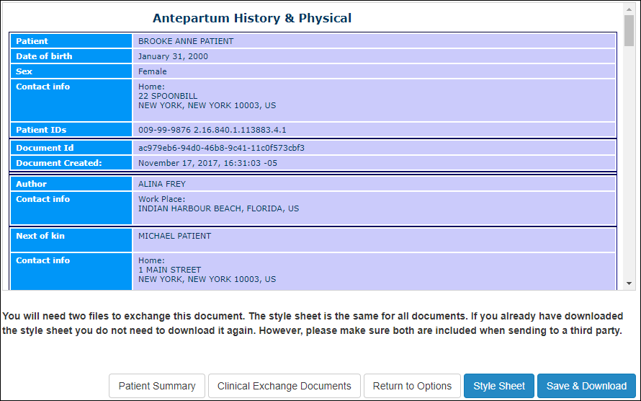

Figure 212: Clinical Document generated

Select **Style Sheet** (if not selected already), then **Save & Download** button. This generates the document and redirects the user back to the Clinical Exchange Documents screen, showing the newly created clinical document in the table.

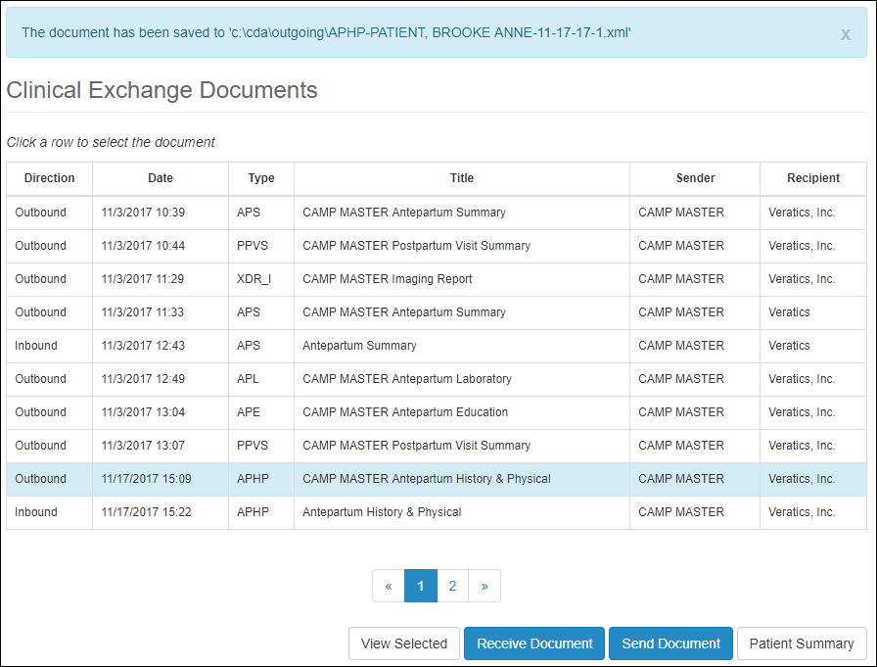

Figure 213: Generated document saved to Clinical Documents

## Orders

To access the Orders screen, click on the Orders link on the left side pane, under the Patient section. The Orders menu option allows the user to view all orders for the patient from their CPRS record.

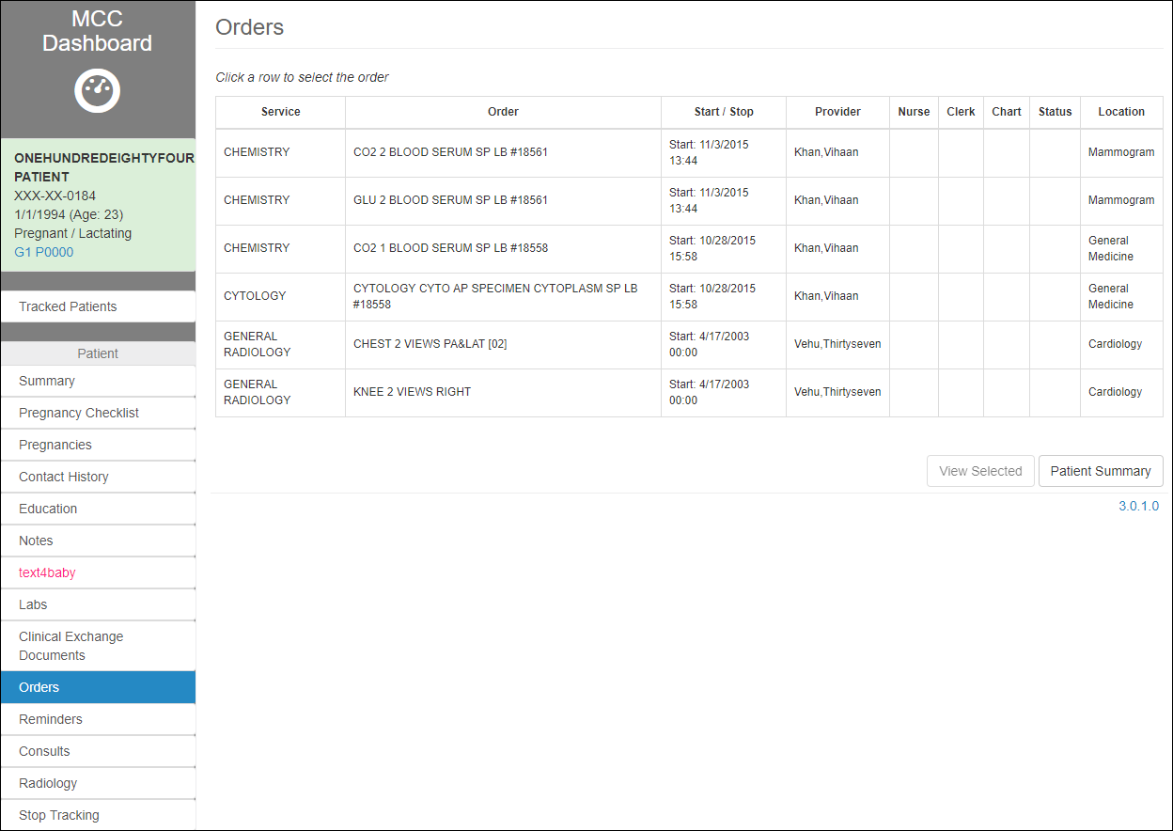

Figure 214: Orders

The screen displays a table of all the orders associated with the selected patient, containing the following info:

1. Service
2. Order
3. Start/Stop
4. Provider
5. Nurse
6. Clerk
7. Chart
8. Status
9. Location

The user has the following options, by selecting the correspondent button at the bottom of the screen:

1. **View Selected** order
2. Navigate back to the **Patient Summary** screen.

To view the Order’s details, highlight the corresponding row in the Orders table and click View Selected.

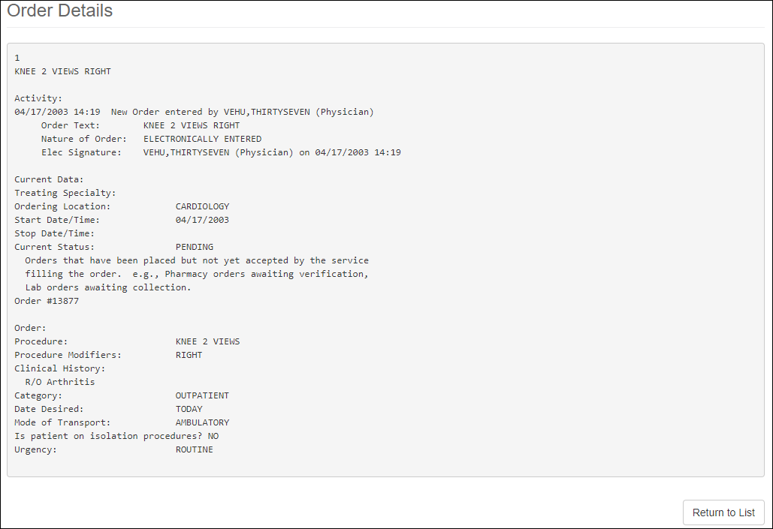

Figure 215: Order Detail

Theorder details display. To exit the order details and return to the list of Orders, click **Return to List** button at the bottom of the screen.

## Reminders

To access the Clinical Reminders screen, click on the Reminders link on the left side pane, under the Patient section. The **Reminders** option allows the user to view the clinical reminders for this patient.

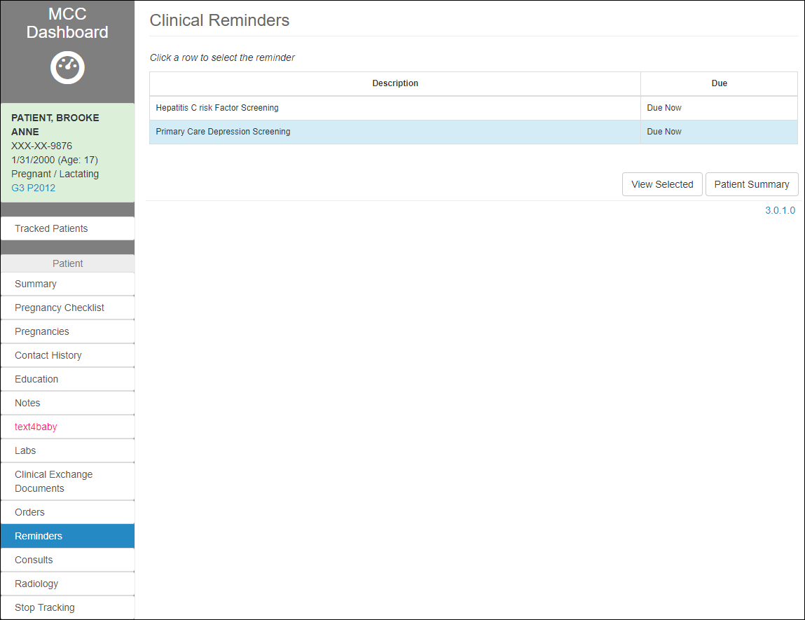

Figure 216: Clinical Reminders

The screen shows a table of all the Clinical Reminder associated with the selected patient, containing the following info:

1. Description
2. When is it Due

The user has the following options, by selecting the correspondent button at the bottom of the screen:

1. View Selected reminder
2. Navigate back to the Patient Summary screen.

To view the Clinical Reminder’s details, highlight the corresponding row in the Clinical Reminders table and click View Selected.

Figure 217: Reminder Detail

return back to Clinical Reminders screen

## Consults

To access the **Consults** screen, click on the Consults link on the left side pane, under the Patient section.

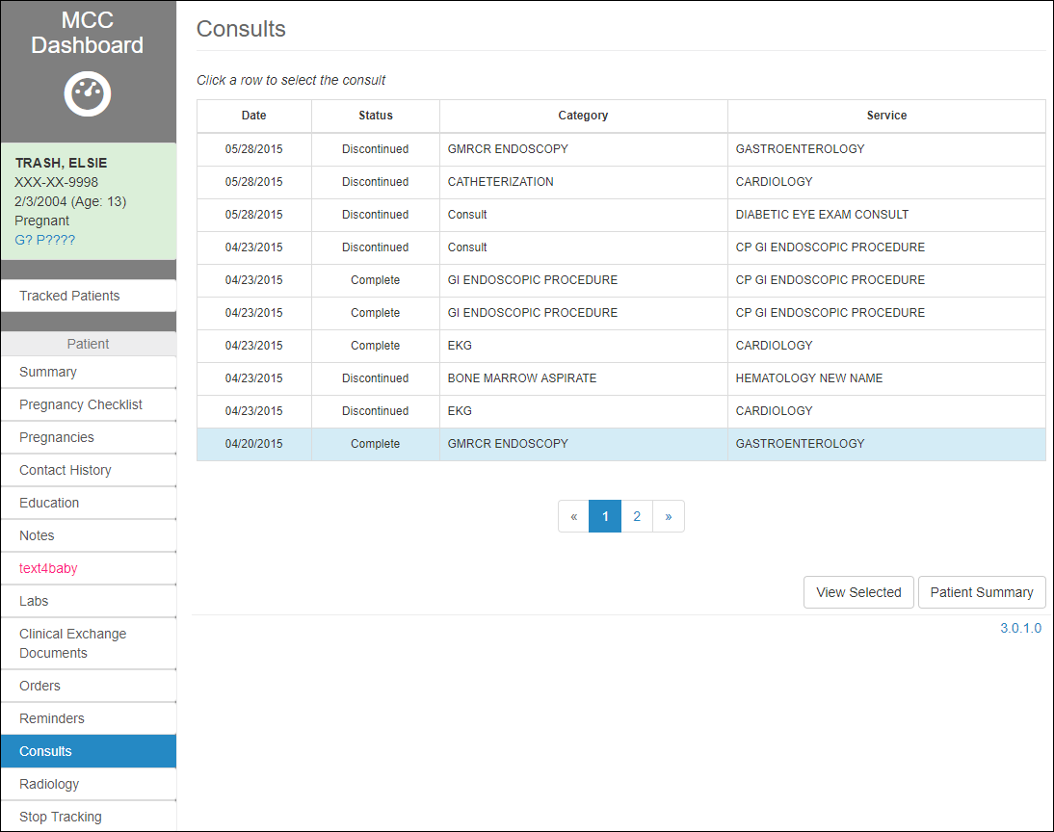

Figure 218: Consults

The screen shows a table of all the Consults associated with the selected patient, containing the following info:

1. Date
2. Status
3. Category
4. Service

The user has two options, by selecting the corresponding buttons at the bottom of the Consults screen:

1. **View Selected** consult
2. Navigate to back to **Patient Summary** screen

To view the Consult’s details, highlight the corresponding row in the Consults table and click **View Selected**.

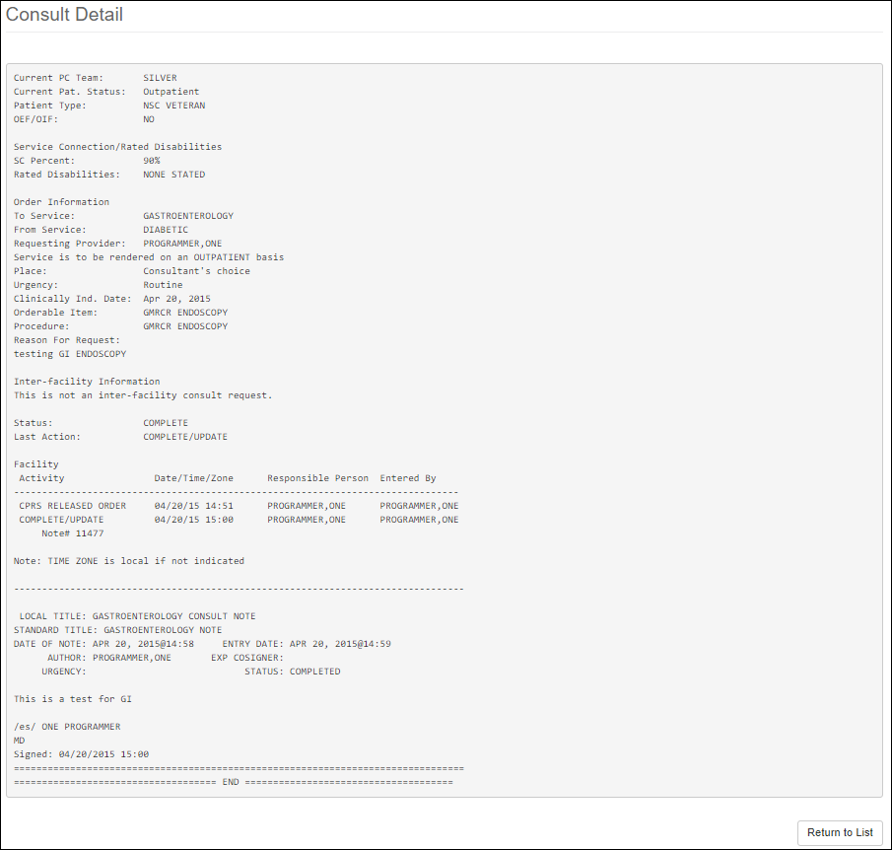

Figure 219: Consult Detail

To return to Consults screen, select **Return to List** button at the bottom of the Consult Detail screen.

## Radiology

To access the **Radiology Reports** screen, click on the **Radiology** tab on the left side pane, under the Patient section. The page displays a list of Radiology Reports for the patient from their CPRS record.

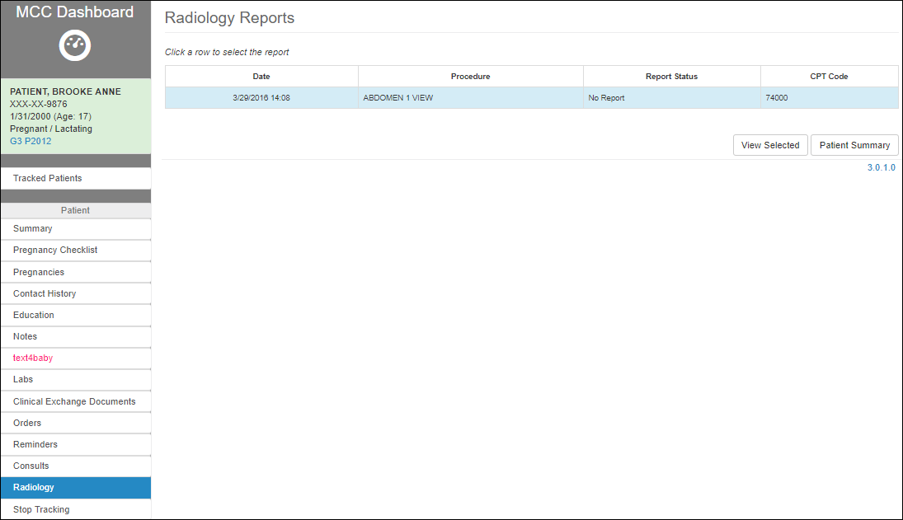

Figure 220: Radiology Reports

The screen shows a table of all the Radiology Reports associated with the selected patient, containing the following info:

1. Date
2. Procedure
3. Report Status
4. CPT Code

The user has the following options, by selecting the correspondent button at the bottom of the screen:

1. **View Selected** reminder
2. Navigate back to the **Patient Summary** screen.

To view a Radiology Report’s details, highlight the corresponding row in the Radiology Reports table and click **View Selected**.

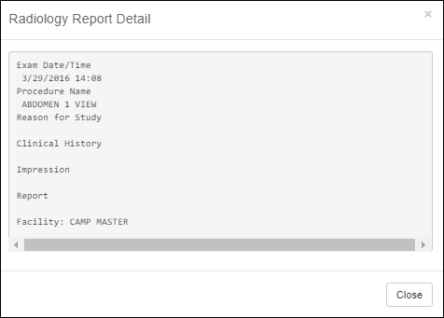

Figure 221: Radiology Report Detail

The Radiology Report Details should now open in a separate window. To close the window, select **Close** or click the X in the top right.

## Stop Tracking

To stop tracking the patient, click on the **Stop Tracking** tab on the left side pane, under the Patient section.

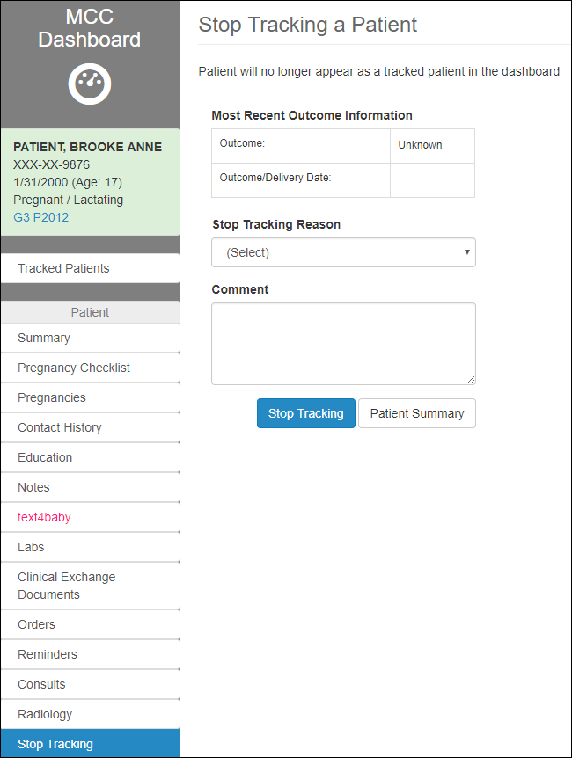

Figure 222: Stop Tracking Patient

The user is redirected to **Stop Tracking a Patient** screen, which allows the user to enter pregnancy outcome information, select a reason from the drop-down list, and add a comment related to the tracking ending, by using the following fields:

1. Most Recent Outcome Information
2. Stop Tracking Reason
3. Comment section

The user has the following options, by selecting the correspondent button at the bottom of the screen:

1. **Stop Tracking**
2. Navigate back to the **Patient Summary** screen.

To Stop Tracking:

1. Ensure the Most Recent Outcome Information for Outcome and Outcome/Delivery Date is correct.
2. Select a reason in the Stop Tracking Reason dropdown list:

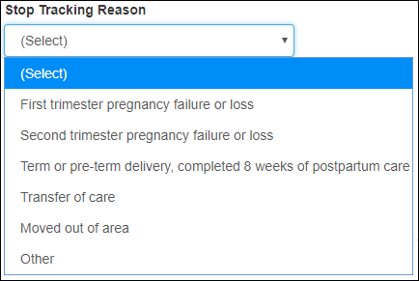

Figure 223: Select Reason for Stop Tracking

1. Add an additional comment in the Comment textbox.

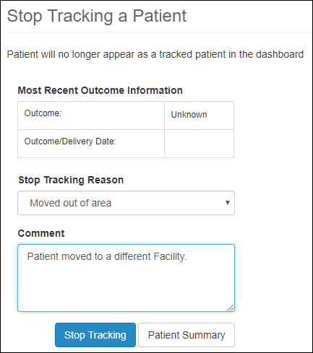

Figure 224: Stop Tracking Details

1. Select **Stop Tracking** button.

The user should be redirected to the **Tracked Patients** screen and the patient should no longer be listed as being tracked.

To see a history of patient’s tracking, the user could select the **Tracking History** tab, as presented in section Tracking History.

# Glossary

## Glossary of Terms

|  |  |
| --- | --- |
| **Term** | **Definition** |
| Dashboard | Menu |
| Estimated Delivery Date | Anticipated date the patient will deliver newborn(s). |
| Flagged | A patient whose health status in CPRS indicates pregnant will be flagged for tracking in MT. |
| Gestational Age | The age of the fetus. |
| Lactation | Production of breast milk. |
| Pregnant | A patient’s health status. |
| Provider | Licensed Medical Practitioner |
| Tracking | Using the software to manage the clinical and educational tasks of a patient. |
| User | Person viewing or entering information into the application. |

# Acronyms

|  |  |
| --- | --- |
| **Acronym** | **Definition** |
| CNT | Clinical Note Template |
| CPRS | Computerized Patient Record System |
| DOB | Date Of Birth |
| EDD | Estimated Delivery Date |
| F/U | Follow-up |
| GA | Gestational Age |
| GP | Gravida Para |
| H&P | History and Physical |
| HPI | History Of Present Illness |
| IHE | Integrating the Healthcare Enterprise |
| IPV | Interpersonal Violence |
| L&D | Labor And Delivery |
| LMP | Last Menstrual Period |
| MCC | Maternity Care Coordinator |
| MCCD | Maternity Care Coordinator Document |
| MD | Medical Doctor |
| MT | Maternity Tracker |
| OBGYN | Obstetrics and Gynecology |
| PP | postpartum |
| ROS | Review Of Systems |
| SSN | Social Security Number |
| VA | Veterans Affairs |
| VHA | Veterans Health Affairs |
| WIC | Women, Infants and Children |